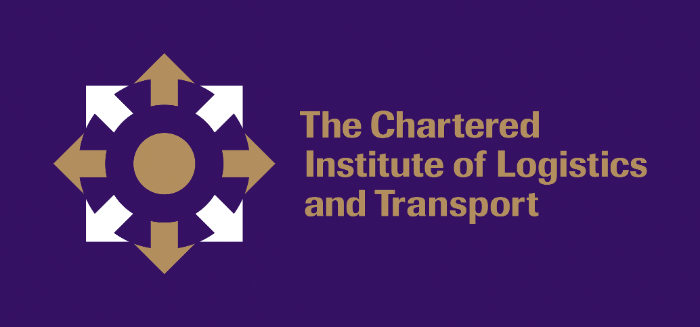

WEST MIDLANDS REGION
STAFFORDSHIRE GROUP

INTERNATIONAL STUDY TOUR
to
SWITZERLAND (Zurich Area)

4th to 12th JUNE, 2016

£1,100 pp in a twin-bedded room

or

£1,500 pp in a single room

The prices include:-

8 nights B & B Accommodation at the Royal George Hotel
in Einsiedeln

Excursions, Meetings & Technical Visits,
Dinner on arrival evening & Gala Dinner at end of Tour

To obtain a booking form please contact Andrew Dartnell FCILT
on

Tel: +44 1889 – 560195; Mob: +44 7974 – 588052
or
email: friesian@btopenworld.com

