Introduction
The COVID-19 pandemic is having devastating effects on the Egyptian economy in the short term. The disease-induced emergency is paralysing all sectors of the economy and opening the door for unprecedented losses. According to economists’ commentaries, the long term economic impact largely depends on how long the disruption lasts.
The Egyptian government has taken a gradual approach in responding to the Covid-19 crisis, in an attempt to try to limit the scope of the outbreak and to flatten the curve. Schools, universities and educational centres were closed on the 15th of March until further notice. Female government employees with young children were granted paid leave and most organisations have set forth altered working procedures to avoid crowding including reduced staff, work from home as well as reduced working days and hours.
At the same time, Egypt’s initial two-weeks suspension of International flights that started Thursday March 19th was extended for another two weeks (mid-April). Egypt has kept its airspace open to allow tourists and expatriate workers to return home. Internal and freight flights were not included in the decision as Egyptian airports continue to receive charter and scheduled flights (without passengers) to allow tourist groups in Egypt to complete their programmes and return to their country on their determined travel dates.
A curfew from 7pm to 6am was introduced on the 25th of March 2020 with the suspension of all mass public and private transport during curfew hours. All shops and malls are completely closed on the weekend and during curfew hours on weekdays. Only supermarkets, pharmacies and bakeries are exempted from the closure. Sporting clubs and gyms are also shut down. Other measures undertaken to contain the pandemic include but are not limited to the following:
- Suspension of all sports and public events
- Deployment of Military Biological units to support the Ministry of Health to sanitize public facilities
- Banning of public gatherings and meetings
- Closure of all religious establishments (Mosques and Churches) until the end of month, prayers are to be observed at home
The above-mentioned measures had an adverse impact on the whole economy including great disruptions to the transport and logistics sector.

- How has the Covid-19 crisis hit the transport and logistics industry in your country and what are the key challenges?
The aviation sector was hit the hardest with a complete halt of passenger transport. The decision did not include cargo flights. According to official estimates, flight suspensions have resulted in financial losses for Egyptian airlines exceeding EGP 2.25 billion.
Other modes of public passenger transport including the bus service, the Cairo Metro and the Egyptian National Railways were much affected by the limitation imposed on operating hours with a considerable rise in traffic during the two hours before curfew. In this context, the Ministry of Transport undertook the following counter measurements to contain the spread of the disease:
- daily sanitization of railways and metro cars and stations
- placing posters detailing coronavirus prevention measures including washing one’s hands frequently and avoiding touching one’s face, as well as avoiding shaking hands and covering one’s mouth when sneezing or coughing.
- use of the internal radio of each station to raise awareness about the virus,
- additional metro and railways cars were brought into operation to prevent overcrowding.
- distributing face masks to metro commuters and station workers at peak hours to help stop the spread of the novel coronavirus, according to a company statement.
The maritime sector was also greatly affected. The east side of the Port Said port is closed, while the west side remains open with limited operations. The port of Alexandria is only accepting vessels to discharge cargoes and the port of Damietta is restricted to container ship activity only. Ports and terminals in operation do so with delays due to carriers and customs shorter working hours and reduced capacity.
Egypt is following recommendations from the World Health Organization (WHO) as a means for helping protect customers and team members. Specifically, it is reported that disinfection is carried out by the state Quarantine Department at the ports, while the authorities advise that all have to keep minimum contact and use PPE. All shipping agents are provided with specific disinfection and cleaning instructions for all the cargo and containers. It is forbidden to deal with cargo or containers unless such disinfection and cleaning operations are done by the authority and a certificate issued.
Agents have also been instructed to notify the health authorities if there is any intention to sign on or sign off of any crew in the ports. Under the possibility that a crew/passenger/suspect case is acknowledged, crew is disembarked, ship disinfected, all returned on board and ship allowed to enter port. In cases with 2 or more sick crewmembers, vessel is to remain at roads in quarantine. Special attention is given to vessels coming from risk areas including Taiwan, Japan, Malaysia, Vietnam, South Korea, Singapore, Iran, Italy, Iraq, Kuwait, Bahrain, Germany, France, Switzerland, Spain and Thailand.
For the time being, there have been no reports of disruption to shipping through the Suez Canal. According to official navigation statistics, the number of ships crossing the canal in both directions during March 2020 (1662 ships) is higher than the number of ships crossing the canal during March 2019 (1589 ships). However, Egypt’s Suez Canal Economic Zone (SCZone) postponed indefinitely an international economic forum aimed at attracting investments that was planned to be held on March 21 and 22.

- What are the lockdown effects on business relationships and business models?

The diagram below provides an overview of the impact of the COVID 19 pandemic on business in Egypt.
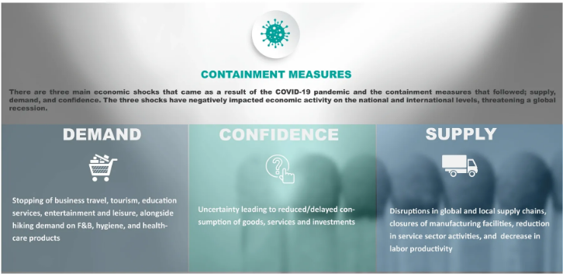

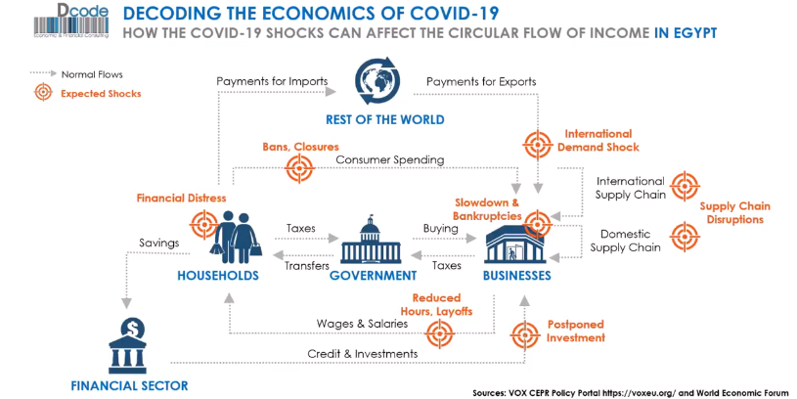

As illustrated above, the outbreak had a disruptive impact on all sectors of the economy with several sectors responding better than others depending on the type of product or service being provided and the type of technology being utilized.
- Manufacturing: The manufacturing sector in Egypt is labor intensive and accordingly was hit hard. Industries such as construction and real estate, automotive, textiles and most retail outlets are suffering the most.
- Travel and Tourism suffered greatly due to the ban on international travel and is likely to take time to recover. Estimates suggest that the collapse of travel and tourism alone will result in a fall in national GDP by between 0.7% and 0.8% (EGP 36-41 billion or $2.3-$2.6 billion).
- Education: In Egypt, digital learning has been part of the school education reform strategy for three years now, with a special website to help teachers and students communicate. Universities have also resorted to e-learning platforms and online classes. It is important to note however that the online system is in its experimental phase and does not cover all school grades in the 27 governorates of Egypt. The shift to distance and online learning has therefore brought its own challenges. In this context, the Minister of Education has formally announced that students will only be examined on the material delivered to them in schools until the 15th of March 2020.
- E-commerce and ICT: Other sectors that depend on e-commerce (e.g. some retail services including those offering food and beverage) are benefiting from the current situation.
- The pharmaceutical sector is also gaining both on the short and long term as attention and support go towards health sector and its investment.
- The Informal Sector: Informal activities (workers with no contract and social insurance) represent 40%-50% of total economic activities which in turn increases their vulnerability in terms of income levels, safety as well as security.

- To what extent have businesses and organisations been able to change their operational response already to manage through the Covid-19 period?
Many service providers were able to respond relatively quickly to the crisis either by focusing more on existing on-line offerings or by creating new ones. Such services include education and training offered by government and the private sector, banking, food and beverage, pharmacies and retail. However given the long term nature of their investment and the complexity of their business models, sectors like manufacturing and construction did not manage to come up with short term solutions to the business disruption associated with the COVID-19 outrbreak.

- What help and support is being given in your country by government, CILT or other trade bodies? How can B2B and CILT play a role in overcoming the Covid-19 challenges?
The Egyptian government is implementing several measures to boost the industries and businesses expected to be hit hardest by the COVID-19 pandemic. Such measures include:
- Reduction of the price of natural gas provided to industry from US $5.5 to US$ 4.5 by US$ 1 per million British Thermal Unit (BTU)
- Authorities are delaying due dates for property taxes on factories and tourist facilities for three months.
- Interest rate cuts by 3% (300 basis points)
- A 6 months delay in the due dates for all types of consumer and small business loans
CILT Egypt is studying with Highly Professional Advisors - HPA, alternative means of offering the CILT Diploma on-line for students. It is important to note that HPA has considerable experience in providing on-line course work. The only challenge relates to the fact that HPA has only completed the accreditation process less than a month before the COVID-19 crisis.
On the medium and long-run, CILT can play an important role in overcoming the Covid-19 challenges facing Egypt by show-casing to government and business, international practices in dealing with the lock-down. In particular, CILT can provide recommendations in areas related to transport and logistics automation and management as well as provide industry leaders (of all sectors and subsectors) with information and advice about state of the art solutions and business continuity planning methodologies.
In the short-term, CILT Egypt recommends that a series of regional and country-specific webinars are organized to discuss and brain-storm around the most pressing issues and topics specific to each region/country.

