CILT INTERNATIONAL OFFICIAL UPDATES ON CORONA VIRUS (COVID-19)
Cilt Malaysia’s Response in two parts:
Part I – Operational scenario and
Part II – as regards the 4 questions.

Part I – Operational Scenario
Logistics and Other measures undertaken by Malaysian Authorities in the light of The Movement Control Order (MCO) effective from 18th March to 31st march, 2020 and the further extension to 14th April 2020 to ensure continued supply of essential goods and services.

- Port Clearance of Cargoes:
  - Port Kelang, Port of Penang and Johor Port have nearly reached 100% of their capacities to hold goods. The Ministry of Transport has therefore instructed to the affected ports to:
    - Be given special exemption to clear non-essential goods to warehouses outside the port area temporarily so they can continue to release essential goods promptly and immediately.
    - The various ports has therefore to implement plans to immediately expedite the movement of goods currently congesting their warehouses in the port areas.
    - Freight forwarders and haulier companies will be allowed to move their goods out for 24 hours per day in a given time frame.

- Logistics Services:
  - To allow for smooth transit and delivery of all goods during the Movement Control Order period, Royal Malaysian Police personnel will ensure the vehicle of freight forwarders and hauliers will be allowed to move within a given time frame for the purpose of sending goods to their intended destinations unimpeded.
  - In doing so the freight forwarders and hauliers sending goods must adhere to conditions stipulated through the Media Statements issued by the National Security Council (NSC).
  - Commercial vehicles are encouraged to be operational between 7pm to 7am. Not withstanding general vehicles movement is not restricted.
  - The transportation of essential items must be preplanned and obtained documentation clearance where necessary so the vehicles movement will face little or no hindrance.
  - The transportation sector had been identified as one of the essential services under the MCO period and plays a key role in ensuring the nation's households will have access to their daily necessities.
  - E-fulfillment hubs and warehouses will continue to operate.
  - Selected workshops and towing services can operate, as long as they conform to the prescribed safety measures and precautions set by the Ministry of Health (MOH), NSC and respective state governments, including local city and municipal councils.

- Export and Import Activities:
  - All export activities will be allowed to continue. It is vital to ensure that supply chains are not severed and countries that need our exports will be able to continue receiving them. This include shipping movement.
  - All cross border movements of goods is operational subject to National Security Council orders from time to time.
  - No production activities are allowed at this point in time but will be reviewed by the Authorities from time to time.

- Public Transportation:
  - All forms of public transportation such as trains and buses are allowed to operate within the hours of 6am to 10am and from 5pm to 10pm only. Taxis and ehailing operators may still operate within the stipulated regulations issued.
  - All Terminals are required to provide for body temperature scans and to provide for hand sanitizers at all ticketing counters.
  - Terminal operators are also required to do disinfecting of assets like benches and desks and all similar items from time to time to ensure cleanliness is maintained at all times.
  - Trains and buses will also undergo regular disinfections daily.

- Air Services:
  - Air services as an essential service will continue to operate subject to passengers being screened on departure and arrivals.
  - Private jet operation will also continue.
  - Basic items of purchase is allowed to operate at all airports, such as pharmaceutical outlets, sundry shops selling essential items and banking facilities.

- Updates of Information:
  - The Ministry of Transport will issue operational information from time to time as regards vehicle movement including issuance of Frequently Asks Questions (FAQ's) to the public to assist the public in managing their movement during the MCO period.
  - This include temporary exemptions of renewal of vehicle road tax with the proviso that Insurance Coverage is intact.
  - Renewal of drivers Licence will be exempted until 30 days after the declaration that the MCO is lifted.
  - Information as regards vehicle drivers test deference will all be made available through the updater, as well as commercial vehicles maintenance checks availability.

- Feedbacks from the various commercial sectors:
  - Feedbacks from the various chamber of commerce like The Federation of Malaysian Manufacturers, Malay Chamber of Commerce and the Associated Chinese Chambers and Industry and The Malaysian International Chamber of Commerce and Industry are actively communicating with the Authorities as it affect the economy as a whole and those that affect the movement of goods.

- Formation of Special Cabinet Committee:
  - A Ministerial Cabinet meeting on 1st April, 2020 has agreed to establish a Special Cabinet Committee to develop strategic measures in safeguarding Malaysia's economy and labour market impacted by COVID-19 with the aim of striking a balance between the nation's economic priorities and the effective enforcement of the Movement Control Order (MCO).
  - Other key focus areas of the Committee include measures to sustain Malaysia's economic engines particularly the Small and Medium Enterprises (SME's).
  - The inception of the Committee reflects the Government's quick response to address issues by the masses and the Malaysian business community.
  - The Committee will be co-chaired by The Minister of International Trade and Industry and Senior Minister/Minister of Defence. Members will comprise of other ministers involved in the nation's economy and security.

Infographics Illustration on the dos and don’ts whilst on MCO:
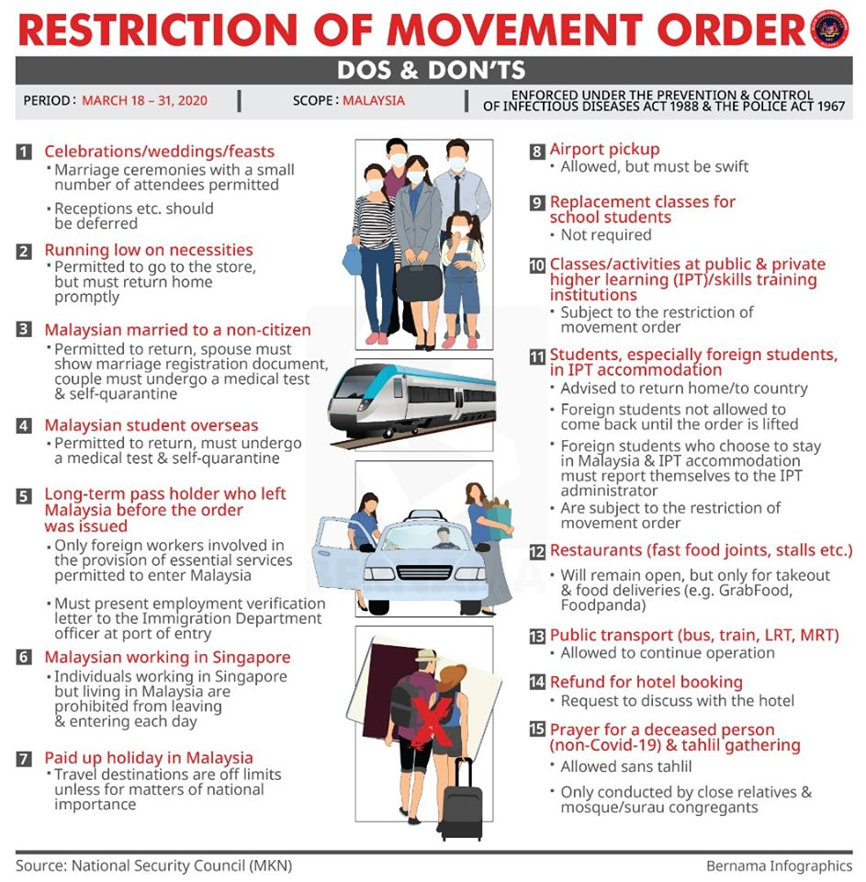
Part II – The 4 Presidential Questions
The Presidential request as to the need to do local research has been relayed to our local universities who are also our accredited training providers. We will follow up on their response accordingly.
As to the 4 questions we have considered it and the following is our analysis of the situation:
- How has covid-19 hit the transport & logistics business and industry in your country and what are the key challenges?

- Covid-19 had resulted in a partial lockdown declaration on activities and movements by the government.
- Only essential goods and services are being allowed to move so that it can be delivered to its destination. The scenario on logistics services are as follows:
  - To allow for smooth transit and delivery of all goods during the Movement Control Order period, Royal Malaysian Police personnel will ensure the vehicle of freight forwarders and hauliers will be allowed to move within a given time frame for the purpose of sending goods to their intended destinations unimpeded.
  - In doing so the freight forwarders and hauliers sending goods must adhere to conditions stipulated through the Media Statements issued by the National Security Council (NSC).
  - Commercial vehicles are encouraged to be operational between 7pm to 7am. Not withstanding general vehicles movement is not restricted.
  - The transportation of essential items must be preplanned and obtained documentation clearance where necessary so the vehicles movement will face little or no hindrance.
  - The transportation sector had been identified as one of the essential services under the MCO period and plays a key role in ensuring the nation's households will have access to their daily necessities.
  - E-fulfillment hubs and warehouses will continue to operate.
  - Selected workshops and towing services can operate, as long as they conform to the prescribed safety measures and precautions set by the Ministry of Health (MOH), NSC and respective state governments, including local city and municipal councils.
- Key Challenges:
  - Strategising communications and channels
    - The main challenge is to have excellent communications from the government to the business organisations and the masses to send clear messages.
    - Quite a disarray in the beginning but fast feedbacks from affected parties resets a better communication methods.
    - The setting up of a Special Cabinet Committee on 1st April will hold and ensure a better communication to ensue.
    - Continuous consultations with chambers of commerce and business associations at ground level, in the policy development process is the order of the day.
    - Two Economic stimulus package had been announced and more forthcoming as a result of feedbacks from the populace and especially the business community. The key to its success is the ability in the government to be sensitive to the voices below.

- What are the lockdown effects on their business relationships and business models?
- All Small and Medium Enterprises has their activities stopped except for the production of essential items such as food, facemasks, sanitizers, disinfectants, pharmaceutical, medical devices and personal protective clothings.
- The economy has to be kept going and most affected are the small and medium enterprise businesses that make up close to 36% of the gross domestic product in the national economy and accounts for 65% of employment.. The Special Cabinet Committee is tasked to get this sector moving again.
- It is vital to keep the manufacturing, construction and mining sectors running to help holding up the economy. Given that Malaysia’s manufacturing sector integrates with global supply chains, MCO’s inflicted disruptions not only cause loss of sales through order diversions but also “collateral damage” on a permanent basis. It is to be noted that Wuhan in China and Singapore did not shut down their production plants.
- To assist businesses they need compassionate support of financial institution and the government in granting automatic moratorium on loans and other assistance. It is to be noted also debtors and suppliers having financial difficulties may drag even good stable companies along the supply chain.
- Financial assistance will also have to take into account to cover post recovery of COVID-19 to stabilize business operations.

- To what extent have businesses & organisations changed or can they change their operations, to manage during Covid-19 period?
- Forced stoppage of work and production calls for immediate plans to restructure business operations accordingly at least for the next six months as sustainability of business operation has to be addressed.
- It is argued that there are inconsistencies in the government interpretations of what is considered essential and non-essential services. It must be noted that the supply chain is wholly integrated. By allowing for the benefit of the doubts there will be more services available on the road. Clearer, inclusive and wider definitions of ‘essential items’ is needed not only to resolve confusions but to attract more business operations.
- The business community wants more approval for industries to operate and allow at least 50% of workers capacity to meet orders.
- The situation for the business is either they operate with the minimal workforce or they go bust. The business structure is rigid that making changes will be impossible in the face of financial constraints and lower manpower availability and adaptability to new changes in the business models.

- What help and support is being given to the Transport & Logistics providers by the government, CILT or other bodies? How can B2B and the CILT play a role in overcoming the Covid-19 challenges?
- Since this sector is considered as essential services business operations takes place as usual.
- Assistance comes in the form of assisting them for smooth operation and unhindered when on the road and that the terminals or destinations are not congested that their drop-off or pick up may be delayed. This where the government has issued directives to all terminals including sea and airports to clear non-essential cargoes to a nearby depot temporarily to allow for unhindered movement of essential items.
- B2B in this sector will hinge on collaborations between freight forwarders an hauliers with the terminals to ensure that deliveries is smooth especially on essential items movements.
- As for CILT Malaysia, as a professional body under the auspices of the Ministry of Transport Malaysia, our best platform will be to assist the Ministry with inputs on logistics information and data. This is what exactly took place when even on day one of the Movement Control Order MOT officials already contacted CILT Malaysia for relevant information where most of the inputs had been reflected in the Ministerial Media Statement that is made from time to time.
- CILT Malaysia being a member of the Association of Professional Institution in the country have pooled their resources for the purchase of much needed medical supplies required by the hospitals.
- CILT Malaysia through individual members have gone to the ground to partake in the preparation of food and distributing it to the frontliners manning the various checkpoints along the main roads at the Kuala Lumpur and its vicinity.
In conclusion, survival of businesses is critical to the country’s economic recovery and thus in turn ensures the population’s sustained employment. Listening to the people and the business community is key.
Warmest regards from Malaysia.
Ts Haji Ramli Amir, FCILT
President
CILT Malaysia

END.

