CILT Kazakhstan continues to promote the Business Support Programme in Central Asia
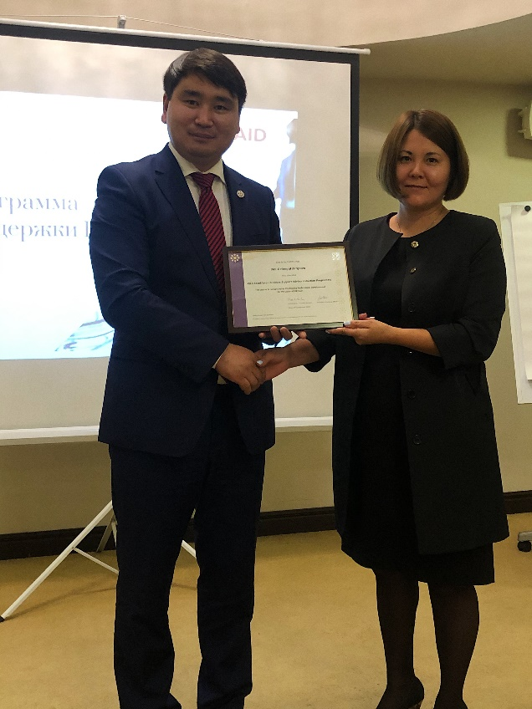
On 9th September 2020. CILT Kazakhstan organized a networking meeting for the approved ‘Business Support Programme’ experts in Almaty, which was attended by some 15 experts.
Building on 2 months of training and development, this key event brought together the BSP experts, the CILT team and key USAID CTJ project personnel.
This was a critical event to bring as many of the advisors together to support them as a group, prior to starting their assignments later in September with Small Medium Emprises located across Central Asia.
As well as received final briefings, the evening allowed us to present training certificates to the BSP experts.

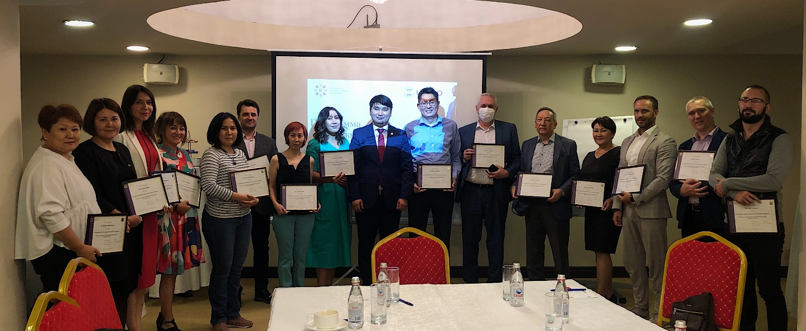
Background
The Business Support Programme (BSP) was launched in July 2020 with the support and cooperation of USAID CTJ Project and CILT to provide support and consulting services to small and medium enterprises (SMEs) across Central Asia
Through cooperation between USAID and CILT (the leading professional organization for supply chain, logistics and transport professionals), a pool of 35 experts (BSP experts) was brought together from a wider variety of professional backgrounds. These included major international/national transport and logistics organizations, local consulting companies, and specialist trade associations with extensive experience in government, customs and tax services.
Under the leadership of Jon Harris, Education and Business Development Lead at CILT International and Oliver Cofler, the CILT International Project Manager and SCALA consultant, as well as the CILT Kazakhstan team, the recruitment of candidates started in May-June 2020 looking for professionals with a wide spectrum of knowledge and skills in both business and technical areas.
During July/August 2020, preparatory work was carried out with the BSP experts, which included conducting 5 online training sessions. These helped to explain the goals and objectives of the Business Support Programme, define the roles and responsibilities of BSP experts and their future clients (SMEs), build an individual development plan for each expert, as well as providing useful materials and helpful business diagnostic tools.
By becoming involved in the BSP programme, BSP advisors/experts are able to:
- Grow their own skills and competencies so they can support businesses growth and recovery through training, facilitation, coaching, mentoring, and provision of technical advice. This will include the use of technical tools and diagnostic techniques.
- Help local economies recover and grow by focusing on the needs of Small Medium Enterprises (SMEs). This will normally focus on private and not for profit organizations of around 25-150 employees, but also with companies with smaller number of employees especially if they have a complex supply chain or are involved with procuring teams of sub-contractors and outsourced staff.
The one of the main objective of the programme was to support BSP experts to became ‘rounded’ professionals that can use different techniques to enhance business performance. This involve a blend of training, technical, coaching and people skills so for each of the advisors we will be looking at how to accelerate those skills set throughout the length of the programme.

This objective was achieved through training and support sessions, as well as working with all the BSPs as a community online. All BSP experts were able to fill in any skills gaps through collaborative sessions with other BSP advisors, working with a CILT appointed mentor (CILT International or CILT Kazakhstan team member of ‘Lead’ BSP) and also by spending time reflecting on how the project has developed their own thinking.
The CILT team have worked with each BSP to understand range of knowledge and skills, and a pro forma covering their core skills, abilities and the technical, management and problem-solving areas where their feel they can bring most value.
As part of the pro forma exercise, CILT team also looked at any skills gaps or areas that BSP experts would like to strengthen and develop – for example some may have very strong technical knowledge on a supply chain or transport topic, but they have been used giving well defined directions on solutions rather than use mentoring techniques to share that knowledge with other professionals and use team building techniques to achieve the outcome.
CILT also provided key tools to help the CPD process including
- A pro forma and guidance on carrying out BSPs skills gap assessment – either on their own or with a CILT mentor
- A pro forma and guidance of individual CPD plan – this is to set goals and overall professional development needs – this is strategic action plan
- A pro forma to use to plan and reflect on each specific activity
- A CPD activity record sheet and guidance - where BSP experts record the time they have spent but also the value of the learning experience to them and what that will mean for their professional practice in future
In addition, the CILT Kazakhstan team held individual meetings with BSP experts on a regular basis and provided them with additional information to support delivery as the programme went into live phase.
Originally CILT were seeking a total of 20-25 BSP experts but have now achieved a pool of 35 expert consultants with different competencies to support the Central Asia marketplace
As well as exceeding the number of anticipated BSP advisors, we have seen substantial demand for support across the region, with over 40 applications from companies from Kazakhstan, Kyrgyzstan, and Tajikistan. Turkmenistan and Uzbekistan. We expect this number to grow to nearer 50-60 by the end of September.

There are key benefits in developing business support programmes like this across the CILT family. If you would like to know more about the approach taken in the Central Asia Region and the way the model has been developed please contact

Jon Harris – jon.harris@ciltinternational.org +00 44 7881 805 952 or
Aibek Kurmanov – kurmanov.aibek@gmail.com

JH/AK 18/09/20
