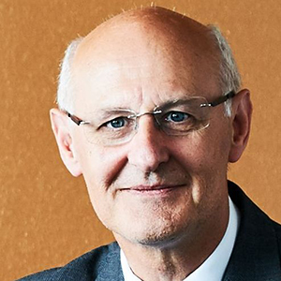
Alan McKinnon is Professor of Logistics in the Kühne Logistics University in Hamburg, Professor Emeritus at Heriot-Watt University, Edinburgh and a Chartered Fellow of the CILT. A graduate of the universities of Aberdeen, British Columbia and London, he has been researching and teaching in freight transport / logistics for over 40 years and has published extensively in journals and books on many different aspects of the subject. Much of his recent research has been on the decarbonisation of logistics and in 2018 he published a book on the subject. Alan has been an adviser on logistics to several governments, parliamentary committees and international organisations, including the OECD, World Bank, United Nations, World Economic Forum, European Commission and the Intergovernmental Panel on Climate Change. He was chairman of the World Economic Forum’s Logistics and Supply Chain Council and a member of the European Commission’s High Level Group on Logistics. He was a founder member of the CILT’s Logistics Research Network and won the Institute’s Sir Robert Lawrence award in 2003.

