Time for our industry to wake up to gender inequality

To conclude my studies in TU Dublin’s programme for MSc. in Supply Chain Management, I recently completed a thesis that asked the question, why does gender inequality exist at leadership levels within our industry in the face of pending leadership shortages? While stumbling in the dark looking for a topic worthy of academic research, I came across an article in the Seattle Times written by Kimberly Perkins, a Seattle based female airline captain entitled “I am among 5% of all pilots in America – a women”. After reading this power piece depicting the gross gender imbalance within US airlines at captain level I was hooked. As I dived into research within supply chain and logistics it quickly became apparent that gender inequality is flourishing, and for the most part flying under the radar. I knew then I had my research topic, questioning what drives gender inequality within our industry today.
Disparity of gender balance grows the higher up the seniority level you go within our industry. Reports and studies showing males making up 92% of Director and C-Suite level management within supply chain and logistics organizations are well documented.
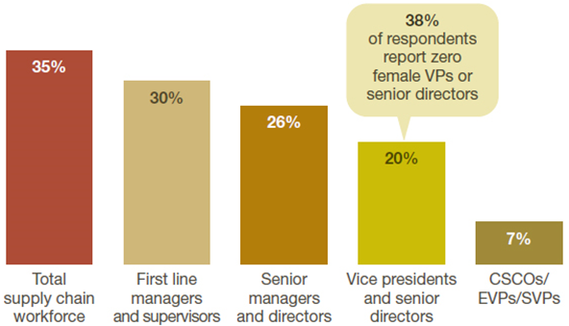
Source 2020: modified from Women in Supply Chains, Gartner Report (Stiffler, et al., 2020)
When you consider the starting base moving towards gender parity at entry level roles, It questions what is happening to make the numbers of women drop off or why are a disproportionate number of males making it to the top? For this reason I decided to confined my research to leadership levels. I conducted in-depth interviews with, female leaders over a cross-section of supply chain and logistics sectors. 43% of these women are C-Suite level, 36% at senior management level and 21% at middle management level.
I found the findings of this research alarming, so much so, that at one time I found myself reaching out to a friend who works in HR consultancy just for a sanity check on the findings. As an operations and logistics manager with over 34 years experience this was a wake up call. Allow me to share some examples of insights and conclusions with you.

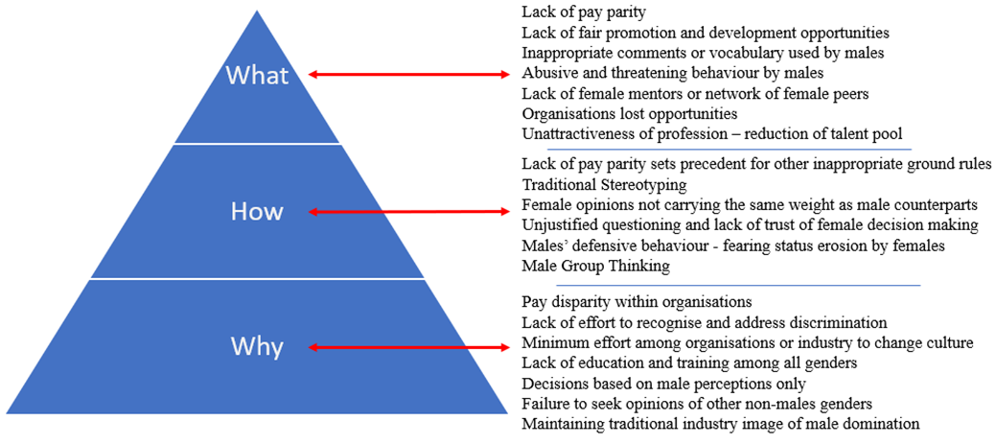
Organisations are being predominantly lead by male leaders. Hence the lack of female perspectives at decision-making levels is resulting in the industry’s lack of process when recognising and addressing issues of gender inequality.
Continued disparity in pay, should not be underestimated as it sets an unjustified status quo which allows further acts of bias and gender discrimination to flourish among organisations in the supply chain and logistics sector.
Of all the female leaders who participated in the interview process of this research, none of them, up to the point of their interview, had been afforded the opportunity nor been requested to freely express their opinions and experiences on gender bias within their organisation. Hence the research concludes this failure to gain insight should be regarded as a wake-up call to both organisations and the industry as a whole. This is compounded when considering the number of years of service female leaders who contributed to this research have amassed to date (two hundred and sixty-four years). All of which must be regarded as current untapped potential knowledge.
How long will the neglect of internal issues such as gender inequality remain sustainable? The report concludes that the clock is ticking, and has been for some time now. Hence the time for action via greater engagement is way past overdue. The time for recognition and meaningful implementation to tackle gender inequality is now if organisations are to recover from lagging impacts and secure future leadership resource requirements.
While it may be considered reasonable to suggest that the onus to tackle gender inequality issues lay at the feet of individual organisations operating within the supply chain and logistics sector, the industry as a whole is likely to suffer if collective ownership and responsibility is not adopted.

Recommendations:
The research recommends that organisations proactively seek assistance from industry bodies such as CILT (The Chartered Institute of Logistics and Transport) and actively encourage and welcome engagement with programmes of empowerment such as WiLAT (Women In Logistics & Transport) to develop female middle managers to the benefit of all within their organisations.
Also recommended is for organisations engage consultancy services to establish and develop internal educational and training programmes with a view of modernising internal cultures and eliminating potential risks associated with preconceived traditional notions derived from male-dominated decision-makers at the top.

I’ve spent my whole career in the supply chain and logistics industry and it was 32 years before I had to report into a women. Now I’m awake to gender inequality I’m not surprised. I’ll be forever indebted to the women who shared their insights with me as part of my research.

Adrian Byrne, B Bus, CMILT
General Manager
ATC Computer Transport & Logistics

