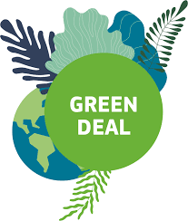

Effects on Turkısh exports

EU Green Deal

**CILT TURKEY – 09 April 2020**

As it is commonly believed that the planet is facing environmental disasters as a consequence of climate change problematics, the European Union (EU) intends to inspire a sustainable green transition. The European Commission presented “*The European Green Deal*” as an indicator of this leading mission, which is a reaction to a warming atmosphere, climate change and polluted air. The European Green Deal aims to transform the countries and citizens of the European Union into a fair and competitive environment where Greenhouse Gas (GHG) emissions will be zero by 2050.

The main driving forces behind GHG are the economic sectors and climate change have severe impacts on human activities. What is more, the five main emission source sectors can be listed as fuel combustion and fugitive emissions from fuels (energy including logistics); industrial processes and product use (IPPU); agriculture; land use, land use change and forestry (LULUCF); waste management.

Climate change and global warming as a result of human activities are major threats for all the life in the world owing to the diverse and comprehensive effects on biodiversity, the environment, the economy, the human health and the well-being. It is a common concern for everyone who wants a global solution to reduce the threats and consequences of climate change. It is discussed by the Commission through European regulations and policies on the reasons and consequences of climate change and is an ambitious partner for international activities in this field. Also, high-quality data are extremely critical for tracking progress in reducing GHG emissions along with drivers, effects and adaptation to climate change.

As the European countries and the rest of the world appear to have austere environmental issues, such as climatic impacts and extreme weather events in the near future, the EU is among the leading regions struggling with the climate change and trying to lower the GHG emissions



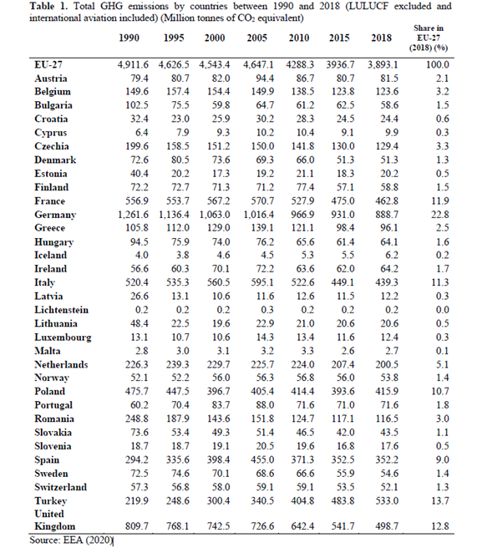

When the GHG emissions of the member countries of the EU is examined, according to Table 1, the ranking of the top three countries’ share in the total GHG emissions of the EU in 2018 is Germany (nearly the quarter of the emissions), France and Italy

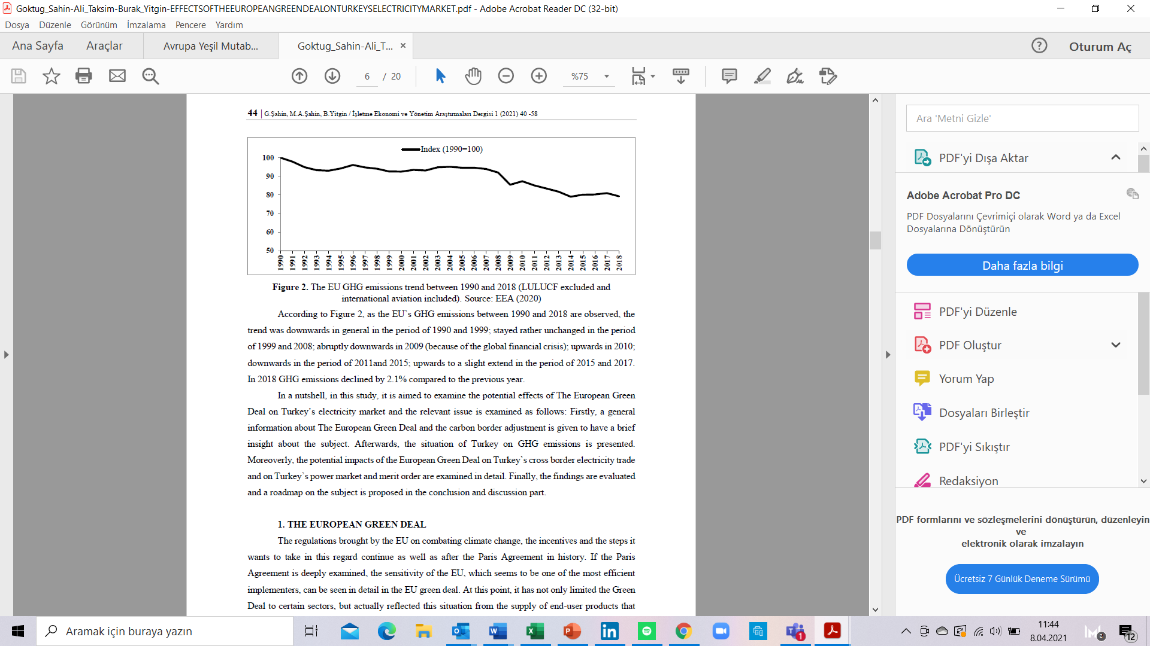

According to Figure 2, as the EU’s GHG emissions between 1990 and 2018 are observed, the trend was downwards in general in the period of 1990 and 1999; stayed rather unchanged in the period of 1999 and 2008; abruptly downwards in 2009 (because of the global financial crisis); upwards in 2010; downwards in the period of 2011and 2015; upwards to a slight extend in the period of 2015 and 2017. In 2018 GHG emissions declined by 2.1% compared to the previous year.

1. **THE EUROPEAN GREEN DEAL**

The regulations brought by the EU on combating climate change, the incentives and the steps it wants to take in this regard continue as well as after the Paris Agreement in history. If the Paris Agreement is deeply examined, the sensitivity of the EU, which seems to be one of the most efficient implementers, can be seen in detail in the EU green deal. At this point, it has not only limited the Green Deal to certain sectors, but actually reflected this situation from the supply of end-user products that may affect climate change to energy consumption in homes and even agricultural policies.

The European Green Deal is the name given for all the action plans implemented by the EU in order to play a dominant role in the battle against the climate crisis and global warming. This agreement includes a series of studies aimed at making all the EU member states carbon-neutral by 2050. The key EU regulations and policies on the matter can be listed as follows (European Commission, 2019c); “Climate Change Investments, Contribution of Forests and Lands in Combating Climate Change, Energy Efficiency and Renewable Energy Investments, EU Emissions Trading System, Member States'Objectives for Non-Emissions Trading Sectors, Preparing for the Effects of Climate Change, Progressively Reducing Fluorinated GHGs, Protecting the Ozone Layer, Reducing GHG Emissions in Transportation, Supporting Low-carbon Technologies.”.

In this sense, the EU implements a series of measures, especially the climate law and the carbon border tax, within the scope of this agreement. Simultaneously with these measures, the EU tries to support this process by creating various transition funds so that companies can move away from carbon and fossil-based energy and fuel in order to switch to green energy. The size of the funds allocated by Europe for environmental projects in the next 10 years is over one trillion dollars.

Nowadays, the increasing need for energy along with price and production-based volatility in energy markets have turned the direction of investments around the world into clean energy, that is, green finance. Increasing awareness of global warming and environmental sensitivity has also directed the investments of governments, financial institutions, investors and businessmen to spend the least harmful technologies on the environment.

The main goal of the European Green Deal is described as a carbon neutral Europe and the aim is to achieve zero GHG emissions across Europe by 2050 as mentioned before. Actually, this statement does not mean zero emissions. It articulates zero emission increase compared to 1980. The first step is to create a new European Climate Law and put it into effect as soon as possible. In addition, when Europe's GHG emission value for 1990 is taken as reference, the 40% emission reduction target previously envisaged for 2030 has been raised to the 50-55% band.

The EU Commission plans to review all laws and regulations and align them with the European Green Deal goals. In this context, firstly, the Renewable Energy Directive and the Energy Efficiency Directive will start with, at the same time the Emission Trade Directive will be reviewed. Turkey may be effective and efficient in the development of the EU's digital energy market. EU's most important natural area of logistics Turkey, it can take an active role in EU gas and hydrogen infrastructure. Circular Economy will increase employment in Textile, Construction, Electronics and Plastics Sectors. The adaptation of Turkey’s industry to Circular Economy will lead to product diversity and profitability and will also strengthen new employment. The Turkey’s construction sector can undertake important projects in the EU by developing projects that comply with sustainable and energy efficiency standards. In addition, there are 50 million buildings in the EU's renovation stock. These small projects are also a great potential and opportunity for Turkish contractors. Turkey can be effective in areas from agriculture to digital technologies.

Essentially, one of the main goals of the European Green Deal is not only achieving the two aforesaid goals of Europe. The important feature that aspired to provide with the European Green Deal of Europe can be defined as increasing the competitiveness of the countries in the EU. At this point, the EU also comprehends the European Green Deal as a tool to save its own economy. The relative competitiveness of companies that act in line with the emission standards introduced by the EU outside Europe will decrease and they will be more competitive with neighboring countries with the European Green Deal. If the subject is examined in more detail, actually there is an emission trading system in the EU like the companies are responsible for the carbon emissions of the electricity they produce and consume. It would be appropriate to go through the sectors of cement, iron and steel which are the most carbon intensive electricity consuming sectors to give a concrete example.

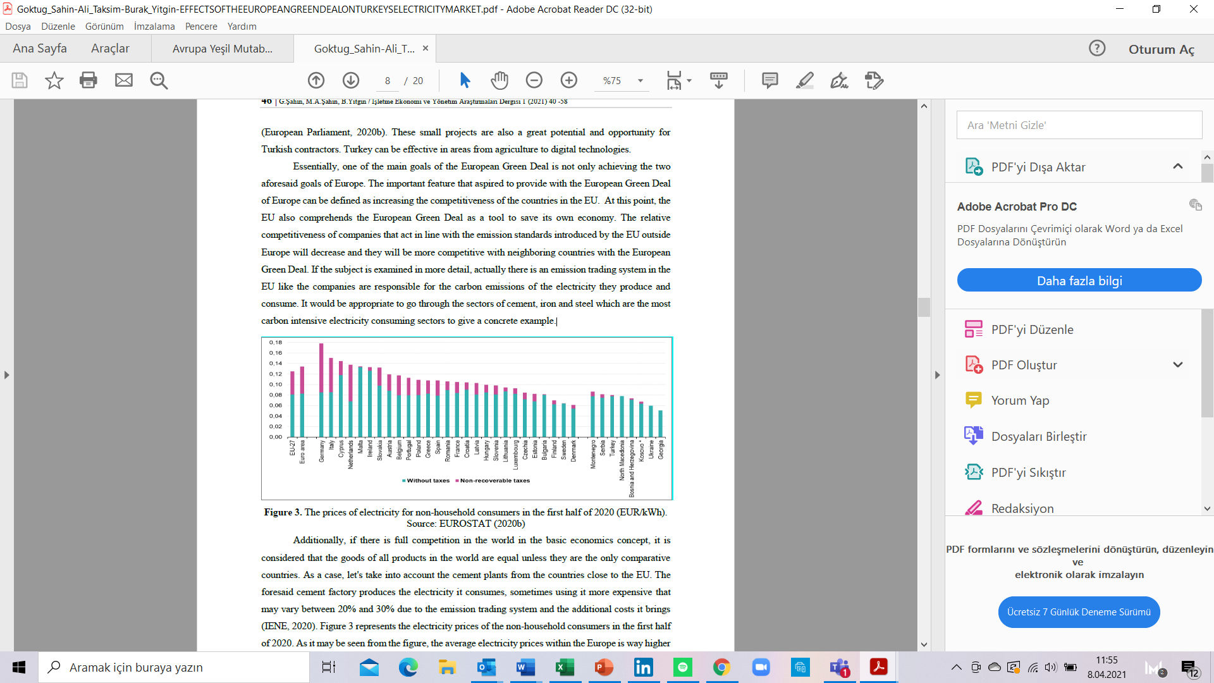

Additionally, if there is full competition in the world in the basic economics concept, it is considered that the goods of all products in the world are equal unless they are the only comparative countries. As a case, let's take into account the cement plants from the countries close to the EU. The foresaid cement factory produces the electricity it consumes, sometimes using it more expensive that may vary between 20% and 30% due to the emission trading system and the additional costs it brings.

Figure 3 represents the electricity prices of the non-household consumers in the first half of 2020. As it may be seen from the figure, the average electricity prices within the Europe is way higher compared to the neighboring countries. The main reason for this difference is the mandatory carbon cost in the EU. Considering that sectors such as cement and iron-steel are energy-intensive, it is apparent that countries within the EU will be less competitive than countries outside the EU. In this context, it is obvious that the cement producers exporting to Europe can provide it with much more advantageous prices compared to cement producers in the EU.

The main purpose of addressing this issue is that Europe, which aims to create a more environmentally friendly, sustainable and natural economy with its climate sensitivities, causes economic losses due to the fact that the whole world does not have the same mentality or the same practices. Many products that can be produced in Europe, especially energy-intensive products, are exported to Europe just because of these emission taxes and fees. This situation can be shown as one of the reasons of the increasing employment problem in the EU, rather than just a self-sufficient Europe. In this context, the EU basically aims to attain the producers within the EU to equal competition conditions with the producers outside the EU.

At this point, reducing carbon emissions is an attainable situation in terms of structure. It is extremely easy to design this on paper by introducing taxation and additional incentives. The EU's climate plan this time differs from one of the priorities at this point. Along with the regulation, the EU shows that the current climate understanding is requested not to harm its own economic power. The EU has already lost its competitiveness, especially in energy-intensive sectors in line with its climate policies, and its exports have decreased, and its imports have increased. The negative effects of these climate policies are observed not only in the trade balance but also in the unemployment data.

When the related informative data of Turkey is observed, it can be seen that more than two times the spike in carbon emissions to 1990 levels is valid. The main reason behind this increase comes from the energy, industrial production, transportation and construction sectors. The EU aimed to reduce emissions by 50% compared to 1990 levels by 2030 and to create "*domestic climate neutrality*" by 2050 with the European Green Deal.

1. **THE CARBON BORDER ADJUSTMENT**

According to EUROFER (n.d.), the Carbon Border Adjustment (CBA) is a method to promote the EU's climate leadership by representing the carbon intensity of goods imported into the EU. This process is critical because the EU producers have the highest environmental and climate conservation targets in the world-and higher production costs that follow this initiative.

It is known that the details of the carbon border regulation will be clarified as a result of the meetings to be held with stakeholders in the next year. Although the details of this point are not yet finalized in the system and methodology, it is known what it aims at as of its philosophy. The EU wants to use its increased market power in line with new energy policies and create a more competitive environment. Although there are many regulations on how to do this, it mainly focuses on "carbon leakage". The basic rationale behind carbon leakage is this subject. If there is no "carbon cost" in every country in the world, there is no logic in applying this to products produced in the EU.

In a framework in which a good produced for 10 euros; it may be expected to have an additional cost of 2 euros coming from the ETS, in that sense it would cost 10 + 2 euros, with a total cost of 12 euros, even though the cost of goods to be imported from elsewhere in the EU is 11 euros as an example, consumer choice of a product of 11 euros will be fair. At this point, not only the producers in the EU. become less competitive, but also carbon emissions continued worldwide. Based on this example, it should be noted that the biggest deficit is in energy-intensive sectors worldwide. Electricity trade has the same problem from the EU perspective as well. The EU Commission is still working on its policy to overcome this issue as well; however, it is still uncertain and need to be implemented with the stakeholder engagement. Also, it is uncertain that which sectors the EU will prioritize under which headings and implement this policy.

At this point, stakeholders pushed the EU commission to consider different implementation options. It is essential to declare under which standards a carbon emission system will be accepted within the EU and accordingly it will not be re-taxed at the EU border. Otherwise, double carbon taxation would be possible. The issue of how the importer obligations will be is a complete mystery. The most realistic approach in this matter is to categorize the products and determine the "*default benchmark levels*" on the basis of product groups. At this point, the EU averages can be taken as well as world averages.

Actually, it is well-known that the negotiations are being conducted between the World Trade Organization (WTO) and the European Commission. On the other hand, the fact that Turkey is considering at this situation is obviously far more complicated. Since 1995, Turkey has been a member of the EU Customs Union. The EU-Turkey Customs Union Agreement covers all products that are manufactured but not unprocessed agriculture, services and public procurement. Bilateral concessions to trade concern commodities from agriculture, coal and steel. The EU is not clear yet about how to regulate it, while it is one of Turkey's largest trading partner. One similar tariff can be applied to Turkey and Turkey's entry into the EU's emissions trading system is also among the foremost options. At this point, it is essential to discuss the options with an increase in the level and application of dialogue between Turkey and the EU.

In 2019, approximately 70 billion euros of imports from the EU is realized by Turkey while about 9 billion dollars of these exports came from energy-intensive industries. In the short term, sectors such as iron and steel, electricity and glass would have to pay this system’s bill. Turkey will face the short-term cost of just a 12% export item, although these costs could be lethal on behalf of the sector concerned. It is well known that a crisis is often an opportunity. Carbon cost of protection on behalf of Turkey's trade with the EU are also another way of payment. Turkey's folding lower carbon prices would improve the productivity of the current industry, and these investments need to be minimized on behalf of EU trade due to higher productivity in the long run, which will make Turkey a more sustainable economy.

1. **TURKEY’S GREENHOUSE GAS (GHG) EMISSIONS**

The information related to Turkey’s GHG emission is necessary for policies concerning climate issues in Turkey and the World. Turkey faces increases in GHG emissions alongside with the rapid growth in its economy.

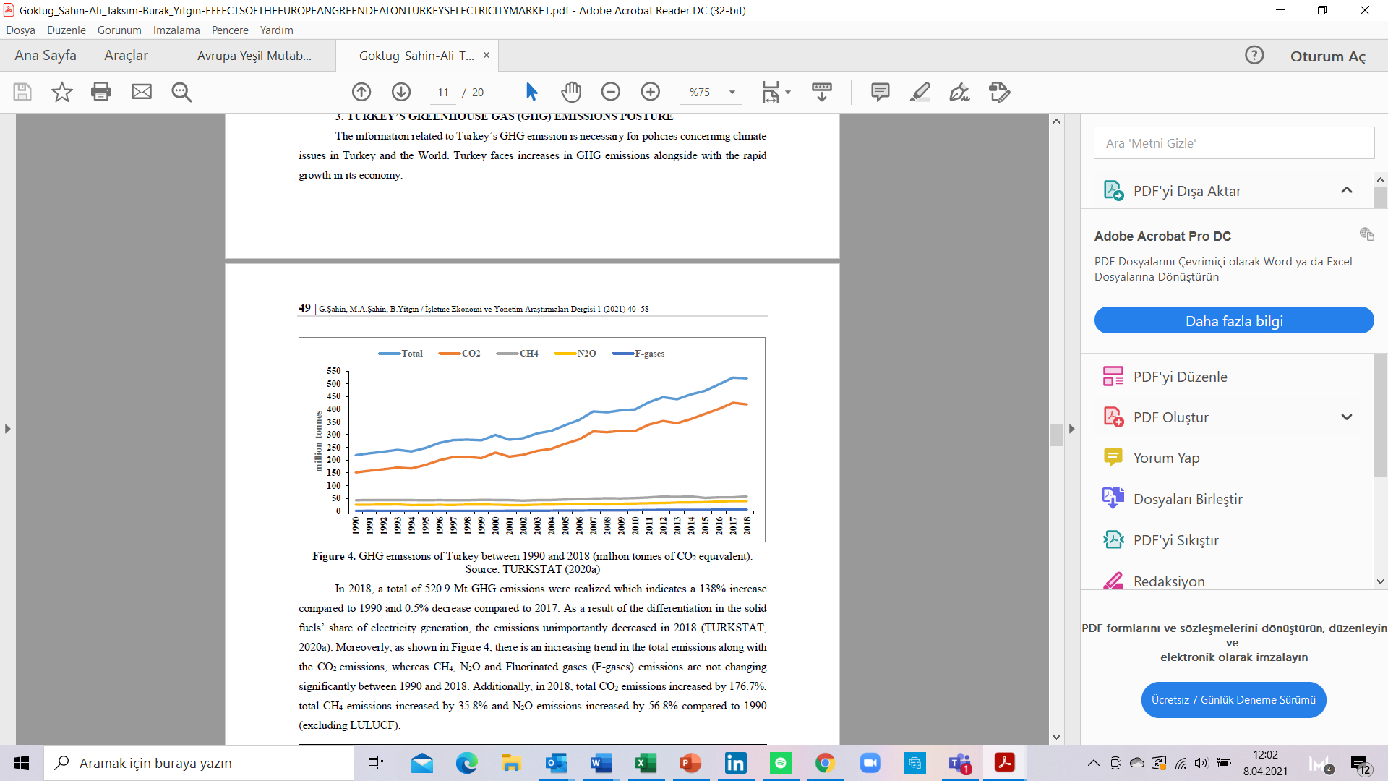

In 2018, a total of 520.9 Mt GHG emissions were realized which indicates a 138% increase compared to 1990 and 0.5% decrease compared to 2017. As a result of the differentiation in the solid fuels’ share of electricity generation, the emissions unimportantly decreased in 2018 (TURKSTAT, 2020a). Moreoverly, as shown in Figure 4, there is an increasing trend in the total emissions along with the CO2 emissions, whereas CH4, N2O and Fluorinated gases (F-gases) emissions are not changing significantly between 1990 and 2018. Additionally, in 2018, total CO2 emissions increased by 176.7%, total CH4 emissions increased by 35.8% and N2O emissions increased by 56.8% compared to 1990.

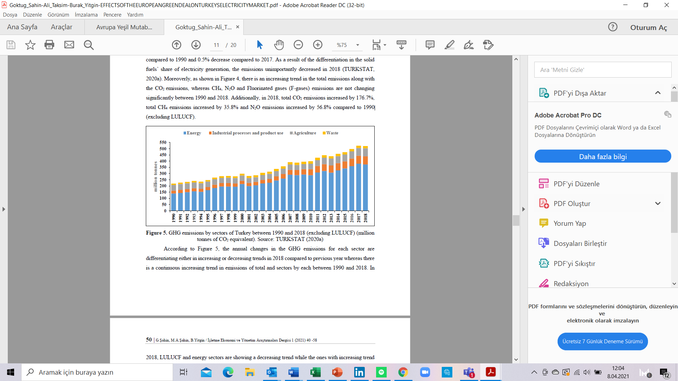

One important point is that, Carbon equalization tax on Turkish products is going to be costly for the Turkish recovery process in the COVID-19 world, as export performance will be negatively impacted. Second is that European value chains already operating in Turkey, and those that might start thinking about moving to Turkey in the post COVID-19 world will want to see a green transformation program there as well.

A new growth strategy is needed for Turkey to jumpstart job creation anyway. A green transformation program in Turkey, comprising energy transition and efficiency, digital transformation and smart, sustainable cities, working together with the EU’s Green Deal appears to be essential. A mutually beneficial green transformation agenda appears to be a new positive agenda item between the EU and Turkey. Energy transition in Turkey could be a good starting point for the discussion, together with a program for smart sustainable cities.