Title: Australia’s High Productivity Vehicles Delivering Continued Safety, Productivity and Sustainability outcomes during and after the Pandemic
Background:
The beginnings of a new road freight productivity scheme was first initiated by the then National Road Transport Commission (NRTC) over the period 1997-2006. The scheme was called the ‘Performance Based Standards’ (PBS) Scheme and it was the scheme whereby these new ‘High Productivity Vehicles’ were allowed to operate. After trials the States and federal government finalized the scheme in 2007 and handed the operational aspects of this new national scheme over to the newly created National Heavy Vehicle Regulator (NHVR) in 2013.
These vehicles from a safety, productivity and environmental perspective have produced significant benefits when compared to Australia’s conventional trucking fleet.
The Australian Road Freight Ups and Downs during the COVID-19 Pandemic
Australia’s 2020 pandemic year saw freight highlights and lowlights over this period. Interstate transport continued to move across State borders, food and supermarket road transports actually grew, construction transport continued strongly as did household deliveries, although this was mainly done with smaller light commercial vehicles. Retail and non-essential manufacturing took a significant downturn in activity. However, overall road freight transport grew by a weak but positive 1.4% over the year, whereas other sectors returned negative GDP contributions.
However, even though there was some sectoral downturns in heavy truck operations, the uptake of Australia’s High Productivity Vehicles continued at a strong but slightly lower rate than the current six year average. (See Table 1).
Table 1: Change in the Annual Population of Australian High Productivity Vehicles
Year | 2015 | 2016 | 2017 | 2018 | 2019 | 2020 | Average 2015-2020
HPV Articulated Combinations | 1546 | 2132 | 2643 | 3321 | 4172 | 4748 | 3093
HPV Truck and Dog Trailers | 2072 | 2886 | 3780 | 4847 | 5745 | 6230 | 4260
Total | 3618 | 5018 | 6423 | 8168 | 9917 | 10978 | 7353
Growth Rate |  | 1400 | 1405 | 1745 | 1749 | 1061 | 1227
Source: National Heavy Vehicle Regulator (Australia) 2021

The Safety, Productivity and Environmental Benefits of HPVs
There have been three published national studies on HPVs in Australia over the last seven years: 2014, 2017 and very recently in 2021. The three classes of benefits, gained through the use of HPVs, all come about through the large saving in kilometres travelled when compared to using an equivalent capacity basket of conventional trucks. The kilometre saving, as a fractional saving, are viewed as the productivity benefit. As crash rates can be related to millions of kilometres travelled, safety savings can be estimated by how many million kilometres the HPVs actually save and applying the crash rate to that saving. The environmental benefits arise from the net fuel savings in performing a given tonnage task with HPVs when compared to a basket of conventional vehicles, non HPVs, performing the same tonnage task. In 2014 it was estimated that the population of HPVs would save some 7.3 billion kilometres in travel, or 2.7 billion litres of diesel fuel by 2030. As the growth rate for HPV adoption has been greater than that rate forecast in 2014 these estimates will certainly be exceeded.
The following three HPV configurations, Figures 1,2 and 3 represent 76% of the Australian HPV fleet as at 2020. That is, they are the most popular configurations of the many HPV truck types. (PBS Vehicle Configurations (nhvr.gov.au))
Figure 1: Construction/Quarry Rigid Truck - 34% of HPV Population
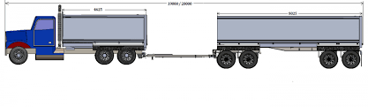
Gross Vehicle Mass 57.5 tonnes, Length 20m, Productivity Benefits over conventional vehicle class – 20.9%, Major Crash saving over conventional Rigid construction truck and trailer combinations – 62%

Figure 2: Enhanced Semi-Trailer – 18% of HPV Population
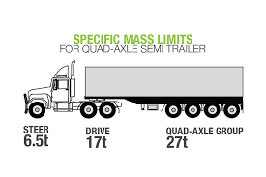
Gross Vehicle Mass 50.5 Tonnes – Length 20m, Productivity Benefits over conventional vehicle class: 16.2%, Major Crash saving over conventional 19m tri axle semi-trailer – 53%

Figure 3: A-Double – (High Productivity Road Train) - 24% of HPV Population
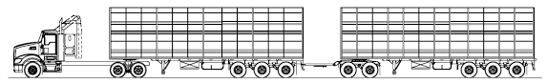
Gross Vehicle Mass 85.5 Tonnes – Length 36.5m, Productivity Benefit over conventional vehicle class – 32.5%, Major Crash saving over conventional double road train – 30%
The implementation of HPVs in Australia has delivered an all-round sustainability benefit, in safety, productivity and net fuel savings. The growth in the use of these vehicles will continue this trend.

Author: Dr Kim Hassall National Chair CILT-Australia, PhD FCILT CPL

