**Sustainability - a global challenge for us all**

**Stop, pause, think**

Apart from being professionals involved in logistics and transport, what unites us all?

Quite simply, sharing the same planet. Whether your job touches on the area of sustainability, or it is central to your professional role, none of us can escape the responsibility we hold in protecting our planet’s interests. From making operational decisions about how we dispose of and recycle waste, through to strategic long-term business investment in vehicles and assets, everything we consider now has an upstream and downstream sustainability impact. This article presents some hard-hitting facts, and some suggestions for future action.

*When was the last time you stopped, paused, and reflected on your environmental impact?*

This could be at a personal level, job level or perhaps as a member of CILT in your country. There is no doubt that there has never been such an important time for our profession to have a voice, provide evidence, and inform policy. Whether we are acting locally, regionally nationally or globally, working on environmental, economic or social sustainability, being part of the international CILT family offers a unique opportunity to open up the debate and stimulate action.

We've spent some time researching and evaluating how countries with a CILT presence are shaping up against the UN sustainability goals and other key environmental factors. Our research is here to give food for thought, to provoke debate and to ask our professional members to take stock and consider their own contribution to the pressing global sustainability agenda.

**The global profile of sustainability and the Paris Agreement**

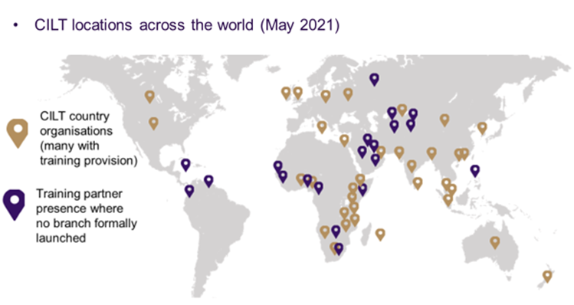CILT is now operational in over 40 countries across the world.

This takes account of established branches and territories, new country organisations being developed, and places where we have training and education partners in place.

This gives us a strong global reach and while some of these locations may still be quite ‘new’ to CILT, it's important to remember that sustainability research, social reform and environmental change agendas may still be strong in these locations.

We've taken a high-level look at the latest statistics and performance of these countries against the UN sustainability goals, not just to identify where the biggest challenges are, but also to see how we as the CILT professional family can support each other, develop solutions, and prioritise where a professional voice in this area is most needed.

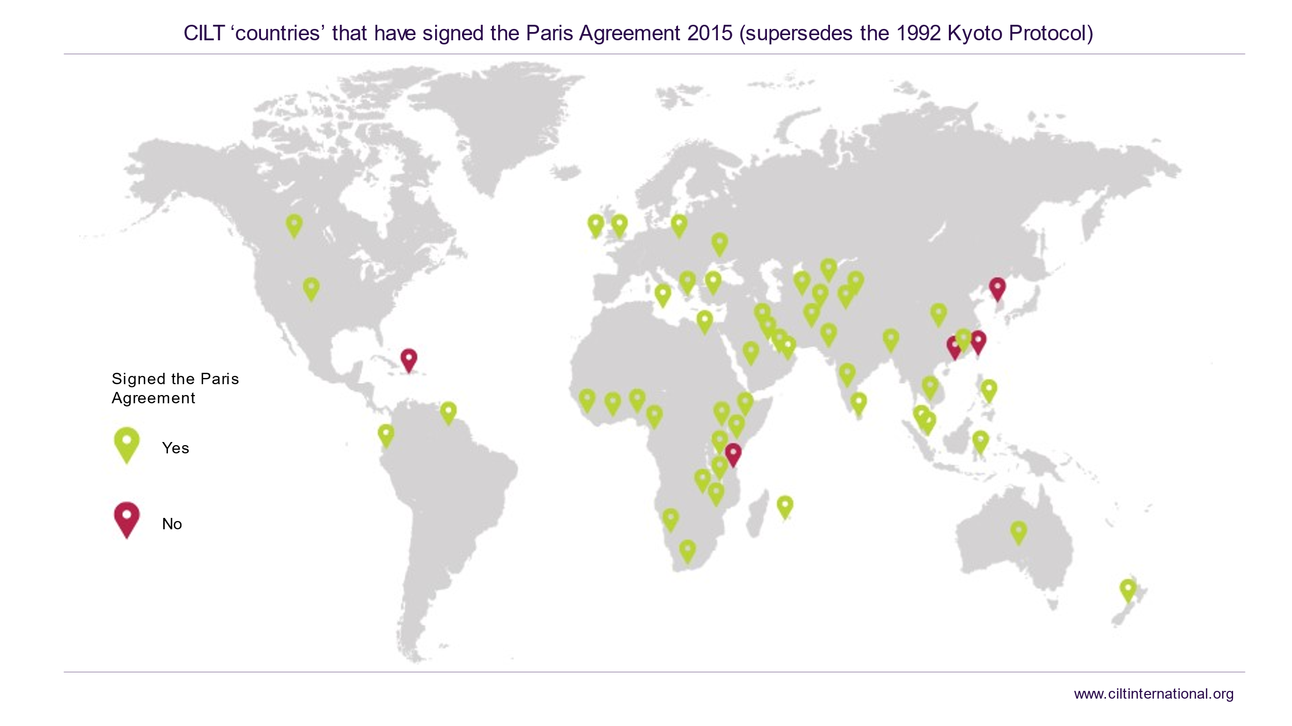Let's start with the good news that that over 90% of CILT countries are covered by the 2015 Paris Agreement on climate change and carbon, taking over from the Kyoto Protocol. The Paris Agreement is a legally binding international treaty on climate change. It was adopted by 196 parties at COP 21 in Paris, on 12 December 2015 and came into force on 4 November 2016.

Its big goal is to limit global warming to well below 2, preferably to 1.5 degrees Celsius, compared to pre-industrial levels. To achieve this long-term temperature goal, countries aim to reach global peaking of greenhouse gas emissions as soon as possible to achieve a climate neutral world by mid-century.

The Paris Agreement is a landmark in the multilateral climate change process because, for the first time, a binding agreement brought all nations into a common cause to combat climate change and adapt to its effects.

Implementation of the Paris Agreement requires economic and social transformation, based on the best available science. The Paris Agreement works on a 5-year cycle of increasingly ambitious climate action carried out by countries. By 2020, countries submitted their plans for climate action known as nationally determined contributions (NDCs).

For more information take a look at the website and short videos at <https://unfccc.int/process-and-meetings/the-paris-agreement/the-paris-agreement>

**Following the facts – the environmental picture**

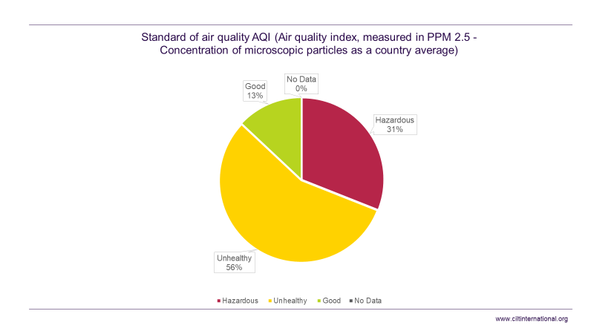Turning firstly to the overall environmental picture, the air quality indicators paint a stark picture. Whilst 13% of the countries we operate in are maintaining ‘good’ air quality standards (based on World Health Organisation levels of acceptability), 56% are witnessing unhealthy levels of air pollution, with a further 31% at hazardous / acute levels.

Whilst each country profile will produce different causal factors, it's fairly obvious that use of fossil fuels, manufacturing practices, and transport and logistics activities will be key contributors.

By bringing together the combined abilities of our CILT members - urban planners, transport planners, modal specialists, logisticians and environmental experts - we have the opportunity to develop and deliver collaborative solutions and make our cities smarter and better places for all.

Let's take a more detailed look at how individual countries have responded to the Paris agreement on the targets that they have set themselves. The table below sets out the greenhouse gas commitments made along with these specific air quality index results per country.

**Commitments made to global environmental agreements and standards – by CILT country**



**Calling for a Carbon Zero response**

Our current international focus on sustainability has highlighted best practice in the area of carbon reduction.

One example of a proactive’ carbon zero response can be found in CILT UK's *Routes to Net Zero 2050* report which was published earlier in 2021.

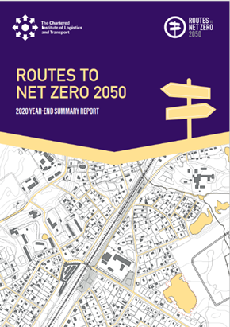This 2020-year end report summarises the work of CILT UK over the last year on transport decarbonisation and is intended to update CILT members, government ministers and officials, industry and other interested parties.

Throughout 2020, UK governments and their agencies and advisers have published studies, consultations, and statements and these together with parliamentary inquiries, work by international and industry bodies, and academics have been considered, leading to proposals and recommendations for policies to be promoted by CILT.

CILT UK welcomed the UK government’s Ten Point Plan for a Green Industrial Revolution which included areas directly relating to or affecting, transport. CILT UK importantly recognised that zero carbon measures must be balanced as part of an integrated approach to transport and within the overall decarbonisation agenda.

For more information on the CILT response you can -

* View the Route to Zero carbon page on the CILT website at <https://ciltuk.org.uk/routetozero>
* Watch our ‘In Conversation’ interview with Paul Le Blond, a key author of the report at <https://www.youtube.com/watch?v=WyqoTbn3gt8>

**Understanding the many facets of sustainability**

Of course, whilst there is a global focus on climate change and an increasing urgency to reverse environmental degradation, we cannot ignore the critical interdependency between environmental, social and economic agendas.

In each of our CILT countries there will be different drivers, issues and priorities. Although there isn't a single solution or formula for rebalancing previous impacts, as members we are all advocates of sustainable development and able to make a difference at whatever scale we can.

Whether you represent a corporate organisation with strategic corporate social responsibility objectives, or you work within a small to medium enterprise, or you find yourself within the public sector, it's vital not to forget the social and economic sustainability angles.

The next sections comprise and examination of the indicators of economic and social impact across our CILT family.

**Following the facts – the economic impacts picture**

Firstly, let's take a look at employment. For CILT countries covered by the Organisation for Economic Co-operation and Development (OECD) it's a positive picture with over 80% of countries meeting or exceeding the UN sustainable development goals, but this drops to just 35% when we consider the non-OECD locations.

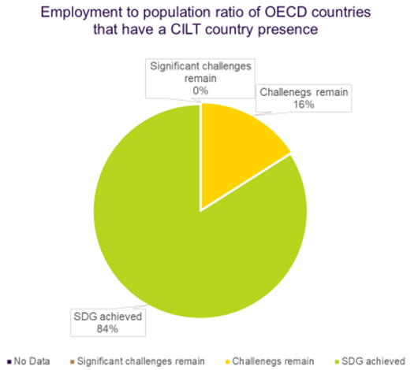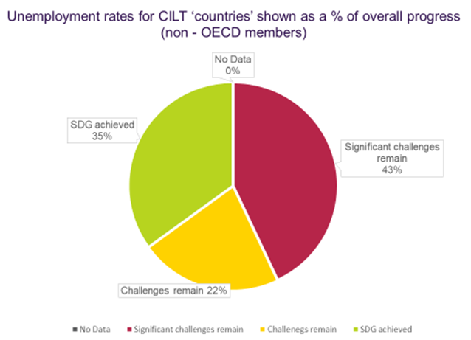

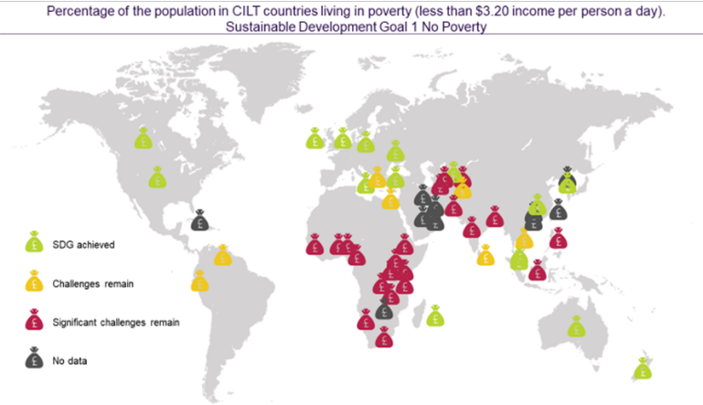

Then there is the issue of poverty (UN Sustainable Development Goal 1) where our research shows a complete mix across the world.

Whilst the most significant challenges remain in the African continent, there are significant poverty pockets elsewhere and a number of locations where no specific measurements have been taken against this particular UN goal.

By seeking to develop new employability and skilling models, and attract younger people into transport and logistics, we will help rebalance some of these key inequities, and do our part to generate appropriate training and job opportunities.

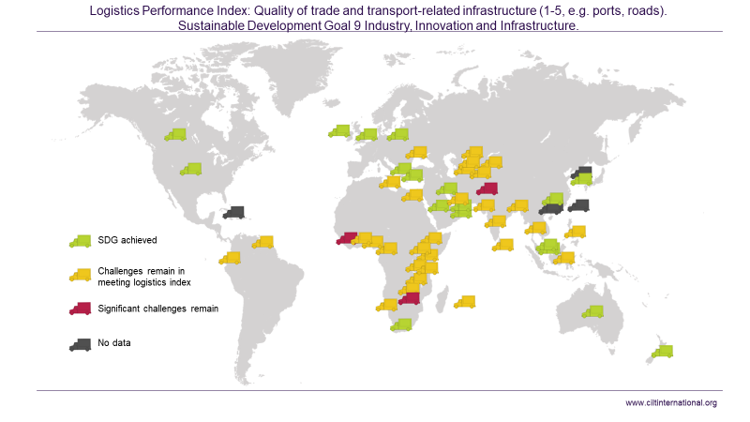If we now turn to the logistics performance index (LPI) for each of our CILT countries, we will see a brighter picture.

Over 90% of our CILT countries either meet the sustainable development goal or still have some challenges still in place to tackle.

But importantly this recognises the critical role of logistics to each national economy and also its potential role in tackling long term economic sustainability.

Although job creation and economic stability are key components of overall sustainability success, we mustn't forget the social dimension.

**Following the facts – the social dimension**

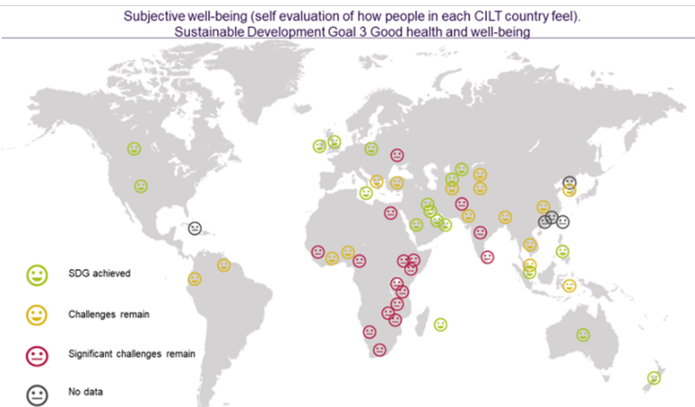UN Sustainable Development Goal 3 is all about health and wellbeing, and we have picked on two key metrics to help us understand the current challenges.

The index here focuses on how well people in each country feel. Let's not underestimate the importance of this indicator, reinforced by the way in which the COVID-19 pandemic has impacted on mental health, wellbeing and social contact as we know it.

Less than half of our CILT countries have achieved this sustainable development goal - and this was measured prior to the Coronavirus pandemic.

In terms of rebuilding communities, industries and the transport and logistics sector, there's a part for us each to play, however small, to help rebuild personal and organisational wellbeing.

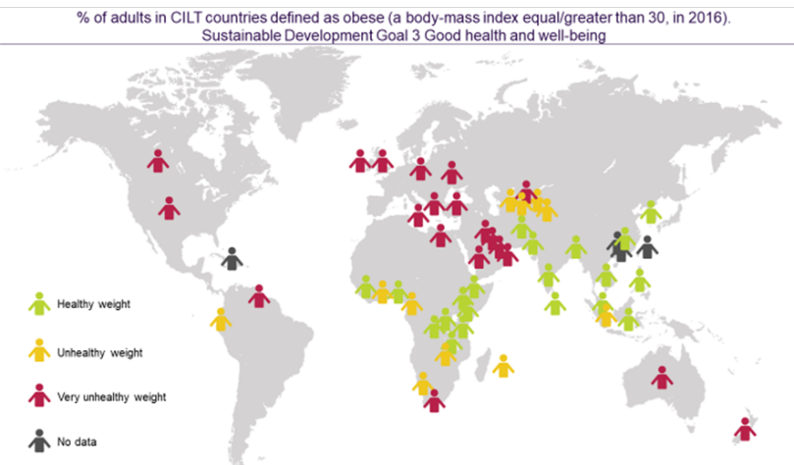But before we leave the social dimension behind take a look at this map.

Physical health and wellbeing are also critical to long term sustainability - and we have seen a significant rise in adult obesity across most of the western world over the past decade.

This in turn affects overall wellbeing, fitness, agility and impacts on areas beyond the world of work. So, when we think of corporate social responsibility it's vital that wellbeing of employees (and their families) is also taken into consideration.

Here is another area where we as professionals we can have a direct impact - whether it's through the way we advocate public transport, walking or cycling, improve city design around people’s mobility needs, or consider how we work even more proactively with the health sector.

**A Young Professional’s Perspective**

We've presented these facts and figures not to compare CILT countries, but rather to highlight that we are all in this together.

By being united as a CILT global family there is scope to accelerate learning between each other, collaborate constructively, share solutions, and above all to have a strategic voice.

There's a key opportunity here for younger professionals to have a real impact on the sustainability agenda and to shape the way we approach these economic, social, and environmental challenges.

What kind of world are we creating through our professional decisions? How empowered are younger members of our teams to stand up and be counted? How do the next generation of transport and logistics professionals see sustainability and how enabled do they feel to change the status quo? Considering health and wellbeing factors, are young people seeing what sustainability success means in a completely different way?

Here is testimony from Molly Gregory, a second-year geography student at the University of Gloucestershire, about her motivations and career ambitions to work in the humanitarian sector.

**Why sustainability is so important – perspectives of a young professional**

Sustainability is a word that gets used heavily in today’s society and workplaces. But what does it mean and why is it important, to young professionals who are about to enter the global world of work, especially into the transport and logistics sector? The way I think about sustainability globally is from the perspective that the planet is our home and we all like to look after and take pride in our homes, so why is the planet thought of as any different?

This means for a young professional entering the transport and logistics sector, sustainability needs to be at the forefront of ideas and practical application. The key to achieving this is education and training within the sector, which is paramount for the future of sustainable knowledge and understanding in logistics and transport. The input and energy from younger people’s engagement within the industry will bring a fresh thinking minds and creativity to a business which is only just starting to make sustainability a key priority for future developments.

The sustainable development goals produced by the United Nations should be something countries and large companies should live by, as being ‘sustainable’ is not only about the health of the planet; it is also about the health of populations and reducing inequalities globally. Inequalities such as poverty and lack of opportunities for women are some of the biggest barriers to development, and to truly be classed as ‘sustainable’ these must be addressed.

As part of the younger generation, I believe as a whole, we are much more conscious about the harm we are causing to the planet, throughout the decisions we make, even the everyday ones like either buying a plastic water bottle or opting for refillable water bottle. The little choices we make in day-to-day life make all the difference to the overall health of the planet and the time to act or start acting is now, as there is no better time than the present.

I believe if we listen to the planet the planet will listen to us and provide us with the resources we need to carry on developing sustainability. As nations, we are well on the way to achieving sustainability, but this can only happen if we continue to work as a collective towards the same goals. If we can work together to fight Covid-19, we can work together to fight climate change.

**Food for thought**

*We hope that we have got you thinking.*

What does this mean for me personally? What does this mean for me in my professional capacity? Does it change the way I should think about sustainability? What can I do as a professional member of CILT to make a difference? And what can our CILT organisation do in our own country - at a local, regional or national level?

For CILT, the answer is to ensure that we create a sustainability forum in your own country. Is it to make sure all of our committees and project initiatives consider sustainability as a central pillar? Might it be to develop your own policy group to bring together thoughts on this agenda and influence strategic change?

For each of you reading this article it will be a different answer. But whether your next action is to commit to turn the light off every time you leave a room, to walk or cycle more, to develop a CSR policy for your company, or to get more involved with CILT on the sustainability agenda, **you’ll be making an impact**.

Thank you for taking the time to **stop, pause and reflect**. Now it's over to you to ‘**do’.**

*For more information on environmental / sustainability forums and policy groups, please contact Jon Harris for help and advice.*

*E:* [*jon.harris@ciltinternational.org*](mailto:jon.harris@ciltinternational.org) *and T: +44 (0) 7881 805 952*

**Meet the authors**

*Jon Harris, MRTPI, FCILT*

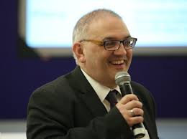International Education Strategy and Business Development Lead, CILT International.

Jon leads the international education and business development activity for CILT, but also co-directs Gloucestershire Community Rail Partnership, a community organisation designed to advocate sustainable transport and improved accessibility to rail.

Jon is a qualified urban and transport planner, has worked in the public, private and non-government sector for over 30 years, and is passionate about equality, inclusion and sustainability.

*Molly Gregory, BSc (Hons) Human Geography Student*

University of Gloucestershire, U.K.

Molly has a passion for learning about how humans interact and impact the environment around them, and how the environment impacts us. As a geographer, sustainability is at the forefront of what she does, and a key motivator. Molly aspires to work in the humanitarian sector providing aid to the people who need it most, whether from a natural or human crisis.

Molly is a CILT International intern on the University’s Future Plan placement programme from March - September 2021.