I am CILT
With CILT I acquired relevant knowledge on road design and traffic management. This enables me to make input to the recommendation for government to design and construct a new Kawo bridge in Kaduna Nigeria. The new bridge is more environmentally friendly and can reduce human and vehicular traffic congestion along the route linking the bridge.

Before: When the Kawo Bridge in Kaduna is CONGESTED.
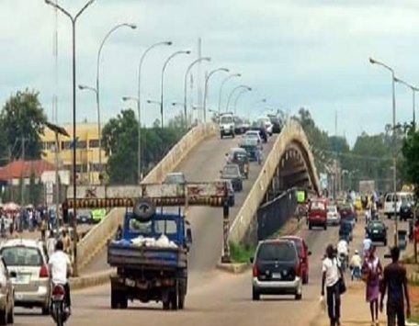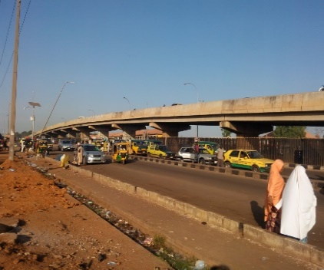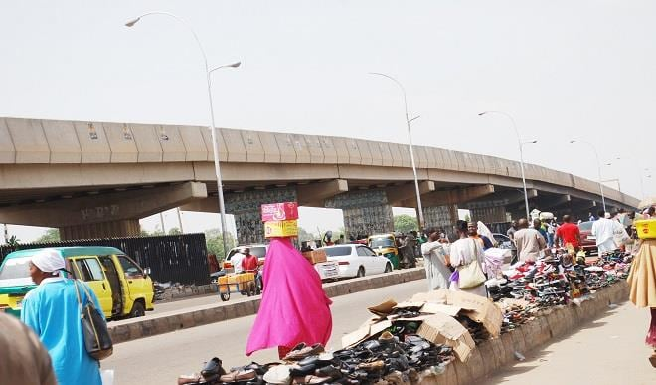

Now: When the Kawo Bridge is being DEMOLISHED AND RECONSTRUCTED
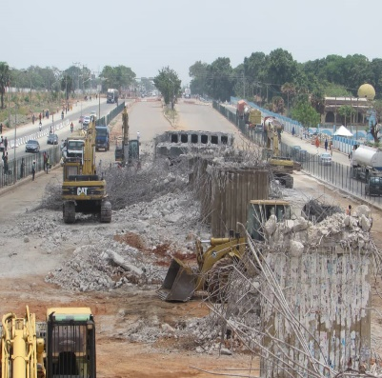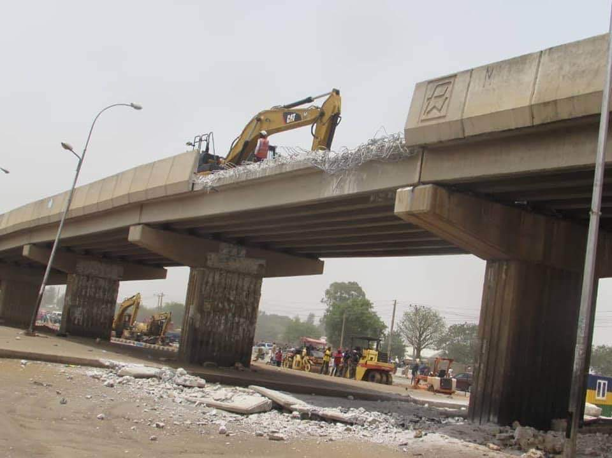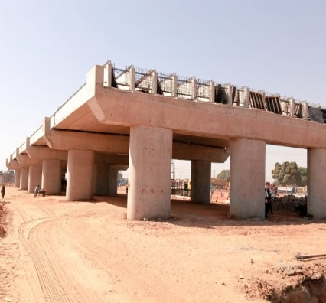

After: How GREEN the Kawo Bridge will turn out after RECONSTRUCTION.
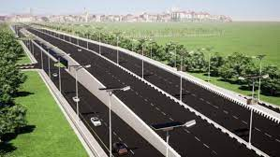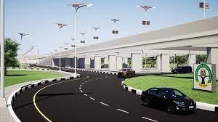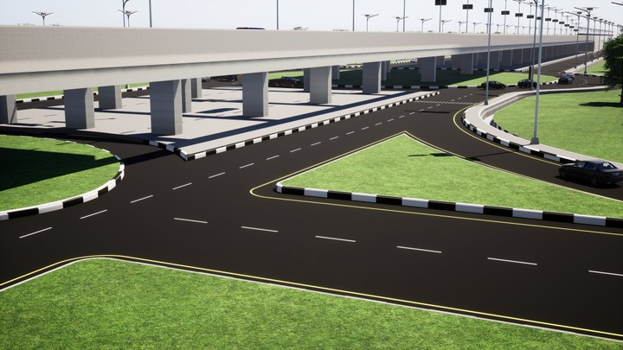
KAWO BRIDGE TURNS GREEN.
The remodeling and reconstruction of the Kawo/Mando intersection flyover bridge is an important transport infrastructure development project in Kaduna city in Nigeria. Commuters are excited over the expansion of the bridge because of the traffic congestion faced on daily bases. The State government saw the need to remodel the bridge for the purpose of easing traffic and vehicular congestion. To sustain the growing intra and intercity traffic flow along the road, additional road lanes and three roundabouts are being constructed along-side the flyover. When completed the bridge will ease traffic congestion along the road. Commuters are also optimistic that their days of long queues and hours in traffic will soon come to an end, while residents and business owners are optimistic that the construction work will turn their environment greener.

