Making the Physical Internet a Reality
Steve Rinsler and Ben Waller discuss the physical internet, explore how it could work, and explain why it is not just jargon and hype…

What is the Physical Internet (PI)?
The Physical Internet (PI), through digital integration, offers the opportunity to transform today’s transportation systems, so that they become self-organising data and decision-making networks where every physical object in the supply chain (truck, pallet, case), exists simultaneously in both the physical and digital worlds.

Yikes. Why would that be a good thing?
Supply chains today are complex; daily, millions of items are transacted and dispatched to millions of locations, and these items will be variously
- delivered to the customer,
- consumed in delivery of a service,
- collected for return to sender,
- displayed for sale,
- stored for future use or call off,
- moved from one transport mode to another,
- consolidated to make a larger batch of items,
- resorted into a new assortment of items for a next stage of transport.
Much of this operational complexity remains sub-optimised, organised at the level of a single supply chain, which could be better managed if consolidated through a more collaborative planning process. As a result, there remains a huge untapped potential for cutting costs, satisfying customer needs, and reducing environmental impact. Most companies plan and execute their operations with extremely limited visibility of the flows of other companies or institutions, largely because focusing on their own supply chain performance minimises the risks of not meeting client service objectives inherent in collaborating or mixing flows. It is left to carriers and 3rd party logistics providers to identify opportunities for sharing and optimisation of logistics, and so that the larger logistics companies can, if their client is willing to participate, consolidate and optimise the flows of many service users.

But surely carriers and 3PL are best placed to find and deliver collaborative solutions?
. . Despite best intentions, even the largest of 3PL are often unable to identify flows that could be combined, customers that have complimentary demands, and operational processes that could be standardised. Often a 3PL is so focussed on the objectives of the largest customers, that there is limited time or incentive to look for consolidation opportunities beyond back-loads, despite the possibilities that can be unlocked by combining flows. Postal services represent the classic shared mass sortation and delivery solution to optimising the delivery of ‘many to many’ flows, but most supply chains, with requirements more complex than that a postal delivery system, remain a dedicated solution, and the consequence is excess waste and environmental impact, epitomised by, for example, empty trucks returning to dispatch hubs after driving excess distances to deliver to dispersed customers. Possibly the closest to a multi-user system are the pallet networks that provide a shared service, but one that requires very little information to enable as everything is a standardised return. However, the physical internet can offer such a multi-user, many-to-many collaborative platform, that can allow LSPs enable multi-client and user sharing of transport and logistics capacities; a real-time information exchange can automate the sharing and optimisation of freight movement and flow and enable this capability in a secure way that respects the confidential and competitive information contained within a delivery chain.

Okay, that sounds promising - but quite complicated - so how does that actually work?
We replicate the physical world in a digital simulation. Using pooled data as inputs on real world demand and capabilities, the dynamic simulation employs algorithms that deliver optimised solutions to shared logistics needs. This dynamic problem solving means copying every key systemic detail of the client freight demand, and the logistics and transport system that can handle and move that demand.

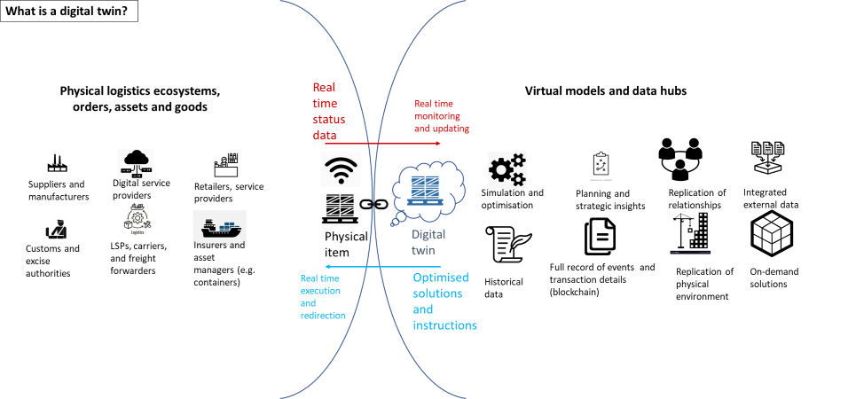

By making a digital copy, or digital twin, of every item and capacity within a wider network of unlinked logistics users, the physical internet allows for close integration of the physical logistics chain infrastructure with the digital communication infrastructure, so that the two are continually updating and linked, feeding live dynamic information that allows for self-routing optimisation of goods through the system. Unused capacities and optimal consolidated flows can be identified and the more efficient and effective logistics analysis and instructions that are generated can be shared in real time amongst any number of logistics service providers participating within an open but regulated network. The whole logistics system exists as a digital model that is a digital twin of the real-world system, so solutions can be delivered for all participants in real time.

That sounds challenging - how is the data collected to make this happen?
Every item moving through the system is allocated a unique id, (much as cases, pallets, and containers traditionally use barcode labels that connect to databases), and data is automatically created as the connected item moves through the system. Some data related to a particular item is static, such as the loading volume of an empty container, whilst other data is dynamic such as location and temperature. Sensors gather dynamic data such as temperature, and location is gathered either through location mapping or gateway indicators (such as leaving a geofenced area such as a warehouse). Dynamic information is gathered and transmitted in real time - as much as possible – as data input to the processing hub. Dynamic data on every item, order, container, transportation vehicle, such as freight train, is matched with static data, and live data is consolidated with data coming from a range of other systems (such as port management systems), to allow two outcomes:
- An optimised solution to the consolidated flows of goods, optimising both at a local and granular level (such as vehicle fill), and at a system level (such as the best split of volumes through two different transport routes, optimised for a range of efficiency gains such as backhaul vehicle fill).
- A single record as packet of data, an accumulating and transactional chain of events which is recorded to create an auditable documentation of what happened to the item from dispatch to destination. This auditable and distributed transactional record is commonly referred to as blockchain.
Digital twin data packets and the goods in the physical supply chain move in parallel through the two logistics chains. Much like how in the data internet, data packets are transmitted to the final destination through a mass redistribution of information, so the SKUs or containers are routed to destinations through a mass flow of goods.

Wow, okay, but I know that my systems describe my supply chain in a specific way that is different to that of another company in the same sector. And we are talking about mixing flows from many sectors. So, do we have to translate our data into a common language?
Yes, but we built a translation engine that will do that for you. The physical internet does exchange information in a standardised way, as packets of data, and so requires a standardised way of describing the physical infrastructure and the goods moving through it. The networking protocols must be agreed and understood, just as TCP protocols create a standard set of protocols for moving data through the internet ensuring that the data is split into packets, is addressed, and received properly and also ensures that the order of sending matches the confirmation of delivery.
ICONET, an EU funded research project, has defined four core services that a physical internet must provide to allow the system to optimise flows; these are shipping, encapsulation, routing, and networking.
- Shipping describes the movement orders, what is to be moved and any specific instructions. This data is then used to optimise the way that the goods are handled and accumulated, otherwise known as
- Encapsulation, which describes the packaging and packing of goods, how they are conveyed, and this data, with the shipping instructions, effectively create a dataset of input demand, which must be matched with capacity.
- Routing describes the best delivery route and path for every item passing through the system.
- The capacity is compared with demand through the networking service, which describes the logistics and supply chain infrastructure, such as warehouses, freight terminals, and haulage fleets.
Indeed, leading edge use of machine learning is making it possible to identify the packets of data from the patterns in the data. Although clearly, to make sure the data is reliable, most users will integrate data using middleware that requires API and manual matching to set up the translation, at least until AI solutions have matured.

Okay, so it is about sending and collecting standardised packets of information to allow a simulated solution in real time. But how do these protocols create a standard set of data?
Let’s take encapsulation as an example, to help demystify the mechanics of the protocols. A fresh and perishable product, such as freshly caught fish, must be moved as quickly as possible. This product must be shipped from origin to destination, through a described chill-chain infrastructure and network, and the best route will be calculated to combine this flow with others. Encapsulation describes the packaging of this fish through the chain, so splitting out key characteristics such as how it is packed, the handling containers used, and any specific information on the overall logistics order that changes the way that the handling or transportation could be optimised, such as temperature and handling requirements, or what cannot be transported with those products, etc. By codifying the key parameters, a wide variety of goods and requirements can be described using as few fields and codes as possible.

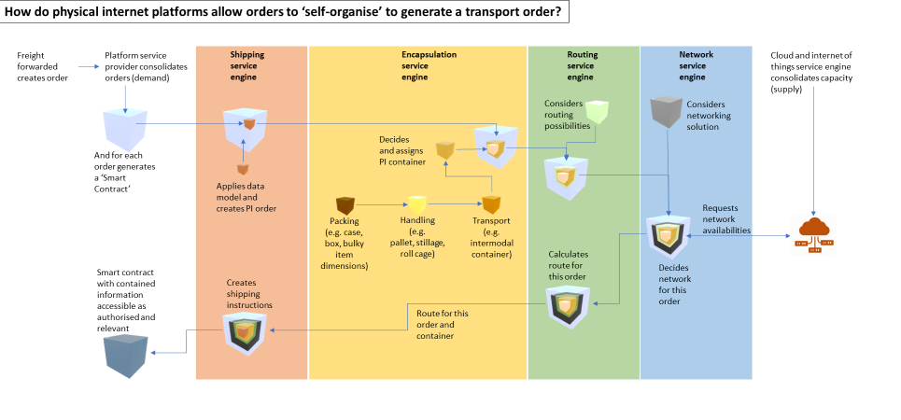

What kinds of solutions could a PI network deliver?
A PI network can be seen, just like the data internet, as an endlessly connected network within which there are nodes of activity. This nodes and hubs are areas of local optimisation. Examples within a wider freight network include:
- port activity, optimised both internally and for externally integrated logistics chains,
- a high-volume freight corridor that allows for economies of scale in moving consolidated freight over longer distances
- multi-user last mile delivery services, optimised around the constraints of the urban environment and home delivery customers
- And a shared warehousing network solution that allows users to rent or sell storage space as required, and inventory managers to deploy stock tactically to create optimal geographical coverage.

How can a complex operation such as a deep-sea terminal be optimised both internally and for a wide range of external users and processes – that sounds like a scenario that would naturally generate conflict?
Think of port activity as a cog in a bigger logistics set of gears. A large seaport acts as a gateway to and out of Europe to deep sea trade across the world, and inbound freight must be unladen, stored, resorted and consolidated to new routes into the huge hinterland of the port, and the high volume railways, rivers and canals that extend far into the European continent. Such a transport node is both a physical hub and a point of information exchange for many disparate carriers, freight forwarders, customs organisations, logistics service providers and traders, and the identification of all goods flowing through the port, and the infrastructure within the port and beyond. This operation can be synchronised so that internal optimisation is not entirely a sub-optimised system, but instead is one that works to the rhythms and tacit times of the logistics processes and supply chains that feed into and out of the port.

How can this physical internet help consolidation? Surely carriers and operators just do this themselves?
Absolutely so! Rail freight forwarders, shipping companies, road haulage providers and third-party logistics companies are always looking for synergies and consolidation opportunities. Unfortunately, they are only ever working with partial information, at best. Equally, it takes time to make collaboration work in a semi-manual system and opportunities and logistics demands require 30 second answers. Competition between logistics service providers often means that information on capacities and flows are not shared, so that a two-way flow recognised by one provider gives them an edge in a contractual negotiation with their clients. Such an approach does provide an optimised multi-user logistics solution, but within very constrained boundaries. The aim of the physical internet is to open up all capacities and flows, to create a greater degree of optimisation. One example of an application of this is the creation of a high volume corridor for long distance freight; depending on the lead time urgency of the client, this high volume route could incorporate various transport modes and lead times, so for example, the goods could be transported on the long leg by road, rail or river barge. Remember, the physical internet integrates the logistics of communication and data with physical infrastructure and flow, so that all flows from the two ends of this long distance route can act as consolidation funnels to create a faster throughput for all participants at much higher capacity utilisation. If you are familiar with the Bernoulli principle in fluid dynamics, the overall outcome can be likened to the relationship between pressure and speed of flow within a liquid; the greater the volume of goods entering the system, the faster it will flow (assuming that the transport system has the ‘pipeline’ capacity to flow at faster speeds.

Does this mean I would share all parts of my logistics network with others? Why would I want to share a warehouse with a competitor? In fact, why would I want to share the benefits of this technology?
Naturally, it is a strategic decision for supply chain management teams to make, to decide what operations should be shared, as a utility, and which should be dedicated as a competitive advantage. For example, one solution enabled by PI is sharing a market-wide or multi-market network of warehousing facilities. It may be that a business does not have enough volume for a dedicated warehouse network, or has variable, dynamic, seasonal, safety, or tactical stock buffer requirements; in which case, sharing a network of warehousing spaces where the business can decide what to store where and when means that they have a more responsive buffer stock that can be delivered to the right locations at the right time without the waste incurred by underused space in a dedicated network of warehouses.
On the other hand, a retailer expanding their last mile logistics capability in response to a rapid shift towards online shopping and home delivery may wish to build a dedicated network that is justified by their throughput volumes, and by the competitive advantage over other retailers that this private and in-house solution generates – even if it does provide a sub-optimised solution for home delivery.
In reality, urban last mile logistics will continue to be driven by both competitive advantage and the pressures of regulation, and so even retailers, wholesalers or service providers with large throughput volumes may be compelled to collaborate. For example, local government regulation may require that deliveries to airports, city centres, retail parks, factories, or households are consolidated to reduce traffic.

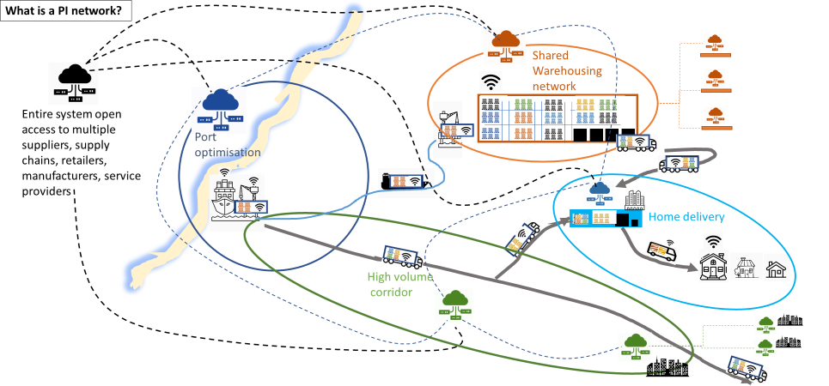

So, to move away from what I know, and the working and proven certainties of that, what are the benefits this change would bring beyond collaboration? I need tangibles.
Okay, change is difficult, collaboration even more so, both requiring frequently underestimated investment in cost, time, energy, and people, but the aim of the physical internet is to make collaboration low risk, easy and secure. Firstly, as described already, the physical internet gives users access to asset pools to encourage collaboration, at every scale, from conveyance (pallets, containers, specialised packaging), transport mode (Europe wide fleets of road, rail and river transport), and facilities (such as ports and warehouses). Secondly, as outlined, the throughput optimisation generated by scale should bring significant cuts to lead time, cost and environmental impact, and the ability to access dynamic delivery chain optimisation should provide a responsiveness at a much lower cost than could ever be achieved using bespoke solutions (think next day couriers compared to postal networks).
Beyond these benefits are the rewards of a much more data rich supply chain; firstly, visibility of movement, as the physical internet automates tracking, tracing, ETA updates, and rerouting for selling from in-transit stock. Customers of logistics service providers will benefit from greater certainty of the timing of goods despatch, and up to date information on ETA, allowing them to align and optimise their own in-house operations such as stock putaway. For businesses that are committed to ambitious and stretching targets for reduction in greenhouse gas emissions and other environmental impacts, reductions in empty running, more efficient routing, and removal of underutilised warehousing space all deliver easy wins on top of cost savings and the revenue implications of higher product availability.
For businesses with extended supply chains across borders and trade frontiers, the automatic auditing that the physical internet generates should enable solutions for security and customs challenges, such as reporting unauthorised access to vehicles or loads, border controls, documentation, tariffs, and duties. The deployment of blockchain, although not itself a requirement of the PI, is a natural complimentary solution to the networked solution, adding to the overall security and careful control of access to sensitive data; the platforms and hubs are designed so that access to data can be managed in a granular and precise way, so that privacy and competition protections can be ensured. Furthermore, the removal of physical checks and paperwork has immediately obvious benefits in an age of pandemic, as the PI system of data exchange allows for contactless management of administration and fewer touchpoints for goods.
So yes, there are tangle benefits that can be estimated. But beyond the calculable and known benefits outlined above, the dynamic integration of hundreds of thousands of supply chains and logistics networks should deliver significant multiplier effects, secondary benefits that are difficult to quantify as they are today’s unknown wastes. Firstly, a migration towards a PI logistics system should generate what economists call ‘economic network effects’, which simply means that the more users that join a network, the better it gets for all users, and the system becomes a natural marketplace. A classic example of this is the telephone network, where utility increases with each additional telephone contact that joins the network; one telephone is useless, two is time saving, and millions of users, phones and numbers makes communication lower cost and easier for everyone. A more contemporary scale network would be the Amazon retail platform and their web-hosting services; they have become a scale system which effectively penalises smaller retailers that do not join the network.
But perhaps the most valuable intangible benefit is the opportunity the physical internet offers in freeing up people, skills, and knowledge; by removing swathes of paperwork, manual work and auditing, we can liberate employees from manual intervention and management firefighting, and help them to develop their creativity, problem solving and ownership of their expertise, allowing them to engage in more strategic, fulfilling, and value adding activity.

Okay, I’m in. How do we make this a reality?
Well, like all change, it will start with small steps until the change reaches a critical mass. An EU sponsored research project, called ICONET, has established living labs that test and pilot PI concepts in real world environments with participating companies. But getting others to join the party will require a low risk, low cost, and easy way in. There will be a need for a single access point, a host which can charge users for use of the system, and a no commitment, cancel anytime subscription model; think Microsoft 365, or perhaps a pay as you go service such as Amazon which charges users a base subscription, which provides a discount on each subsequent use of the service. The system must be able to deal with high volumes of data traffic without the need for any intervention or complex setup; think of the social media networks and their level of transactions. The PI platform services will have to be robust enough to handle similar volumes and frequencies of exchange, and like telephone exchanges will continually route sets of data packets to their destinations. The integration will be continuous and ever changing, on demand, a set of continual plug-and-play systems. The API and systems should be easy to integrate without change requests, consultancy costs or upgrades, so be modular, flexible, plug and play interfaces; data standards will be required, as developed by the ICONET project, alongside open source APIs that convert any specific data format to the standard protocols and formats. The host will also need to contract an equally distributed network of cloud storage and processing, as replicating the logistics system with a digital twin will need a lot of servers at nodes with backup protocols, and the ability to switch and reallocate processing to avoid system and platform overload or non-availability. And to ensure security, strict access protocols will be required, again, with security guarantees backed to some extent by the host organisation. The first investors should probably be a consortium of parties able to back leading component solutions, with an eye on clear immediate and measurable benefits, such as border customs controls; these could be government agencies or global logistics providers. Certainly, smaller companies and authorities have more to gain than larger companies, but even the largest companies will benefit from the snowballing of users and logistics capacities offered by the physical internet. And those that are there at the beginning also benefit from learning first. In such turbulent times, change is not an option, and the governments and logistics companies that can attract investment and dedicate energy to building this new network will, paradoxically, gain competitive advantage through building a shared and open path that should enable a green revolution, a step change in the cost of logistics, and more intelligently flexible infrastructure that all can join.

About ICONET

The strategic goal of ICONET is to establish a “cloud-based PI framework and platform”, through an incremental and verifiable approach that exploits progress in digital and physical interconnectivity through open and public Application Programming Interfaces (APIs). For further information on some of the concepts and applications mentioned in this article, please go to the ICONET website: https://www.iconetproject.eu/
ICONET is an EU funded Horizon 2020 project, ending early in 2021. This project has received funding from the European Union’s Horizon 2020 research and innovation programme under grant agreement No 769119. The views expressed in this article are those of the authors, and do not necessarily represent the views of the ICONET Consortium (and the views expressed by the ICONET Consortium do not necessarily represent the views of the EU Commission/INEA).

About the authors

Stephen Rinsler, Hon FCILT. Stephen is a lifetime Supply Chain and Procurement Logistician who has run large supply chains in Unilever from Forecasting and Procurement through Demand and Factory Planning to Warehousing and Distribution. He was a Director of Exel Logistics (DHL) and now is a Director of Bisham Consulting. Passionate about education and learning he has chaired both the CILT(UK) and CILT(International)
Ben Waller is a freelance writer, consultant, and occasional lecturer, with twenty years of experience in supply chain research and consultancy, primarily in the automotive sector.

Pallets have been identified with a label since 1979, and whether made up of one product or a range of different products, the database behind the pallets stores detail on the makeup of that pallet. Individual parcels and cases have barcodes; whilst you cannot differentiate one case of a product from another of the same product, if doing so is important, then as with food and pharma the labels can also include batch details, manufacturing date, etc and the information is stored as an extension to the product label in an additional database. Equally, a container or vehicle will have a code that will tie up to a manifest provided by a vehicle loader, and the data must be available to anyone who needs the information.

