CHARTERED INSTITUTE OF LOGISTICS AND TRANSPORT SRI LANKA HOLDS ITS 33RD AGM

Chartered Institute of Logistics and Transport (CILT) Sri Lanka held its 33rd Annual General Meeting (AGM) on 29th March 2017 at the Kingsbury Hotel attended by a large gathering, the highest ever recorded in an AGM in the history of CILT Sri Lanka. This year also marked as the first AGM where all members were elected by a secret ballot. Capt Lasitha Cumaratunga was reelected as the Chairman for a second term. The three Vice Chairpersons elected were Dr T. Lalithasiri Gunaruwan, Ms Gayani de Alwis, and Dr Ms Namalie Sirisoma. Mr Channaka de Alwis and Mr Upali Gunawardena were elected as the Secretary and Treasurer respectively.

The key feature of the newly elected Council is the presence of six females in the CILT Council which was a repeat of 2015. CILT is actively promoting gender diversity in the industry through their women’s forum, Women in Logistics and Transport (WiLAT). The election of women in the Council augurs well towards this endeavor.

Chairman Capt Cumaratunga in his AGM address spoke about various activities that CILT conducted in the past year, the most notable being the highly successful International Conference which was well attended by the logistics fraternity of the country. Lasitha especially commended the work of WiLAT and Young Professionals’ Forum (YPF) for continuously making an impact in their respective spheres conducting value adding programs and extended his support to exceed their potential in the journey ahead. Capt Cumaratunga also spoke about CILT’s plan on unveiling the new education program series targeting new entrants to the industry and all others who are interested in professional development and support capacity building in the country for logistics and transport industry. He finally thanked the outgoing Council for their support rendered in the past year.

In his acceptance speech, Capt Cumaratunga elaborated his plans for the new term, stating that CILT Sri Lanka must focus its efforts to make the logistics & transport sector attractive to the young talent of the country, influencing investments in innovation, education and green technology. CILT, as a symbol of Logistics and Transport industry, has a vital role to play in this aspect, he said.

The Chartered Institute of Logistics and Transport (CILT) is a leading global professional body associated with the logistics and transport industry. Established in UK in 1919 and having received the Royal Charter in 1926, the Institute has an impressive history and is always adapting to stay consistent with current logistics and transport practices. The Institute holds unparalleled international recognition and works towards achieving its objectives of promoting and encouraging the art and science of logistics and transport among its members through its educational and continuous development programs. CILT Sri Lanka began functioning as a territory of CILT from 2013. This enables CILT Sri Lanka to elect its own membership, accredit educational institutes and conduct educational programmes. With a membership of over 33,000 from 32 countries across the globe, CILT provides a professional identity to those in the ever expanding logistics and transport sector. It is a strong, active and a unified professional association that is able to speak with authority on strategic issues affecting businesses and people, both locally and globally.

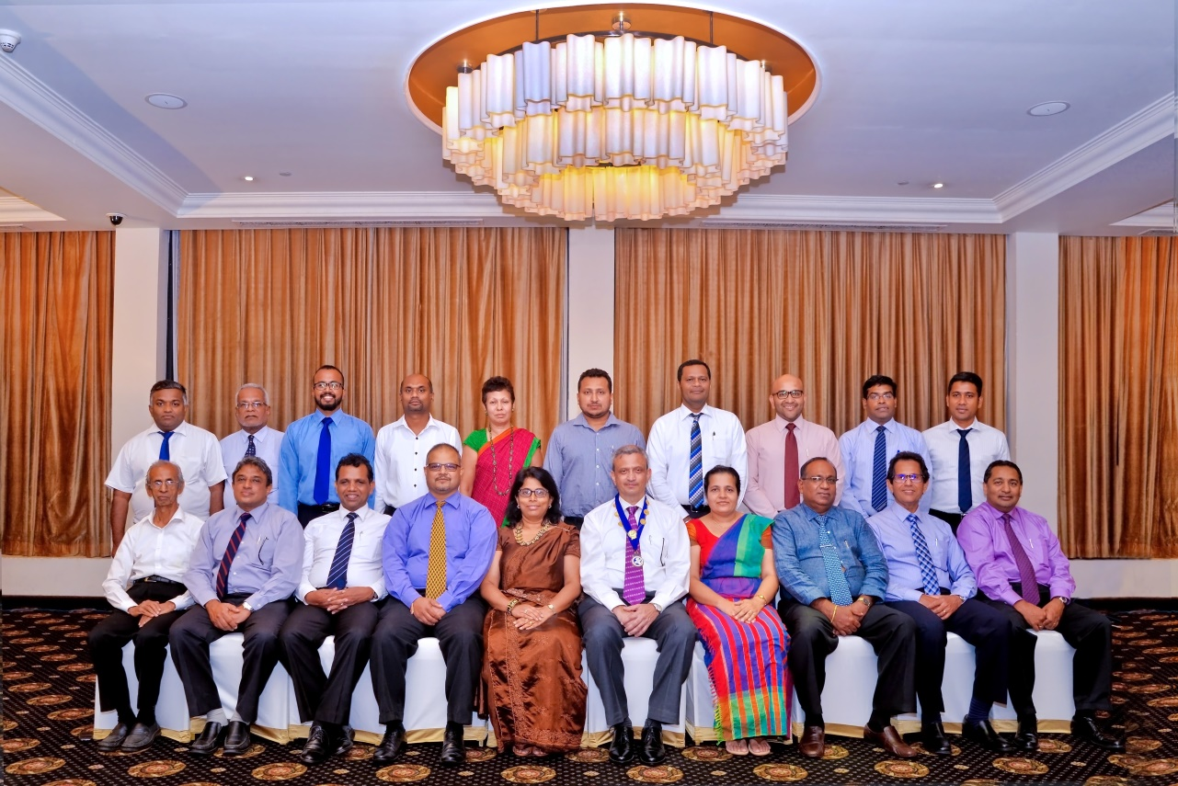
CILT Sri Lanka Council 2017/18

Seated from left to right
Mr H A Premaratne (FCILT), Prof Amal Kumarage (FCILT), Dr Lalith Edirisinghe (CMILT), Mr Channaka de Alwis (CMILT) (Hon Secretary), Ms Gayani de Alwis (CMILT) (Vice Chairperson), Capt Lasitha Cumaratunga (CMILT) (Chairman), Dr Ms Namali Sirisoma (CMILT) (Vice Chairperson), Mr Upali Gunawardena (CMILT) (Hon Treasurer), Mr Saliya Senanayake (FCILT), Mr Niral Kadawatharatchie (CMILT) (Immediate Past Chairman)

Standing from left to right
Dr Indika Sigera (CMILT), Mr C J C Rodrigo (FCILT), Eng Nishal Samarasekera (CMILT), Mr Henry de Silva (CMILT), Ms Chandrika Nalheer (CMILT), Mr Chanaka Gunatilake (CMILT), Mr Chaminda Perera (CMILT), Mr Ibrahim Saleem (CMILT), Dr T Sivakumar (CMILT), Dr Tissa Liyanage (CMILT)

Others who were not present
Dr T Lalithasiri Gunaruwan (FCILT) (Vice Chairman), Mr Tissa Wickramasinghe (FCILT), Dr Ms Ganga Samarasekara (CMILT)

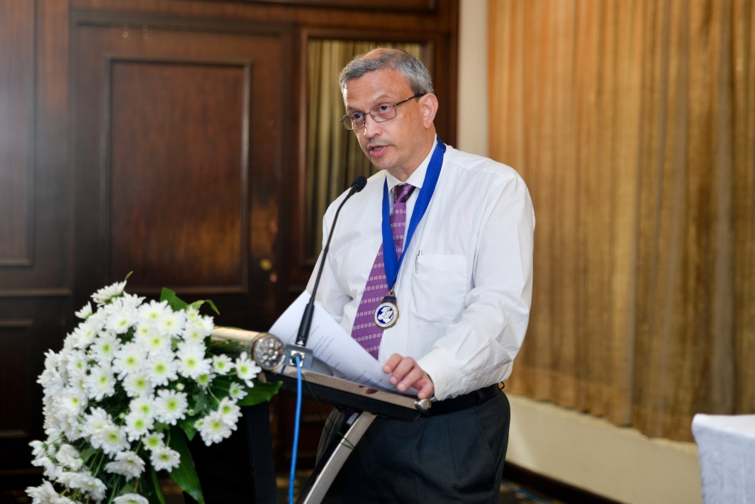

Chairman of CILT Capt Lasitha Cumaratunga addressing the gathering

