COUNTRY: CILT INDONESIA
URL: http://www.cilt-indonesia.org
DATE AUDITED: 18 October 2018

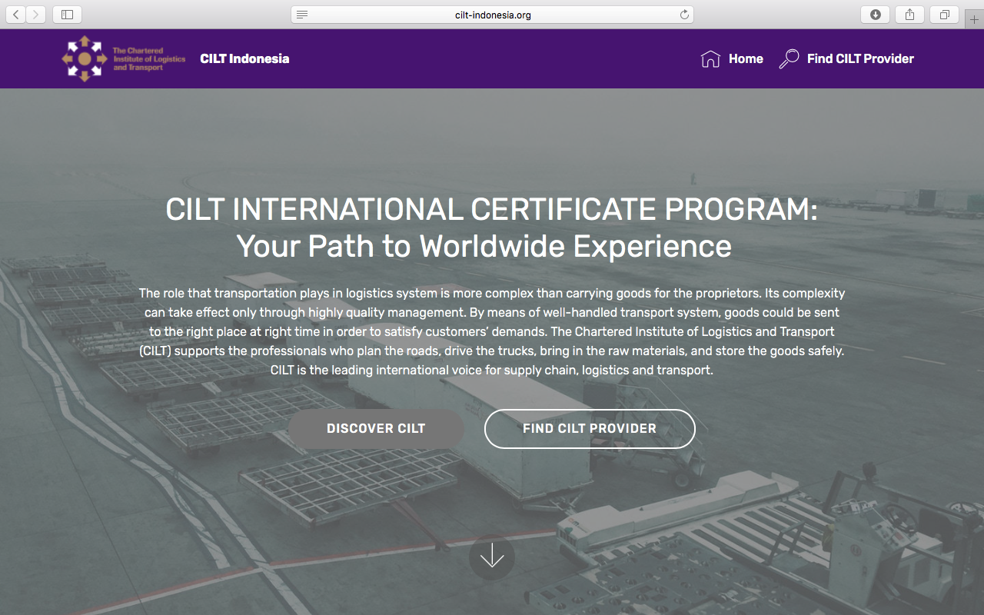

1. CREATING A JOURNEY

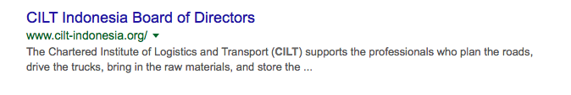
What was checked? | Action required
Search: The meta titles and descriptions do not appear to have been optimised for Google. | Optimise page titles and descriptions.
Business page: There isn’t a Google Business page available for this location. | Create Google Business page to help boost SEO and to allow users to easily locate and find you.
Https present: No. | The website should have a trusted SSL Digital Certificate (this will show as a green padlock).

2. BRAND COMPLIANCE

What was checked? | Action required
Logo: The correct logo has been used, however it is too small. If the user clicks on the logo, they are taken out of the CILT Indonesia website and into the website build platform homepage (see under Navigation). | Suggest redesigning the website to make it on brand, using the correct sized logo. Refer to the brand guidelines and see the main website http://clitinternational.org for reference.
Photography: A lack of photography. Presently there is no photography portraying what CILT does. There is a gallery of the board of directors on the homepage. | Suggest redesigning the website. It would benefit from having more dynamic on brand images that are appealing and welcoming and include images of people at all levels in the work place. Suggest removing the gallery of directors from the home page and moving it to a designated area accessed by the main navigation bar. Please refer to the brand guidelines for guidance and the main website: http://ciltinternational.org for content reference.
Tone of voice: The style of language is very factual. The language is not welcoming, appealing or engaging. | Please refer to the brand guidelines and look to re-write the copy to be engaging to portray CILT as inclusive and to be appealing to workers at all levels. Also look at the main website: http://ciltinternational.org for reference of tone.
Colour: The correct brand colours have been used, however they are overshadowed by a large grey area. | Suggest the brand colours are more prominent and surround some engaging photos. Please refer to the brand guidelines.
Font: The correct web font appears to have been used
Link back to CILT International: No. | Please add clear links back to the main, international website: http://ciltinternational.org. See brand guidelines.

3. USER INTERFACE DESIGN

What was checked? | Action required
Homepage proposition: There is no homepage proposition. Despite a paragraph description it is unclear what CILT do. | Consider the layout of the homepage and introducing the ‘Stronger Together’ statement. Change the copy and focus it more concisely on what CILT do. Currently the content makes the website feel like a training provider rather than a membership organisation that offers life-long learning and career support – some of which is training.  Make the homepage appealing and welcoming to people at all levels. Please refer to the brand guidelines for guidance and look at the main website: http://ciltinternational.org
Design: The design is not on brand. | Suggest redesigning the website. This site would benefit from being more ‘on brand’.  Change the copy and imagery to focus more concisely on what CILT do.  Add clean and dynamic photography and more inclusive and appealing wording.  Please refer to the brand guidelines for guidance and look at the main website: http://ciltinternational.org
Typography: The font appears to be correct
Favicon: An incorrect favicon has been used | Please use the correct graphic icon as per http://ciltinternational.org
Feedback: Poor. | The website would benefit from better feedback on mouse-overs and clicks so users can access the information
Text within images: No. | Please ensure all text within images is html text.
Accessibility: The website is basic but appears to be accessible.
Responsive: This website is responsive to mobile devices, however the navigation is poor and quickly leads the user out of the CILT Indonesia website and into the website of the builder. | Suggest making the experience more user-friendly to use.

4. CONTENT AND INFORMATION ARCHITECTURE

What was checked? | Action required
Country selector iframe: Missing. | Please add to the top of the website. See http://ciltinternational.org and refer to the brand guidelines.
Navigation: The navigation bar is too small. Clicking on some areas of the navigation bar take the user out of the CILT Indonesia website and into the Mobirise website. The CILT logo and wording, CILT Indonesia show on the navigation bar at the top of each page but always take the user out of the CILT website. | Suggest redesigning the website to be more user-friendly, as per previous suggestions.
Find membership details: There was no dedicated area for membership. | Create new content for this area asap. Consider making it prominent, easy to access and as a navigation tab in itself. Please refer to the brand guidelines and the main, international website: http://ciltinternational.org for guidance.
Broken links: No broken links were found. | Once the site has been refined, suggest using a free link checker. Like this http://www.brokenlinkcheck.com or similar.
WiLAT and YP check: There is no mention of WiLAT or YP. | Create an area and new content for this asap. See the main, international website: http://ciltinternational.org for guidance.
Quality of content: The focus of the content is study. This is not on brand and does not portray what CILT are about. | Suggest re-writing the content to utilise the CILT tone of voice and articulate what CILT stands for. Suggest making the content engaging, appealing and inclusive to people at all levels. Please refer to the brand guidelines for guidance and look at the main website: http://ciltinternational.org
Contact details: These are at the bottom of the homepage. | If re-writing the website, suggest a designated link to contact on the main navigation bar.
News: None. | Consider capacity and adding a dedicated area for this. Please refer to the brand guidelines for guidance and look at the main website: http://ciltinternational.org

5. SOCIAL MEDIA
What was checked? | Action required
Social media links: No. There are links to social media accounts from the CILT Indonesia website, but they take the user to the accounts of the website builder Mobirise. | Please remove or hide the links to the Mobirise accounts asap. Consider capacity to add further links. Only add links to social media sites if they are well maintained and already have good level of interaction. Refer to brand guidelines for guidance.
LinkedIn account: Not found. | Consider capacity and whether a LinkedIn account should be created for CILT Indonesia. Please refer to the brand guidelines for guidance.
Facebook account: Not found. However there is a link to Facebook from the bottom of CILT Indonesia homepage which takes the user to the Facebook page Mobirise.  Like: n/a  Last updated: n/a | Please remove or hide the link to the Mobirise (the website building platform) Facebook account asap.  Consider capacity and whether a Facebook account for CILT Indonesia should be created. Please refer to the brand guidelines for guidance
Twitter account: there is a link to a Twitter account at the bottom of the website, however this link leads to the twitter account of the website builder: https://twitter.com/mobirise.  Followers: n/a  Last updated: n/a | Please remove or hide the link to the Mobirise Twitter account asap.  Consider capacity to both update and monitor this account and whether training is required to maintain this site or whether it should be retired.  Please refer to the brand guidelines for guidance.

