_
COUNTRY: CILT PAKISTAN
URL: * There is no domain for this website ciltpak.com *
DATE AUDITED: 12 October 2018

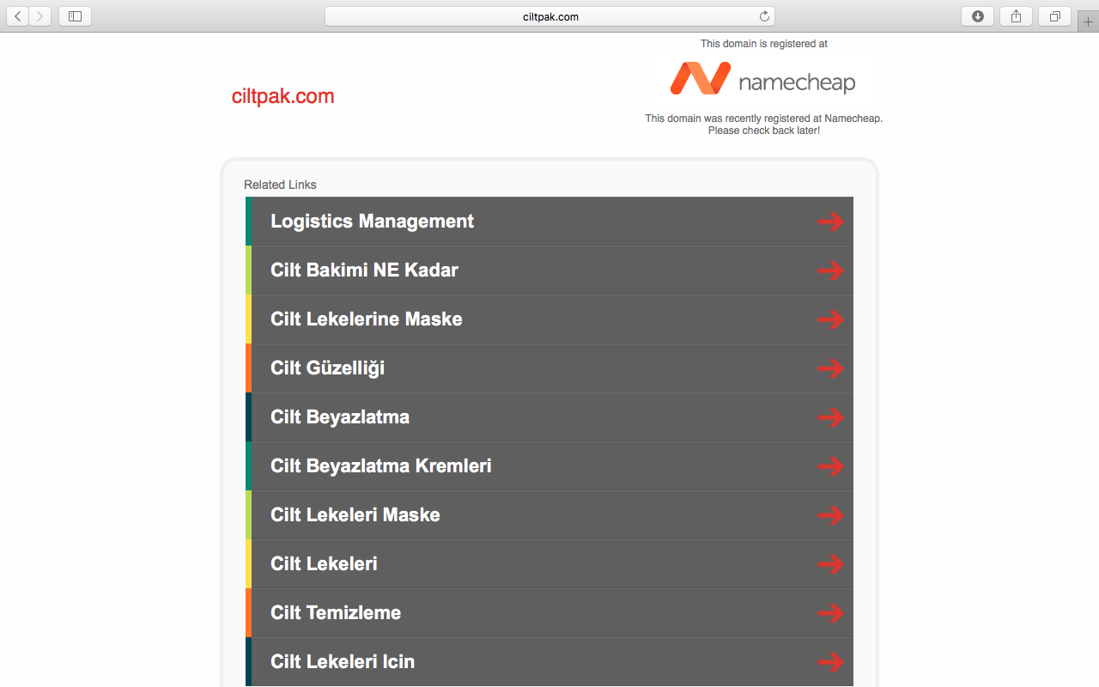

1. CREATING A JOURNEY

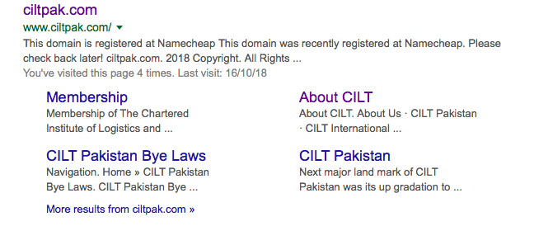

What was checked? | Action required
Search: The meta titles and descriptions do not appear to have been optimised for Google. | Obtain domain. Create website. Optimise website titles and descriptions.
Business page: Present. | Suggest completing full opening ours, adding logo and other branded content.
Https present: No. | N/A. Website when running should have a trusted SSL Digital Certificate (this will show as a green padlock).

2. BRAND COMPLIANCE

What was checked? n/a | Action required
Logo: | n/a
Photography: | n/a
Tone of voice: | n/a
Colour: | n/a
Font: | n/a
Link back to CILT International:

3. USER INTERFACE DESIGN

What was checked? | Action required
Homepage proposition: | n/a
Design: | n/a
Typography: | n/a
Favicon: | n/a
Feedback: | n/a
Text within images: | n/a
Accessibility: | n/a
Responsive: | n/a

4. CONTENT AND INFORMATION ARCHITECTURE

What was checked? | Action required
Country selector Iframe: | n/a
Navigation: | n/a
Find membership details: | n/a
Broken links: | n/a
WiLAT and YP check: | n/a
Quality of content: | n/a
Contact details: | n/a
News: | n/a

5. SOCIAL MEDIA
What was checked? | Action required
Social media links:
LinkedIn account: There is nothing obvious running. There is an inactive page called CILT Pakistan but it is not clear if it is connected: https://www.linkedin.com/in/cilt-pakistan-1a75b2151/ | Consider capacity and whether an account should be created. Please refer to the brand guidelines for guidance.
Facebook account: Found with a search on Facebook:  https://www.facebook.com/cilt.pk/  Likes: 364  Last updated: November 2017  This page is on brand but not inclusive, inviting or inspirational. The page does not reflect the nature of CILT. | Engagement with posts and content is very low with few likes or shares. Consider how well the platform is working and decide whether the content can be improved or whether it should be retired.
Twitter account:  Followers:  Last updated: | Consider capacity and whether an account should be created. Please refer to the brand guidelines for guidance.

