_
COUNTRY: CILT SRI LANKA
URL: http://www.ciltsl.com
DATE AUDITED: 12 October 2018

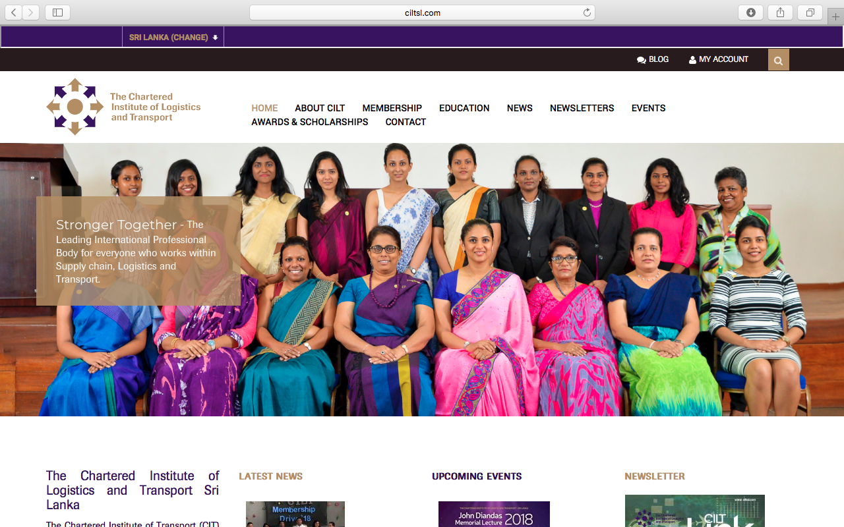

1. CREATING A JOURNEY

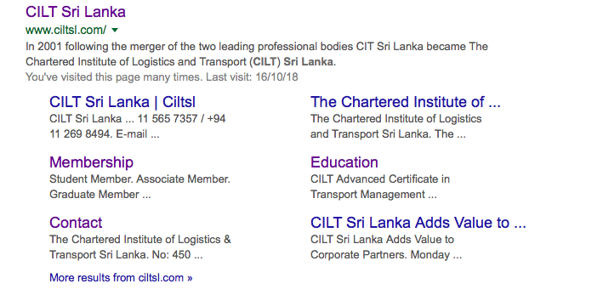

What was checked? | Action required
Search: The meta titles and descriptions do not appear to have been optimised for Google . | Optimise page titles and descriptions.
Business page: There is no Google business page available for this location . | Create a Google business page to help boost SEO and to make your location more accessible.
Https present: No. | Website should have a trusted SSL Digital Certificate (this will show as a green padlock).

2. BRAND COMPLIANCE

What was checked? | Action required
Logo: The correct logo has been used.
Photography: There is a lack of photography throughout the website. | The website would benefit from having more on brand inspiring images (eg images of people interacting in the workplace). Please refer to brand guidelines for guidance.
Tone of voice: The wording does not feel inclusive or positive. | Please refer to the tone of voice section in the brand guidelines and look to re-write the copy in an inclusive and engaging way. Also look at the main website: http://ciltinternational.org for reference of tone. Consider having the website proofread.
Colour: On the whole, the correct brand colours have been used, however there is a prominent strip along the top of each page which is not on brand. | Please refer to the brand guidelines and look at the main website: http://ciltinternational.org for reference.
Font: The correct font has been used.
Link back to CILT International: There is no obvious link back to the main website: http://ciltinternational.org however a quick link can be found at the bottom of the “contact” page. | Please add in links back to the main, international the main website: http://ciltinternational.org

3. USER INTERFACE DESIGN

What was checked? | Action required
Homepage proposition: There is no single homepage proposition. There is a band of constantly changing images but no immediately obvious statement that the organisation is there to network and support workers. | Remove the text relating to parliamentary acts. Change the copy and imagery to be more welcoming and inclusive and to focus more concisely on what CILT do.  Please refer to the brand guidelines for guidance and look at the main website: http://ciltinternational.org for reference.
Design: This is not on brand. Areas such as “News” and Newsletters are duplicate on the homepage which is confusing and messy. | The homepage would benefit from prioritising key content. Rather than the same carousel, different more dynamic images can be used on different pages to help users navigate through the content.
Typography: On brand. User-friendly.
Favicon: No favicon has been used. | Please use the graphic icon as per http://ciltinternational.org
Feedback: Button feedback was OK.
Text within images: Yes, see below. | See below.
Accessibility: This is poor practice for accessibility reasons for people using screen readers but also for Google and SEO purposes. | Please remove text within images and have as html / text instead.
Responsive: This website is responsive to mobile devices. It is not immediately obvious what CILT Sri Lanka does on the mobile phone homepage. | The navigation provides a poor user experience and could be made more mobile-friendly.  Add copy that summarises what CILT India do.

4. CONTENT AND INFORMATION ARCHITECTURE

What was checked? | Action required
Country selector Iframe: Present.
Navigation: The logo links back to the homepage from every page. The website is relatively user-friendly. | Suggest using highlighting on the menu so the user always knows where they are. Suggest consolidating to one main navigation bar and reducing options within this.
Find membership details: There is a dedicated area for membership easily found in the top navigation bar, however the content is limited and it is not engaging or inviting. No benefits to membership are mentioned. There is a confusing flow chart. The information and instructions are not clear (eg where to send the completed application form to) currently it says “hand over the application”. | Rewrite the membership section to be more inclusive and user friendly. Detail any benefits to membership. Rewrite the guidance to be more user-friendly and include clear information on how and where to submit the form. Refer to http://ciltinternational.org for content ideas.
Broken links: There are many broken links across the website. | Suggest using a free link checker like this http://www.brokenlinkcheck.com or similar.
WiLAT and YP check: YP has it’s own dedicated page accessed via a link found at the bottom of the homepage. The wording is not appealing or inspiring and the content is all out of date. WiLAT has it own dedicated page accessed via a link on the home page. Most of the content is out of date. | Rewrite the copy to be inspirational and appealing. Keep content up to date and encouraging to ensure WiLAT and Young Professionals both have the focus they need. Please refer to the brand guidelines and the main, international website: http://ciltinternational.org for reference.
Quality of content: Some paragraphs are too long. Some of the content is uninspiring. The blog entries are undated. | Suggest using short paragraphs, shortening the text and avoiding repetition.
Contact details: The site address, telephone numbers and email address are found in the dedicated area which is clearly marked in the top navigation bar.
News: There are dedicated “News”, “Newsletters” and “Events” sections clearly marked in the top navigation bar which provide up to date and accessible content.

5. SOCIAL MEDIA
What was checked? | Action required
Social media links: Links to Facebook and Twitter are available at the bottom of the homepage. A Link to the Facebook YP forum is also available on the YP website page. | Consider adding a link to the YP Forum Facebook page to the home page and better placement of links to twitter and CILT Sri Lanka Facebook pages on the homepage.
LinkedIn account: Not found. | Consider capacity and whether an account should be created. Please refer to the brand guidelines for guidance.
Facebook account: Can be found with a search of Facebook: https://www.facebook.com/CILTSL/  Likes: 2192  Last updated: 27th September 2018  YP forum Facebook account: CILT Sri Lanka has a separate Facebook page for YP forum, also presenting with a Facebook search https://www.facebook.com/CILTSLYPF/  Likes: 2221  Last updated: 8th October 2018 | Given the large following, more regular upbeat, engaging on brand posts can be made.
Twitter account: Yes,  Followers: 270  Last updated: August 2018 | Consider capacity and whether an account should be created. Please refer to the brand guidelines for guidance.

