_
COUNTRY: CILT TAIWAN
URL: https://www.talm.org.tw
DATE AUDITED: 9th October 2018

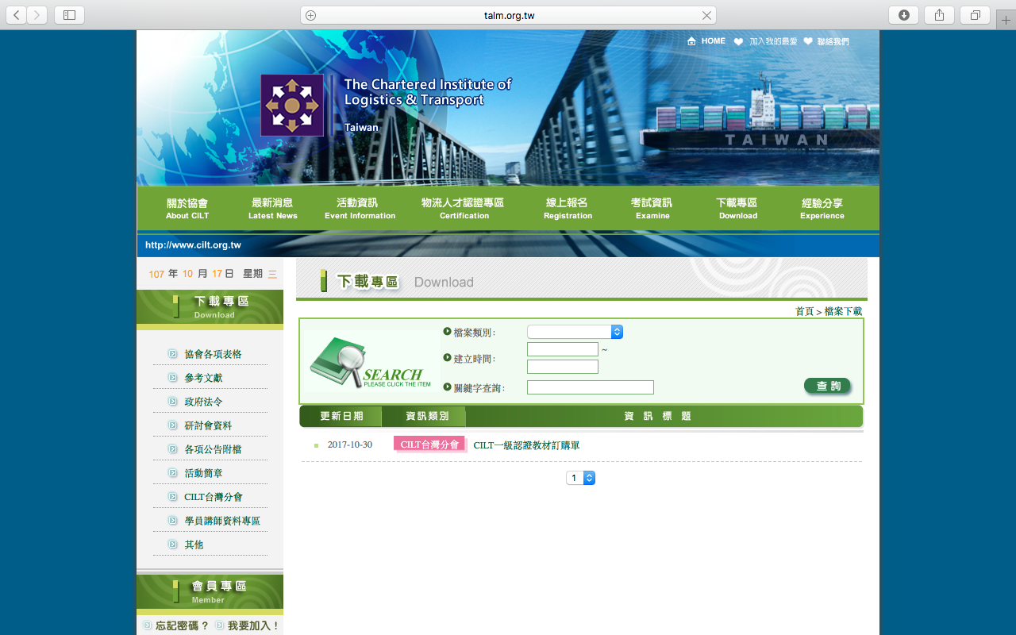

1. CREATING A JOURNEY

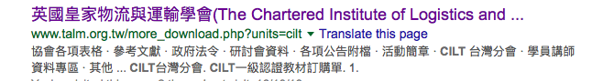

What was checked? | Action required
Search: The website is written in Mandarin(?)It is not possible to establish whether the meta titles and descriptions have been optimised for Google. | Recommend providing an English version of the website to be audited then optimise the page titles and descriptions.
Business page: There is no Google business page available for this location. | Create a Google business page to help boost SEO and to make your location more accessible .
Https present: No. | Website should have a trusted SSL Digital Certificate (this will show as a green padlock).
2. BRAND COMPLIANCE

What was checked? | Action required
Logo: The logo has been used incorrectly, it is too small. The logo has not been positioned correctly and it does not meet the logo exclusion zone guidelines. | Please refer to brand guidelines.
Photography: One image has been used throughout. The imagine is too transport/logistics based and does not portray CILT. | The website would benefit from having more on brand images that include people and look welcoming. Please refer to the brand guidelines for guidance.
Tone of voice: n/a the website has been written in Chinese. | Recommend providing an English version of the website to be audited.
Colour: The correct brand colours have not been used. | Please use the correct colours as highlighted in the brand guidelines. Also refer to http://ciltinternational.org/ for guidance.
Font: n/a the website has been written in Mandarin | n/a
Link back to CILT International: There is no obvious link back to the main website: http://ciltinternational.org | Please add clear links back to the main, international website: http://ciltinternational.org

3. USER INTERFACE DESIGN

What was checked? | Action required
Homepage proposition: n/a | n/a – due to language.
Design: | n/a – due to language.
Typography: | n/a – due to language.
Favicon: No favicon has been used. | Please use the graphic icon. Use http://ciltinternational.org for reference.
Feedback: No adequate feedback. | Please ensure feedback for navigation items and buttons so users are aware they can click on content.
Text within images: | N/A
Accessibility: | N/A
Responsive: The website is not currently responsive to mobile devices. | Please ensure the website is made responsive to mobile devices.

4. CONTENT AND INFORMATION ARCHITECTURE

What was checked? | Action required
Country selector Iframe: Missing. | Please add to the top of the website. See http://ciltinternational.org and refer to the brand guidelines.
Navigation: | n/a – due to language.
Find membership details: n/a website has been written in Chinese. | n/a – due to language.
Broken links: There are over 1,000 web pages and links across the website. There are a number of broken links. | Suggest using a free link checker. Like this http://www.brokenlinkcheck.com or similar.
WiLAT and YP check: n/a | n/a – due to language.
Quality of content: | n/a – due to language.
Contact details: | n/a – due to language.
News: | n/a – due to language.

5. SOCIAL MEDIA
What was checked? | Action required
Social media links: There are no links out to social media accounts on the current website. | Consider capacity. Only add links to social media sites if they are well maintained and already have good level of interaction. Refer to brand guidelines for guidance.
LinkedIn account: Unable to locate from a search on the LinkedIn website. | Consider capacity and whether an account should be created. Please refer to the brand guidelines for guidance.
Facebook account: Unable to locate with a search on Facebook.  Link found: No  LIkes: n/a  Last updated: n/a | Consider capacity and whether this account should be created. Please refer to the brand guidelines for guidance.
Twitter account: Unable to locate with a search on Twitter.  Followers: n/a  Last updated: n/a | Consider capacity and whether an account should be created. Please refer to the brand guidelines for guidance.

