_
COUNTRY: CILT UK
URL: https://ciltuk.org.uk
DATE AUDITED: 12 October 2018

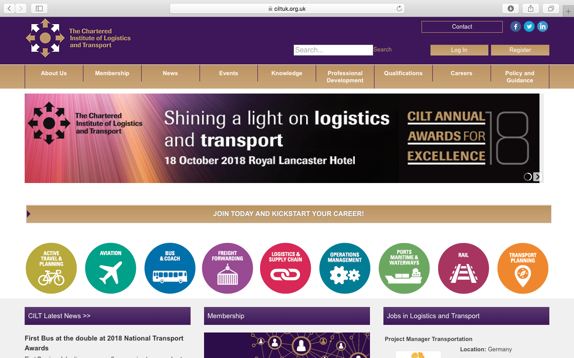

1. CREATING A JOURNEY

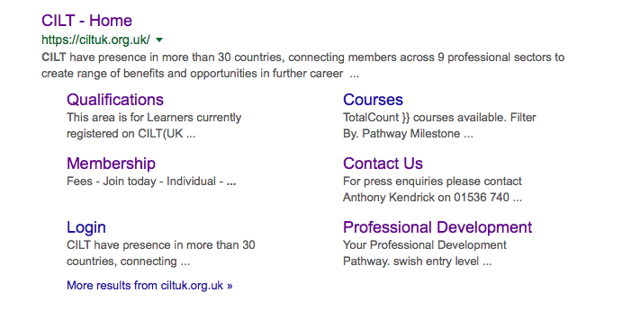

What was checked? | Action required
Search: The meta titles and descriptions do not appear to have been optimised for Google. | Optimise page titles and descriptions.
Business page: Present | Suggest adding the location so the map appears and some on-brand images, business hours, etc.
Https present: Yes, but there are insecure links. | The website should have a trusted SSL Digital Certificate (this will show as a green padlock).

2. BRAND COMPLIANCE

What was checked? | Action required
Logo: The correct logo has been used, however it does not meet the logo exclusion zone guidelines. | Please refer to brand guidelines.
Photography: There is a lack of on brand imagery on the website. | The website would benefit from having more positive and inclusive on brand images throughout, eg images of people interacting. Please refer to the brand guidelines for guidance.
Tone of voice: The wording is informative and engaging but overall the site is too wordy and the content feels overwhelming. | Seek areas of the website that could be re-written to be more succinct and therefore more inclusive.  Look at http://ciltinternational.org for reference of tone and wording.
Colour: On brand in areas, however other colours have been used. | Please refer to brand guidelines.
Font: The correct font has been used.
Link back to CILT International: Yes, there is a link at the bottom of each page.

3. USER INTERFACE DESIGN

What was checked? | Action required
Homepage proposition: There is no single homepage proposition. There is a band of constantly changing images but no immediately obvious statement of purpose ie what CILT does, who it’s for etc. | Consider the layout of the homepage and introducing ‘Stronger Together’ statement. Change the copy and imagery to focus more concisely on what CILT do. Please refer to the brand guidelines for guidance and look at the main website: http://ciltinternational.org for reference.
Design: Not on brand. | Prioritise key content and use on brand imagery. Please refer to brand guidelines.
Typography: Spacing, font and typeface are all good.
Favicon: The correct favicon has been used.
Feedback: Good.
Text within images: Yes. | See below.
Accessibility: This is poor practice for accessibility reasons for people using screen readers but also for Google and SEO purposes. | Please remove all text within images and have as html / text instead.
Responsive: This website is responsive to mobile devices. It is not immediately obvious what CILT UK do on the mobile phone homepage. | Add copy that summarises what CILT do on the mobile homepage.

4. CONTENT AND INFORMATION ARCHITECTURE

What was checked? | Action required
Country selector Iframe: Missing. | Please add to the top of the website. See http://ciltinternational.org for reference and refer to the brand guidelines.
Navigation: The logo links back to the homepage from anywhere on the website. There is too much on the home page. Primary navigation does not stand out. | Suggest navigation is condensed and rationalised under fewer labels. Highlight the menu so the user always knows where they are.
Find membership details: There is a dedicated area for membership. There is a link to this in the top navigation. On the homepage there is a second link to this area.
Broken links: None found.
WiLAT and YP check: Neither appear to be mentioned. A search for “women” on the website brings nothing . | Add or create new content for WiLAT and YP asap and ensure they have the focus they need. Please refer to the brand guidelines and the main international website: http://ciltinternational.org for guidance.
Quality of content: Good. User-friendly. Paragraphs have been kept short, there is no jargon.
Contact details: There is a contact page. However, there are no contact details. | Consider rewriting this area to make it easier and more appealing to get in contact. Add names, telephone numbers, email addresses, the office address and a navigation map
News: There is a dedicated News area, which is up to date. The separate Events area appears to be out of date. | Consider capacity to maintain up to date events content.

5. SOCIAL MEDIA
What was checked? | Action required
Social media links: There are currently links out to social media accounts on the website.
LinkedIn account: Yes. 7560 followers.
Updated 1 month ago.
Facebook account: Yes
Like: 6558
Last updated: 12th September 2018
Twitter account: Yes
Followers: 9442
Last updated: Within the last 24 hours.

