Contents
Council Members 2017 3
President's Statement 4
CILT Committees 2017 - (Appointed from October 2017) 7
Council 2017 8
CILT Staff 10
CILT Mission Statement 11
Chief Executive’s Review of 2017 12
Membership and Membership Services 12
Corporate Governance 14
Management Changes and Business Planning 15
Education and Training 16
CILT Policy 17
Contract Work 18
International Activities 19
Acknowledgements 19
Trustees Report 20
2017 Events 21
Financial Statements 2017 23
Independent Auditor’s Report 27
Income Statement 29
Statement of Comprehensive Income 30
Statement of the Financial Position 31
Statement of Changes in Equity 32
Statement of Cash Flows 33
Notes to the Financial Statement 34
Council Attendance 41

Council Members 2017
President | Ms. Helen Noble FCILT
Vice President | Ms. Grainne Lynch CMILT
Secretary | Mr. Patrick Casey FCILT
Education & Training Officer | Mr. Tim Daly FCILT
Financial Officer | Mr. Richard O’Farrell CMILT
International President | Lt. Col. Kevin Byrne FCILT
International Vice President | Mr. Finbarr Cleary FCILT
Immediate Past President | Mr Paddy Doherty FCILT
Southern Section Chairperson | Mr. Raymond Crowley CMILT
Eastern Section Chairperson | Mr. Richard Butler CMILT
Eastern Section Vice Chairperson | Mr. Wayne Kavanagh CMILT
Ordinary Member | Mr. John Henry FCILT
Ordinary Member | Mr. Gerry Boylan CMILT
Ordinary Member | Ms. Janet Kavanagh CMILT
Ordinary Member | Mr. Mark Delaney CMILT
Ordinary Member | Mr. Donal Keating CMILT
Ordinary Member | Mr. Pat Mangan FCILT
Ordinary Member | Mr. Aiden Flynn CMILT
Ordinary Member | Mr. Gerard Deegan FCILT
Ordinary Member | Mr Gerard O'Reilly CMILT
Ordinary Member | Dr. Eoin Plant CMILT

President's Statement

Helen Noble
CILT Ireland President

In October 2017 I was delighted to take up the role as president of the Institute. I am pleased to report that 2017 was a successful and progressive year for the Institute.

I want to take this opportunity to thank our Council, membership and management team for their commitment and hard work throughout 2017. Recognition must also go to the regional sections who have played a very significant role in ensuring a very full and relevant events programme throughout the year.

2017 has been a year where the Institute has emerged from a challenging period of time against the background of the recovery of the Irish economy and this has been reflected in the Institute’s progressive achievements.
Some of the key achievements were:

- Greater interaction between members and opportunities for networking through an impressive wide-ranging programme of events throughout the year;
- Maintenance of high standard of corporate governance - the Audit Committee set up in 2016 met four times during 2017. This committee has been very active throughout 2017 commissioning a number of key internal audits;
- We have continued to build on our contact with students and have strengthened our panel of lecturers so as to ensure our education and training programmes are at a very high academic standard;
- Considerable upgrade in the standard of the Linkline magazine;
- Finalisation of the website – the new website went live in 2017;
- Growth of the Skillnet network significantly over the year with over 30 companies signing up to the network;
- The Financial performance of the Institute remains strong and we are now moving forward with a budget which will enable necessary development and ensure we meet our key objectives over the next few years.
- Completion of extensive refurbishment of the CILT offices so as to greatly improve the working environment for the staff and their consequent wellbeing.

In the summer of 2017 Pat Treacy stepped down as CEO. I would like to express my own personal gratitude to Pat for the enormous impact and changes he brought to the Institute. Pat ensured that his successor had a strong platform to build upon in terms of governance and professionalism and we are indebted to his leadership and the hard work Pat put into the Institute.

Mick Curran was appointed as Pat’s successor and took over the role as CEO on 11 September 2017. He has brought a fresh enthusiasm and drive to the Institute.

The Institute’s key role is to promote professionalism in the logistics, transport and supply chain and the Institute must therefore be the first choice professional body for those working within these areas. In this regard it is very important the Institute is relevant, that it is representative of the whole industry and not just certain sectors and that it provides its membership with high standards of ongoing education, a forum to meet and debate key issues and real career opportunities.

This goal is reflected in our business strategy for the forthcoming years and will be achieved by:

- Growing the membership of the Institute by the provision of high quality education, training and valuable membership services;
- The development of a strong brand;
- By ensuring at all times we adhere to good governance.

Key objectives identified to support these strategies are:

- Rejuvenation of the membership through thought leadership;
- Further development of the Skillnet network with a wide ranging programme of training courses that will be relevant to companies and make a real difference to the up-skilling of the workforce in the industry;
- Greater collaboration with educational Institutes to identify and deliver educational services nationally and internationally;
- Increase policy development output by providing additional resources for this area;
- Further development of our programme of events to ensure we provide our members with a varied programme of events, opportunities for networking and their continued professional development;
- Continued improvements to Linkline and our website.

We continue to work very closely with Department of Transport, Tourism and Sport (DTTAS) and the Health and Safety Authority and continue to partner with them as the examining agent for the CPC management, DGSA and ADR examinations. I want to thank both bodies for their ongoing support and positive engagement with us throughout 2017. Significant work has been undertaken and more work identified to develop and improve the CPC examinations and we are working closely with DTTAS to achieve this.

Finally, I would also like to take the opportunity to thank our Council for their support, guidance and commitment throughout the year. I also want to thank the Institute’s management, staff and our members for their excellent efforts in promoting CILT. I look forward to working with you all in 2018.

Helen Noble
CILT Ireland President

CILT Committees 2017 - (Appointed from October 2017)

Management | Education
Grainne Lynch (Chair) Paddy Doherty Richard O’Farrell  Tim Daly  Mick Curran (Appointed Sept 17) Tim Hayes by invitation to report  on CPC matters | Tim Daly (Chair)  Janet Kavanagh Michael Dolan, Gerry Boylan
Policy | Business and Membership Development
Eoin Plant (Chair) Rachel Ivers, David O’Connor, John Henry,  Pat Mangan, Declan Allen. | Gerard Deegan (Chair) Mark Delaney,  Ray Crowley, Donal Keating, Aidan Flynn.
Audit
Graham Harrison (External, Chair) Pat Mangan
Maurice Treacy (External)
Southern Section | Eastern Section
Ray Crowley (Chair)  Kieran Gleeson  Dave Williams  Helena Cullinane  Colin Lawless  Kastytis Bereznocenko  Pat Donovan  Donal Dempsey  Gerard Deegan  John Kelleher  Grainne Lynch | Richard Butler (Chair)  Wayne Kavanagh (Vice Chair, Secretary)  Mark Delaney  Aidan Flynn  Stephen Sweeney (Hon. Treasurer)  Janet Kavanagh  Bassey Duke  Adrian Byrne  Robert Ryan

Council 2017
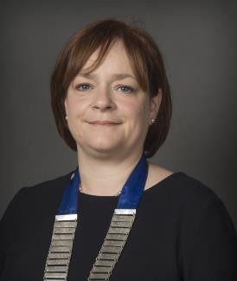 | 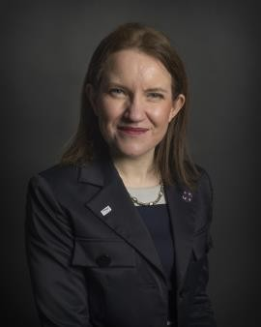 | 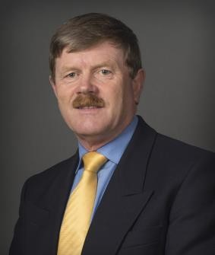 | 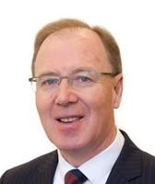
Helen Noble  FCILT  President | Grainne Lynch  CMILT  Vice President | Patrick Casey  FCILT  Secretary to Council | Richard O’Farrell CMILT  Financial Officer
 |  | 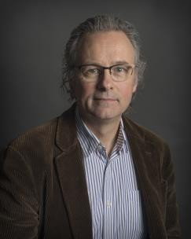 | 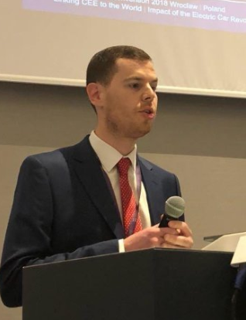
Tim Daly  FCILT  Education & Training Officer | Richard Butler  CMILT  Chair Eastern Section | Ray Crowley  CMILT  Chair Southern Section | Wayne Kavanagh  CMILT  Vice Chair Eastern Section
 | 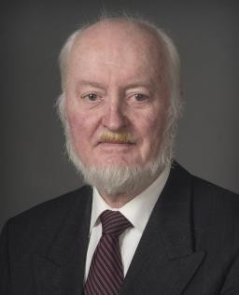
Janet Kavanagh  CMILT  Council Member | John Henry  FCILT  Council Member | Gerard Boylan  CMILT  Council Member | Pat Mangan  FCILT  Council Member

 |  | 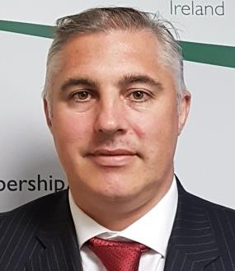 |  |  |  |  | 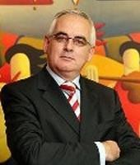
Donal Keating  CMILT  Council Member |  | Aidan Flynn  CMILT  Council Member |  |  | Mark Delaney  CMILT  Council Member |  | Gerard O’Reilly  CMILT  Council Member
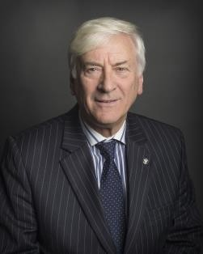
Gerard Deegan  FCILT  Council Member |  | Dr Eoin Plant  CMILT  Council Member
Ex-Officio Members
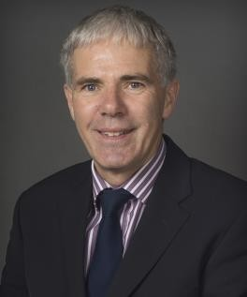 | 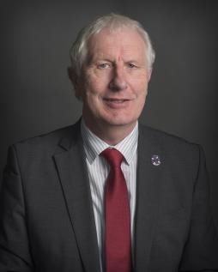 |  | 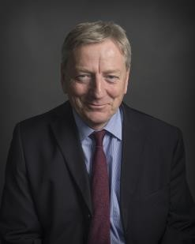
Kevin Byrne  FCILT  International President | Finbar Cleary  FCILT  International Vice President |  |  | Paddy Doherty  FCILT  Immediate Past President

CILT Staff

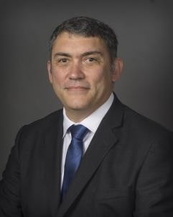 | 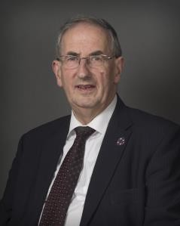 | 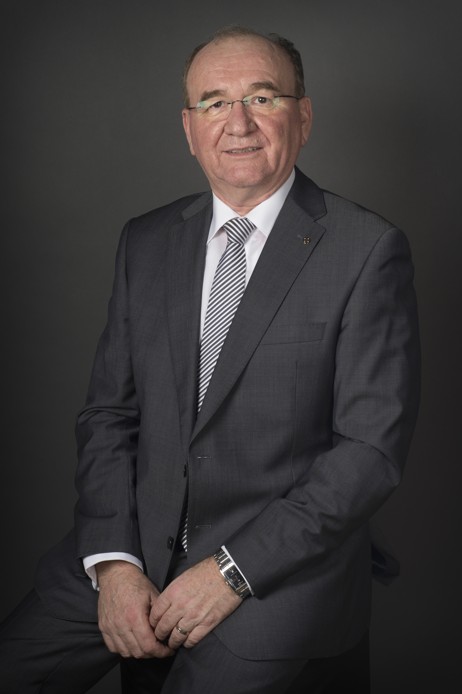
Mick Curran  Chief Executive | Tim Hayes Development Manager | Jerry Meredith  Education Services Officer | Aine Holden Communications Manager
Julia Olan Finance and Administration Manager | Pauline Lacey Education and Training Administrator | Imelda Brown Education and Training Administrator | Amy Kelly Accounts Administrator
Eileen Corry Skillnet and CILT International Administrator

CILT Mission Statement
To promote professionalism in logistics, transport and supply chain

CILT Vision Statement
Be the first choice for our profession

Chief Executive’s Review of 2017
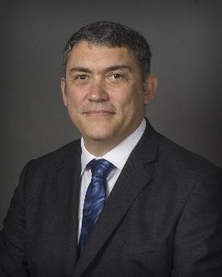

Mick Curran CEO

Membership and Membership Services

On 31 Dec 2017, the total paid up membership of the Institute was 523, this is a good number that we intend to increase during 2018. The Institute is a professional body that relies heavily on its members, both as key resources and customers, and this cannot be taken for granted. The Council is determined to further improve the services provided to members in the years ahead.
Throughout 2017 a wide range of events were held for members that were aligned to our vision and strategy - details of which can be found in the events section of my report. Many of the events were organised by the regional sections and I would like to express my appreciation to the section committees, the head office staff and the many people who played a part in making our events programme a success.
The events are too numerous to write about in detail, so I will confine myself to just a few to illustrate the range and variety of activities undertaken.
On 13 April 2017, Dublin Senior Football Manager and Assistant Director with the Irish Aviation Authority (IAA), Jim Gavin was the keynote speaker at the Institute’s Annual alumni lecture in the Alexander Hotel. Jim spoke about managing performance, he used his considerable experience gained in the Irish Air Corps, the Irish Aviation Authority and in Croke Park. Jim surprised the packed audience by telling the audience that “My life has been about failure in sport and in my career”, this caused many raised eyebrows, but once Jim started to explain that failure is a point of departure from which to grow a team, his meaning became obvious. Jim’s talk made for a very thought provoking evening that was enjoyed by all.
In February Mr José Viegas, Secretary General of the International Transport Forum (ITF) addressed a gathering in the Alexander Hotel Dublin. This event, organised by CILT and the Department of Transport, Tourism and Sport, was heavily attended by Irish Industry leaders who were keen to hear one of the world’s foremost transport experts. The ITF is an intergovernmental organisation with 57-member countries that acts as a think tank for transport policy. Mr Viegas spoke about the future for global transport governance and the need to reduce carbon emissions.

The annual Student Idea of the Year Awards, organised by the Eastern Section and hosted by DIT Aungier Street, took place on the 6th of April. The 2017 overall winner was Galway Native Sean Cunningham of the Limerick Institute of Technology for his project on Investigating Blind Spot Areas on Articulated Trucks. Sean’s project involved firstly identifying the Blind Spots on an Articulated Truck and then designing a device to inform drivers that something or someone is in the blind spot areas.
On 28th September, the Southern Section held an event in Lynch Military Camp in Kilworth, Co Cork. This well attended event allowed members to get a unique insight into the preparations a Unit of the Irish Defence Forces undergo prior to deploying overseas. The audience listened to an informative summary of the Irish Defence Forces involvement with the United Nationals Interim Force in Lebanon (UNIFIL) from 1978 until the present day. After the informative talk, the members were taken through the logistical management and supply chain requirements required to deploy and maintain a unit overseas. Finally, the members were shown a display of weaponry, personal protective equipment and vehicles.
On the 21st of October UCD’s Smurfit Business School played host once more to our annual graduation ceremony. A total of twenty-nine students received their diplomas and chartered membership of the Institute on the day. Head lecturer Larry Banville welcomed the graduates and their families and advised students about the importance of being active in CILT not least when it came to pursing further studies and continuous professional development.
Professor Brian Fynes of UCD was the guest speaker at the graduation and he made a powerful and impassioned speech about the need for tolerance and respect for all. He shared his thoughts on the importance of symbolism and language and drew on analogies in music and literature to deliver his message. He discussed issues facing our industry sector and restated the importance of lifelong learning. Once again, CILT are most grateful to Professor Fynes and his colleagues in UCD for the use of their facilities and their ongoing support.
In 2017 CILT published a yearbook, wall planner and two editions of LinkLine, the Institute’s in-house magazine. There was further communications to members via email and postings to the Institute’s website. Both were used to update members on Institute news, forthcoming events and to provide briefings on developments in public policy and the industry as a whole.

Corporate Governance
In 2016 the Institute established an Audit Committee and internal audit function. The Audit Committee comprises of two external members (one of whom chairs the committee) each appointed for a three-year period and one serving member of the CILT Council who is appointed annually. The internal audit function is procured on a consultancy basis.
The Audit Committee held a total of four meetings during 2017. During 2016 the Audit Committee commissioned an internal auditor, to carry out an initial high-level review of the effectiveness of the Institute’s financial control, internal control and risk management systems. The following processes were reviewed: general governance, financial reporting, revenue, treasury, payroll, procurement, the computer system, contingency planning and crisis management and business risk management. The draft audit report was considered at the Committee’s January 2017 meeting and feedback was given to the auditor. The final report of the review was approved at its March meeting.
The Audit Committee also commissioned an auditor to carry out an audit of the administration of the Transport Managers’ CPC examinations. This audit looked in particular at the adequacy of the system of internal control and financial procedures and considered whether the existing systems provided adequate assurance against fraud and personation and ensured the integrity and security of the examination and certification process. The audit was timed to enable any recommendations to be taken into account in the implementation of the new web-based system for administration of the CPC examinations.
The Committee considered the draft audit report at its September meeting and provided detailed feedback to the auditor and Institute management.

Management Changes and Business Planning

The Council continued to actively support the implementation of our business plan and to build on our successes from previous years. The Institute continues to evolve and align itself to new ways of working and a new organisational culture which promotes continuous improvement, creativity and competitiveness. As we continue to embed these changes we are building stronger foundations and networks which will enable growth and expansion.
We continue to review our existing plans to ensure that they are compatible with the changing external environment. To that end, Council has agreed a new set of key objectives and a budget for 2018 which will support our strategic objectives as outlined below. We are determined to ensure that the Institute will be the first choice professional body for those working in the logistics, transport and supply chain sectors. The business strategy for the years ahead is based on three core strands:
- To grow through the provision of high quality education, training and other services.
- To develop a strong brand.
- To ensure good governance.

The Council continues to monitor, on a monthly basis, the implementation of agreed objectives using a balanced scorecard. This approach is yielding significant dividends in terms of positive delivery of key objectives while at the same time holding the CEO and his team to account. This streamlined and targeted internal reporting process enables us to effectively oversee the work of the Institute’s management team and business committees. It has also been instrumental in ensuring that agreed objectives are delivered in a timely fashion.
It is worth noting some of our key achievements:

- The complete overhaul of our diploma course.
- Introduction of a Level 7 degree course in collaboration with IT Carlow.
- Introduction of CILT Skillet programme with more than 30 companies already involved.
- Accreditation to ISO 9001.
- Introduction of performance management for all staff.
- Attracting new staff and introducing new ways of working for all.
- Upgrade our Linkline magazine and new website that went live in 2017.

A number of management and staffing changes arose during the year and a revised staffing structure was also put in place. This is aligned with the strategy for the future development of the Institute and will support the Institute with the challenges and opportunities ahead.

Pat Treacy decided to step down as CEO in the summer of 2017. Pat has made an enormous contribution to the Institute during his tenure. The most obvious change that Pat introduced was the refurbishment of the CILT headquarters, the result of this refurbishment is a bright, modern pleasant place to work that conveys the professionalism of the Institute.
The Council organised a competitive process to replace Pat and following that process Mick Curran was appointed to the CEO’s position on 11 September 2017. I will continue to focus on delivery of our agreed business plan and vision ‘‘to be first choice for our profession’’.
Ruth Lanigan, who took up the position of Business Development Executive in 2015, decided to leave CILT in December 2016 and emigrate to Canada. Ruth has been replaced by Áine Holden who took up the role of Communications and Marketing Manager. Áine’s influence has been seen by all with enormous improvements to Linkline magazine and also in the quality of events that she has organised.

There has been a lot of change which I see as positive. We continue to attract skilled and capable people who are keen to work and be associated with the Institute. Our people are seen as marketable and in demand which also reflects well on CILT.

Education and Training

We have continued to strengthen our certificate and diploma programmes attracting top quality students. We have aligned the course with standard academic programmes yet have retained our unique point of differentiation which fits well with our cohort of students.

We have continued to increase contact hours with students to double what they were three years ago and have expanded the number and diversity of our panel of lecturers. We now have eight lecturers on the panel and they are drawn from the Dublin Institute of Technology, Trinity College and Institute of Technology, Carlow. There is also a positive gender and nationality balance which supports greater diversity and positive learning outcomes. These changes are designed to improve the programme and ensure its long-term relevance for students in the logistics, transport and supply chain sector. They also provide the fundamental building blocks and preparation for students who wish to continue their education and pursue the degree programme.
In September 2016, we introduced a degree programme in collaboration with IT Carlow which allows our diploma graduates to continue their studies to Level 7.

In terms of education, much has been achieved in a very short time and we are most grateful for the assistance given to us by a wide range of people, including our own course lecturers and external examiners, education professionals across the sector and our members. Students have also provided positive and very helpful feedback.
Currently, we have 72 students enrolled on our diploma course compared to 99 in 2016/17. The course is growing in strength in Dublin but is in decline in Cork. We plan to build engagement through an active marketing campaign in 2018 which will place a particular focus on the Munster region. It should be noted that the changes introduced over the last three years have made the course more challenging which resulted in the loss of some students. It is important that the diploma course continues to improve and that we attain QQI accreditation to ensure that it remains relevant in an increasingly competitive educational marketplace.
CILT Skillnet is a network of companies nationwide. Members may use the network to avail of grant assisted training opportunities for staff at all levels. The network’s long term strategy is to support its members in meeting their training and development needs and to sustain competitiveness and growth for our industry sector.
Our key aims are:

- To provide industry-specific, customised and relevant training to member companies.
- To promote training as a viable strategic tool.
- To improve the quality of training provided.
- To assist in creating long term future plans for our members.
- To positively contribute to the up-skilling of the workforce in our industry sector.

During 2017, a total of 193 trainees attended CILT Skillnet courses, we ran a total of 24 different courses. The most popular course was “Safe & Fuel Efficient Driving (Eco Drive)” which was conducted on four different occasions during the year.

CILT Policy

The primary focus of the Institute’s policy work in 2017 was responding to public consultations and providing briefings for members. The Institute made a detailed submission to one public consultation carried out by the National Transport Authority during 2017,
It was as follows:

- National Transport Authority’s public consultation on the 2016 Rail Review (January 2017)

Two briefing notes were prepared on the following topics during the year:

- Transport Aspects of Budget 2018 and Mid-Term Review of the Capital Plan
- Preliminary Assessment of the implications of Brexit for the logistics and Transport Sector

The Institute also produced a Policy document on the “The Implications of BREXIT for the Movement of Goods.

Contract Work

The Institute has a contract with the Health and Safety Authority to act as the examining body for the Dangerous Goods Safety Advisers (DGSA) and Dangerous Goods Drivers (ADR) exams.
A total of 1811 ADR candidates were examined in 2017, slightly lower than the 2052 examined in 2016. The total number of candidates for the DGSA examination was 170 which again were slightly higher than the 2016 figure of 157.
Quarterly meetings are held with the HSA to review the implementation of the contract and to address any issues arising. The HSA approved the annual rollover of the contract without conditions and the Institute looks forward to continuing this valuable work.
The Institute acts on behalf of the Department of Transport, Tourism and Sport as the examining body for the certificate of professional competence in respect of both road freight and road passenger operations (CPC Management). It has been recognised that the CPC Management course needs be reviewed and updated as part of the on- going enhancement of standards and promotion of professionalism within the transport industry. The Institute supports such an initiative. As advised last year, the Department updated the process for the authorisation of both existing and new course providers. This included revised criteria and guidelines covering training providers, tutors’ qualifications and training facilities. Applications are examined by the Institute against the criteria set down by the Department which makes the final decision regarding the authorisation of a training provider. The Institute also monitored the provision of courses. To meet the updated requirements, the Institute implemented new processes and procedures, liaised with applicants and followed through on issues as necessary. The Institute will continue its work on the review and updating of the CPC Management course in line with the Department’s objectives.

International Activities

Kevin Byrne FCILT took up office as CILT International President in January 2017. Finbarr Cleary continues to serve as CILT International Vice President. These prestigious appointments honour not just the personal qualities of both men but recognise the significant role the Institute here plays in the wider CILT family. We wish them both every success in their positions. As a result of their international appointments, both Kevin and Finbarr will continue to be members of the Irish Council.
In June, the CILT International Convention was held in Macao and Ireland was represented by Kevin Byrne, International President; Finbarr Cleary, International Vice President; Paddy Doherty, CILT Ireland President.
The Institute continues to be a member of the European Logistics Association (ELA) and now serves as their representative in Ireland. The ELA is a federation of more than 30 national logistics organisations covering western and central Europe. It is comprised of over 55,000 professionals and provides certification of qualifications in logistics, promotes the European Logistics Day each year and interacts with EU institutions.
The Institute continues to maintain a strong and productive working relationship with CILT International, CILT (UK) and CILT in Northern Ireland.

Acknowledgements
I would like to acknowledge the help and support which I received from a large number of people in 2017 since I took up my new position. The CILT staff worked tirelessly to achieve the objectives of the Institute during a time of significant and ongoing change while the members of the Council, Institute committees and working groups provided invaluable guidance and support throughout the year. I received advice and assistance from many individuals too numerous to name and people in other professional bodies and educational institutions. I would like to acknowledge the assistance provided by the Institute’s professional advisers, particularly our auditors. In addition, many organisations made their premises available for events and I would particularly like to acknowledge the support provide by the UCD Smurfit Business School, DIT Aungier Street, DIT Bolton Street and IT Carlow.
The Institute continues to enjoy cordial and productive working relationships with many public and professional bodies and representative organisations. I would particularly like to acknowledge the excellent working relationships with the Department of Transport, Tourism and Sport and the Health and Safety Authority and the assistance and support of the Road Safety Authority.

Trustees Report

CILT(Ireland) Report of the Trustees

The three trustees of the CILT(Ireland) are;

The current President: Helen Noble FCILT The immediate past President: Paddy Doherty FCILT
The Vice-President: Gráinne Lynch CMILT

- The trustees met on 2nd May 2018 where it was confirmed that;
  - There are no legal actions being brought against or by the Institute at present.
  - Apart from the building lease there are no other legal documents requiring signing on behalf of the Institute.
  - The financial affairs of the Institute are in good order and the reserves of the Institute are prudently invested and are regularly reviewed.

Helen Noble FCILT

Paddy Doherty FCILT

Gráinne Lynch CMILT

2017Events

Aldi Distribution Centre Tour, Southern Section,
When: 24th January
Where: Mitchelstown Cork

Jose Viegas Speaks to CILT
When: 9th February
Where: Alexander Hotel, Dublin

New CILT International President Kevin Byrne Addresses Irish Members
When: 10th February
Where: UCD Smurfit Business School

CILT Student Awards
When: 6th April
Where: DIT Aungier Street

Jim Gavin, Managing Performance – CILT Annual Alumni Lecture
When: 13th April
Where: Alexander Hotel Dublin

Eiratech Robotics visit, Eastern Section
When: 27th April
Where: Blanchardstown

Musgraves Visit
When: 27th April
Where: Dublin

Road Safety Seminar
When: 4th May
Where: Cork

Sea Trucks Visit Eastern Section
When: 5th May
Where: Dublin Port

Managing the Cost of Logistic Operations
When: 15th May
Where: Cork

CILT AGM
When: 7th June
Where: CILT HQ, 1 Fitzwilliam Place

Kilworth Military Camp Visit – Southern Section
When: 28th September
Where: Kilworth Camp, Cork

Graduation Diploma, Dublin 21st October
When: 21st October
Where: UCD

Dockless Bike Sharing
When: 15 November
Where: CILT HQ, 1 Fitzwilliam Place

Port of Cork Visit
When: 25th November
Where: Cork

Christmas Members Evening
When: 13th December
Where: CILT HQ, 1 Fitzwilliam Place

Charity No. 20012106 (Ireland)
THE CHARTERED INSTITUTE OF LOGISTICS & TRANSPORT
ANNUAL REPORT AND FINANCIAL STATEMENTS
FOR THE YEAR ENDED 31 DECEMBER 2017

President | Ms. Helen Noble (CMILT)
Vice President | Ms. Grainne Lynch (CMILT)
Secretary | Mr. Patrick Casey (FCILT)
International President | Lt. Col. Kevin Byrne (FCILT)
International Vice President | Mr. Finbarr Cleary (FCILT)
Immediate Past President | Mr. Paddy Doherty (FCILT)
Financial Officer | Mr. Richard O'Farrell (CMILT)
Education and Training Officer | Mr. Tim Daly (FCILT)
Chairman of Eastern Section Committee | Mr. Richard Butler (CMILT)
 | ;;;;;;
Vice Chairman Eastern Section | Mr Wayne Kavanagh (CMILT)
Chairperson of the Southern Section Committee | Mr. Ray Crowley (CMILT)
Ordinary Member Mr. Gerard Deegan (FCILT)
Ordinary Member | Mr. Pat Mangan (FCILT)
Ordinary Member | Mr. Mark Delaney (CMILT)
Ordinary Member | Ms. Janet Kavanagh (CMILT)
Ordinary Member | Mr. Aidan Flynn (CMILT)
Ordinary Member | Mr. Donal Keating (CMILT)
Ordinary Member | Mr. Gerard O'Reilly (CMILT)
Ordinary Member | Mr. John Henry (FCILT)
Ordinary Member | Mr. Gerard Boylan (CMILT)
Ordinary Member | Dr. Eoin Plant (CMILT)

CHY number | 6502
Charity registration number | 20012106
Registered office | 1 Fitzwilliam Place
 | Dublin 2
Auditors | Browne Murphy & Hughes
 | Chartered & Certified Accountants
 | & Registered Auditors,
 | 28 Upper Fitzwilliam Street,
 | Dublin 2.
Bankers | Investec Bank plc
 | The Harcourt Building
 | Harcourt Street
 | Dublin 2
 | Permanent TSB
 | 56-59 St. Stephens Green
 | Dublin 2
 | A.I.B.
 | Lower Baggot Street
 | Dublin 2.
 | KBC
 | KBC Bank Ireland plc
 | Sandwith Street
 | Dublin 2
 | Bank of Ireland
 | 39 St. Stephens Green East
 | Dublin 2

 | Page
Independent auditor's report | 27 - 28
Income statement | 29
Statement of Comprehensive Income 30

Statement of financial position | 31
Statement of changes in equity | 32
Statement of cash flows | 33
Notes to the financial statements | 34 - 40

Opinion
We have audited the financial statements of The Chartered Institute of Logistics & Transport for the year ended 31 December 2017 which comprise the Income Statement, the Statement of Comprehensive Income, the Statement of Financial Position, the Statement of Changes in Equity and the related notes. The relevant financial reporting framework that has been applied in their preparation is FRS 102 The Financial Reporting Standard applicable in the UK and Republic of Ireland.

In our opinion the financial statements:
- give a true and fair view of the state of the Institute's affairs as at 31 December 2017 and of its deficit for the year then ended;
- have been properly prepared in accordance with FRS 102 The Financial Reporting Standard applicable in the UK and Republic of Ireland; and
- have been prepared in accordance with the requirements of the Charities Act 2009.

Basis for opinion

We conducted our audit in accordance with International Standards on Auditing (Ireland) (ISAs (Ireland)) and applicable law. Our responsibilities under those standards are further described in the Auditor's responsibilities for the audit of the financial statements section of our report. We are independent of the Institute in accordance with the ethical requirements that are relevant to our audit of financial statements in Ireland, including the Ethical Standard issued by the Irish Auditing and Accounting Supervisory Authority (IAASA), and we have fulfilled our other ethical responsibilities in accordance with these requirements.

We believe that the audit evidence we have obtained is sufficient and appropriate to provide a basis for our opinion.

Conclusions relating to going concern

We have nothing to report in respect of the following matters in relation to which the ISAs (Ireland) require us to report to you where:
- the Council's use of the going concern basis of accounting in the preparation of the financial statements is not appropriate; or
- the Council have not disclosed in the financial statements any identified material uncertainties that may cast significant doubt about the Institute's ability to continue to adopt the going concern basis of accounting for a period of at least twelve months from the date when the financial statements are authorised for issue.
Other information

The Council are responsible for the other information. The other information comprises the information included in the annual report, other than the financial statements and our auditor’s report thereon. Our opinion on the financial statements does not cover the other information and, except to the extent otherwise explicitly stated in our report, we do not express any form of assurance conclusion thereon.

In connection with our audit of the financial statements, our responsibility is to read the other information and, in doing so, consider whether the other information is materially inconsistent with the financial statements or our knowledge obtained in the audit or otherwise appears to be materially misstated. If we identify such material inconsistencies or apparent material misstatements, we are required to determine whether there is a material misstatement in the financial statements or a material misstatement of the other information. If, based on the work we have performed, we conclude that there is a material misstatement of this other information, we are required to report that fact.

We have nothing to report in this regard.

Opinions on other matters

Based solely on the work undertaken in the course of the audit, we report that in our opinion:
- the information given in the Council's Report is consistent with the financial statements; and
- the Council's Report has been prepared in accordance with applicable legal requirements.

We have obtained all the information and explanations which we consider necessary for the purposes of our audit.

In our opinion the accounting records of the Institute were sufficient to permit the financial statements to be readily and properly audited, and the financial statements are in agreement with the accounting records.

Matters on which we are required to report by exception
Based on the knowledge and understanding of the Institute and its environment obtained in the course of the audit, we have not identified any material misstatements in the Council's report.

Responsibilities of the Council for the financial statements
The Council are responsible for the preparation of the financial statements and for being satisfied that they give a true and fair view, and for such internal control as the Council determine is necessary to enable the preparation of financial statements that are free from material misstatement, whether due to fraud or error.

In preparing the financial statements, the Council are responsible for assessing the Institute's ability to continue as a going concern, disclosing, as applicable, matters related to going concern and using the going concern basis of accounting unless the Council either intend to liquidate the Institute or to cease operations, or have no realistic alternative but to do so.

Auditor's responsibilities for the audit of the financial statements
Our objectives are to obtain reasonable assurance about whether the financial statements as a whole are free from material misstatement, whether due to fraud or error, and to issue an auditor’s report that includes our opinion. Reasonable assurance is a high level of assurance but is not a guarantee that an audit conducted in accordance with ISAs (Ireland) will always detect a material misstatement when it exists. Misstatements can arise from fraud or error and are considered material if, individually or in the aggregate, they could reasonably be expected to influence the economic decisions of users taken on the basis of these financial statements.

A further description of our responsibilities for the audit of the financial statements is located on the IAASA’s website at: http://www.iaasa.ie/Publications/Auditing-standards/International-Standards-on-Auditing-for-use-in-Ire/International-Standards-on-Auditing-(Ireland)/ISA-700-(Ireland). This description forms part of our auditor’s report.

The purpose of our audit work and to whom we owe our responsibilities
This report is made solely to the Institute's members, as a body, in accordance with the Charities Act 2009. Our audit work has been undertaken so that we might state to the Institute's members those matters we are required to state to them in an auditor's report and for no other purpose. To the fullest extent permitted by law, we do not accept or assume responsibility to anyone other than the Institute and the Institute's members as a body, for our audit work, for this report, or for the opinions we have formed.

Jon Byrne
for and on behalf of Browne Murphy & Hughes | .........................
 | Chartered & Certified Accountants
 | & Registered Auditors,
 | 28 Upper Fitzwilliam Street,
 | Dublin 2.

 |  |  | 2017 |  |  |  |  | 2016
 | Notes |  | € |  |  |  |  | €
Training & Education |  |  | 823,315 |  |  |  |  | 720,970
Membership |  |  | 38,074 |  |  |  |  | 48,642
Other Income |  |  | 47,944 |  |  |  |  | 35,630
Total income | 3 |  | 909,333 |  |  |  |  | 805,242
Payroll Costs & Direct Outlays |  |  |  | (707,788) |  |  |  |  | (618,680)
Premises |  |  |  | (69,966) |  |  |  |  | (31,153)
CILT Events |  |  |  | (55,294) |  |  |  |  | (39,381)
Administration |  |  |  | (52,448) |  |  |  |  | (61,074)
Depreciation & Amortisation |  |  |  | (29,848) |  |  |  |  | (2,128)
Computer & Technology |  |  |  | (23,372) |  |  |  |  | (16,459)
Total expenditure |  |  |  | (938,716) |  |  |  |  | (768,875)
Operating (deficit)/ surplus | 4 |  |  | (29,383) |  |  |  | 36,367
Total comprehensive income for the year |  |  |  | (29,383) |  |  |  | 36,367
The Income Statement has been prepared on the basis that all operations are continuing operations.

.............................. |  |  |  |  |  | ........................
Richard O'Farrell |  |  |  |  |  | Helen Noble
Financial Officer |  |  |  |  |  | President

 |  | 2017 |  |  |  |  | 2016
 |  | € |  |  |  |  | €
(Deficit)/Surplus for the year |  |  | (29,383) |  |  |  | 36,367
Other comprehensive income |  | - |  |  |  |  | -
Total comprehensive income for the year |  |  | (29,383) |  |  |  | 36,367

 |  |  |  |  | 2017 |  |  |  |  |  | 2016
 | Notes | € |  |  | € |  |  | € |  |  | €
Fixed assets
Intangible assets | 6 |  |  |  | 33,988 |  |  |  |  |  | 14,074
Tangible assets | 7 |  |  |  | 60,512 |  |  |  |  |  | 9,578
 |  |  |  |  | 94,500 |  |  |  |  |  | 23,652
Current assets
Stocks | 9 | - |  |  |  |  |  | 1,792
Debtors | 10 | 97,984 |  |  |  |  |  | 149,463
Cash at bank and in hand |  | 498,879 |  |  |  |  |  | 677,160
 |  | 596,863 |  |  |  |  |  | 828,415
Creditors: amounts falling due within one year | 11 |  | (251,692) |  |  |  |  |  | (383,013)
Net current assets |  |  |  |  | 345,171 |  |  |  |  |  | 445,402
Total assets less current liabilities |  |  |  |  | 439,671 |  |  |  |  |  | 469,054
Capital and reserves
Income & Expenditure Account |  |  |  |  | 439,671 |  |  |  |  |  | 469,054
Total Funds |  |  |  |  | 439,671 |  |  |  |  |  | 469,054
The financial statements were approved by the Council and authorised for issue on ......................... and are signed on its behalf by:
.............................. |  | ..............................
Richard O'Farrell |  | Helen Noble
Financial Officer |  | President
Company Registration No. 20012106

 |  | Total funds
 |  | €
Balance at 1 January 2016 |  | 432,687
Period ended 31 December 2016:
Surplus for the year |  | 36,367
Balance at 31 December 2016 |  | 469,054
Period ended 31 December 2017:
Deficit and total comprehensive income for the year |  |  | (29,383)
Balance at 31 December 2017 |  | 439,671

 |  |  |  |  | 2017 |  |  |  |  |  | 2016
 | Notes | € |  |  | € |  |  | € |  |  | €
Cash flows from operating activities
Cash (absorbed by)/generated from operations | 18 |  |  |  |  | (77,585) |  |  |  |  | 87,169
Investing activities
Purchase of intangible assets |  |  | (36,655) |  |  |  |  |  | (14,074)
Purchase of tangible fixed assets |  |  | (64,041) |  |  |  |  |  | (2,368)
Net cash used in investing activities |  |  |  |  |  | (100,696) |  |  |  |  |  | (16,442)
Net cash used in financing activities |  |  |  |  | - |  |  |  |  |  | -
Net (decrease)/increase in cash and cash equivalents |  |  |  |  |  | (178,281) |  |  |  |  | 70,727
Cash and cash equivalents at beginning of year |  |  |  |  | 677,160 |  |  |  |  |  | 606,433
Cash and cash equivalents at end of year |  |  |  |  | 498,879 |  |  |  |  |  | 677,160

1 | Accounting policies
 | Organisation information
 | The Chartered Institute of Logistics & Transport is a registered charity in Ireland. Its CHY number is CHY 6502.The registered office is 1 Fitzwilliam Place, Dublin 2.
1.1 | Accounting convention
 | These financial statements have been prepared in accordance with FRS 102 “The Financial Reporting Standard applicable in the UK and Republic of Ireland” (“FRS 102 as adapted by Section 1A"} and the requirements of Irish law.
 | The financial statements are prepared in euros, which is the functional currency of the Institute. Monetary amounts in these financial statements are rounded to the nearest €.
 | The financial statements have been prepared on the historical cost convention. The principal accounting policies adopted are set out below.
1.2 | Going concern
 | At the time of approving the financial statements, the Council members have a reasonable expectation that the Institute has adequate resources to continue in operational existence for the foreseeable future. Thus the Council members continue to adopt the going concern basis of accounting in preparing the financial statements.
1.3 | Turnover
Income and expenses are included in the financial statements as they become receivable or due.

Expenses include VAT where applicable as the Institute cannot reclaim it.

1.4 | Intangible fixed assets other than goodwill
 | Intangible assets acquired separately from a business are recognised at cost and are subsequently measured at cost less accumulated amortisation and accumulated impairment losses.
 | Amortisation is recognised so as to write off the cost or valuation of assets less their residual values over their useful lives on the following bases:
 | Website | 33% Straight Line
1.5 | Tangible fixed assets
 | Tangible fixed assets are initially measured at cost and subsequently measured at cost or valuation, net of depreciation and any impairment losses.
 | Depreciation is recognised so as to write off the cost or valuation of assets less their residual values over their useful lives on the following bases:
 | Building improvements | 16.67% Straight Line
 | Computer equipment | 20% Straight Line
 | The gain or loss arising on the disposal of an asset is determined as the difference between the sale proceeds and the carrying value of the asset, and is credited or charged to profit or loss.

1 | Accounting policies
1.6 | Impairment of fixed assets
 | At each reporting end date, the Institute reviews the carrying amounts of its tangible assets to determine whether there is any indication that those assets have suffered an impairment loss. If any such indication exists, the recoverable amount of the asset is estimated in order to determine the extent of the impairment loss (if any). Where it is not possible to estimate the recoverable amount of an individual asset, the Institute estimates the recoverable amount of the cash-generating unit to which the asset belongs.
 | If the recoverable amount of an asset (or cash-generating unit) is estimated to be less than its carrying amount, the carrying amount of the asset (or cash-generating unit) is reduced to its recoverable amount. An impairment loss is recognised immediately in income and expenditure, unless the relevant asset is carried at a revalued amount, in which case the impairment loss is treated as a revaluation decrease.
1.7 | Stocks
 | Stocks are stated at the lower of cost and estimated selling price less costs to complete and sell. Cost comprises direct materials and, where applicable, direct labour costs and those overheads that have been incurred in bringing the stocks to their present location and condition.
 | At each reporting date, an assessment is made for impairment. Any excess of the carrying amount of stocks over its estimated selling price less costs to complete and sell is recognised as an impairment loss in income and expenditure. Reversals of impairment losses are also recognised in income and expenditure.
1.8 | Cash and cash equivalents
 | Cash at bank and in hand are basic financial assets and include cash in hand, deposits held at call with banks, other short-term liquid investments with original maturities of three months or less, and bank overdrafts. Bank overdrafts are shown within borrowings in current liabilities.
1.9 | Financial instruments
The Institute has elected to apply the provisions of Section 11 ‘Basic Financial Instruments’ of FRS 102 to all of its financial instruments.

Financial instruments are recognised in the Institute's statement of financial position when the Institute becomes party to the contractual provisions of the instrument.

 | Basic financial assets
 | Basic financial assets, which include debtors and cash and bank balances, are initially measured at transaction price including transaction costs. Financial assets classified as receivable within one year are not amortised.
 | Basic financial liabilities
 | Basic financial liabilities, including trade and other payables, that are classified as debt, are initially recognised at transaction price. Trade payables are obligations to pay for goods or services that have been acquired in the ordinary course of business from suppliers. Accounts payable are classified as current liabilities if payment is due within one year or less. If not, they are presented as non-current liabilities.

1 | Accounting policies
1.10 | Employee benefits
The costs of short-term employee benefits are recognised as a liability and an expense, unless those costs are required to be recognised as part of the cost of stock or fixed assets.

The cost of any unused holiday entitlement is recognised in the period in which the employee’s services are received.

Termination benefits are recognised immediately as an expense when the Institute is demonstrably committed to terminate the employment of an employee or to provide termination benefits.
1.11 | Retirement benefits
 | The Institute operates a defined contribution scheme for the benefit of its employees. Contributions payable are charged to the income and expenditure account in the year they are payable.
1.12 | Foreign exchange
 | Transactions in currencies other than euros are recorded at the rates of exchange prevailing at the dates of the transactions. At each reporting end date, monetary assets and liabilities that are denominated in foreign currencies are retranslated at the rates prevailing on the reporting end date. Gains and losses arising on translation are included in the income statement for the period.
1.13 | Revenue recognition
 | Income represents revenue from a wide variety of sources, mainly in the form of subscriptions, course fees and examination fees. With the exception of subscription income which is recognised in the year it is received, all income is recognised on an accrual basis.
2 | Judgements and key sources of estimation uncertainty
In the application of the Institute’s accounting policies, the Council members are required to make judgements, estimates and assumptions about the carrying amount of assets and liabilities that are not readily apparent from other sources. The estimates and associated assumptions are based on historical experience and other factors that are considered to be relevant. Actual results may differ from these estimates.

The estimates and underlying assumptions are reviewed on an ongoing basis. Revisions to accounting estimates are recognised in the period in which the estimate is revised where the revision affects only that period, or in the period of the revision and future periods where the revision affects both current and future periods.

3 | Turnover and other revenue
 | An analysis of the Institute's turnover is as follows:
 |  | 2017 |  | 2016
 |  | € |  | €
 | Ireland | 909,333 |  | 805,242
 |  | 909,333 |  | 805,242

4 | Operating (deficit)/surplus
 |  | 2017 |  |  |  | 2016
 | Operating deficit for the year is stated after charging/(crediting): | € |  |  |  | €
 | Exchange losses | 621 |  |  |  | -
 | Depreciation of tangible fixed assets | 13,107 |  |  |  | 2,128
 | Amortisation of intangible assets | 16,741 |  |  |  | -
5 | Employees
 | The average monthly number of persons employed by the Institute during the year was:
 |  | 2017 |  |  |  | 2016
 |  | Number |  |  |  | Number
 |  | 10 |  |  |  | 9
 | Their aggregate remuneration comprised:
 |  | 2017 |  |  |  | 2016
 |  | € |  |  |  | €
 | Wages and salaries | 312,497 |  |  |  | 287,284
 | Social security costs | 32,237 |  |  |  | 29,063
 | Pension costs | 7,138 |  |  |  | 6,552
 | Recharge to Skillnet expenses |  | (26,854) |  |  |  |  | -
 |  | 325,018 |  |  |  | 322,899
6 | Intangible fixed assets
 |  |  |  | Website
 |  |  |  | €
 | Cost
 | At 1 January 2017 |  |  | 14,074
 | Additions |  |  | 36,655
 | At 31 December 2017 |  |  | 50,729
 | Amortisation and impairment
 | At 1 January 2017 |  |  | -
 | Amortisation charged for the year |  |  | 16,741
 | At 31 December 2017 |  |  | 16,741
 | Carrying amount
 | At 31 December 2017 |  |  | 33,988
 | At 31 December 2016 |  |  | 14,074

7 | Tangible fixed assets
 |  | Building improvements |  |  | Computer equipment |  |  |  |  | Total
 |  | € |  |  | € |  |  |  |  | €
 | Cost
 | At 1 January 2017 | - |  |  | 51,050 |  |  |  |  | 51,050
 | Additions | 63,217 |  |  | 824 |  |  |  |  | 64,041
 | Disposals | - |  |  |  | (34,035) |  |  |  |  | (34,035)
 | At 31 December 2017 | 63,217 |  |  | 17,839 |  |  |  |  | 81,056
 | Depreciation and impairment
 | At 1 January 2017 | - |  |  | 41,472 |  |  |  |  | 41,472
 | Depreciation charged in the year | 10,539 |  |  | 2,568 |  |  |  |  | 13,107
 | Eliminated in respect of disposals | - |  |  |  | (34,035) |  |  |  |  | (34,035)
 | At 31 December 2017 | 10,539 |  |  | 10,005 |  |  |  |  | 20,544
 | Carrying amount
 | At 31 December 2017 | 52,678 |  |  | 7,834 |  |  |  |  | 60,512
 | At 31 December 2016 | - |  |  | 9,578 |  |  |  |  | 9,578
8 | Financial instruments
 |  |  |  | 2017 |  |  |  |  | 2016
 |  |  |  | € |  |  |  |  | €
 | Carrying amount of financial assets
 | Debt instruments measured at amortised cost |  |  | 567,113 |  |  |  |  | 806,072
 | Carrying amount of financial liabilities
 | Measured at amortised cost |  |  | 79,771 |  |  |  |  | 56,345
9 | Stocks
 |  |  |  | 2017 |  |  |  |  | 2016
 |  |  |  | € |  |  |  |  | €
 | Finished goods and goods for resale |  |  | - |  |  |  |  | 1,792
 | The replacement cost of stock is not materially different to the balance sheet value.

10 | Debtors
 |  |  |  | 2017 |  | 2016
 | Amounts falling due within one year: |  |  | € |  | €
 | Trade debtors |  |  | 68,234 |  | 128,912
 | Prepayments |  |  | 29,750 |  | 20,551
 |  |  |  | 97,984 |  | 149,463
11 | Creditors: amounts falling due within one year
 |  |  |  | 2017 |  | 2016
 |  |  |  | € |  | €
 | Trade creditors |  |  | 79,771 |  | 56,345
 | Other taxation and social security |  |  | 11,418 |  | 30,474
 | Accruals and deferred income |  |  | 160,503 |  | 296,194
 |  |  |  | 251,692 |  | 383,013
12 | Lease obligations
 | The Institute has an entitlement to a lease up to June 2018. There are negotiations currently in progress with the Institute's landlord regarding the possibility of renewing the lease.
13 | Retirement benefit schemes
 |  |  |  | 2017 |  | 2016
 | Defined contribution schemes |  |  | € |  | €
 | Charge to profit or loss in respect of defined contribution schemes |  |  | 7,138 |  | 6,552
 | The Institute operates a defined contribution pension scheme for all qualifying employees. The assets of the scheme are held separately from those of the Institute in an independently administered fund.
14 | Related party transactions
 | Remuneration of key management personnel
 | The remuneration of key management personnel, which comprises of two employees during the year, and one at the year-end (2016: one), is as follows.
 |  |  |  | 2017 |  | 2016
 |  |  |  | € |  | €
 | Aggregate compensation |  |  | 86,154 |  | 77,626

15 | Capital commitments
 | Amounts contracted for but not provided in the financial statements:
 |  |  | 2017 |  |  |  |  | 2016
 |  |  | € |  |  |  |  | €
 | Acquisition of tangible fixed assets |  | - |  |  |  |  | 75,000
 | Acquisition of intangible assets |  | - |  |  |  |  | 29,439
 |  |  | - |  |  |  |  | 104,439
16 | Controlling party
 | Ultimate control for the Institute rests with the Council members.
17 | Provision of non-audit services
 | Along with providing an audit service Browne Murphy & Hughes also provide non audit services, with the assistance of the presentation of the financial statements.
18 | Cash generated from operations
 |  | 2017 |  |  |  |  | 2016
 |  | € |  |  |  |  | €
 | (Deficit)/surplus for the year after tax |  |  | (29,383) |  |  |  |  | 36,367
 | Adjustments for:
 | Amortisation and impairment of intangible assets | 16,741 |  |  |  |  | -
 | Depreciation and impairment of tangible fixed assets | 13,107 |  |  |  |  | 2,128
 | Movements in working capital:
 | Decrease in stocks | 1,792 |  |  |  |  | 1,368
 | Decrease/(increase) in debtors | 51,479 |  |  |  |  |  |  | (5,191)
 | (Decrease)/increase in creditors |  |  | (131,321) |  |  |  |  | 52,497
 | Cash (absorbed by)/generated from operations |  |  | (77,585) |  |  |  |  | 87,169
19 | Approval of financial statements
 | The Council members approved the financial statements on the 6th JUNE 2018

Council Attendance

 | 23  Jan | 27 Feb | 27 Mar | 24 Apr | 22 May | 26 Jun | 31 Jul | 18 Sept | 23 Oct | 28 Nov | Attendance
MEETING | 1 | 2 | 3 | 4 | 5 | 6 | 7 | 8 | 9 | 10
HELEN  NOBLE | 1 | 1 | 0 | 0 | 1 | 1 | 1 | 1 | 1 | 1 | 8/10
PADDY DOHERTY | 1 | 1 | 1 | 1 | 1 | 1 | 1 | 1 | 1 | 1 | 10/10
FINBARR CLEARY | 1 | 1 | 1 | 1 | 1 | 1 | 1 | 1 | 0 | 1 | 9/10
KEVIN BYRNE | 1 | 0 | 1 | 1 | 1 | 1 | 0 | 0 | 0 | 0 | 5/10
JOHN HENRY | 0 | 0 | 1 | 0 | 1 | 1 | 1 | 1 | 0 | 1 | 6/10
PATRICK CASEY | 1 | 1 | 1 | 1 | 1 | 1 | 1 | 1 | 1 | 1 | 10/10
GERRY  O’REILLY | 1 | 1 | 0 | 0 | 0 | 0 | 0 | 0 | 0 | 0 | 2/10
RICHARD BUTLER | 1 | 1 | 1 | 1 | 1 | 1 | 1 | 1 | 1 | 1 | 10/10
GRAINNE LYNCH | 1 | 1 | 0 | 1 | 0 | 0 | 0 | 0 | 1 | 1 | 5/10
JOHN HARVEY | 0 | 0 | 0 | 0 | 0 | 1 | 0 | 0 | Resigned 01 Oct 17 |  | 1/7
PAT MANGAN | 1 | 1 | 1 | 1 | 1 | 1 | 1 | 1 | 1 | 1 | 10/10
GERRY BOYLAN | 1 | 1 | 1 | 0 | 1 | 0 | 0 | 0 | 1 | 0 | 5/10
JANET KAVANAGH | 0 | 1 | 1 | 0 | 1 | 0 | 1 | 1 | 1 | 1 | 7/10
GERARD DEEGAN | 0 | 1 | 1 | 1 | 1 | 0 | 1 | 1 | 1 | 1 | 8/10
TIM DALY | 1 | 1 | 0 | 1 | 0 | 1 | 1 | 0 | 1 | 1 | 7/10
RICHARD O’FARRELL | 1 | 1 | 1 | 1 | 1 | 1 | 0 | 0 | 1 | 1 | 8/10
MARK DELANEY | 1 | 1 | 1 | 0 | 1 | 1 | 1 | 1 | 1 | 1 | 9/10
EOIN PLANT | 1 | 1 | 1 | 0 | 1 | 1 | 0 | 0 | 1 | 0 | 6/10
DONAL KEATING | 1 | 0 | 1 | 0 | 1 | 1 | 1 | 1 | 1 | 0 | 7/10
RAY CROWLEY | Appointed 01 Oct 2017 |  |  |  |  |  |  |  | 0 | 0 | 0/2
WAYNE KAVANAGH | Appointed 01 Oct 2017 |  |  |  |  |  |  |  | 0 | 0 | 0/2
AIDEN FLYNN | Appointed 01 Oct 2017 |  |  |  |  |  |  |  | 1 | 1 | 2/2

Key: 1 = Present
0 = Absent

