WiLAT Global Report to IMC
- WiLAT steering committee meeting was held on 26th June 2020. The outgoing Chairperson of Global WiLAT Dr Dorothy Chan was felicitated at the virtual meeting. She presented an update on the work done during the past one year and thanked the WSC for their support. Incoming Chairperson Gayani de Alwis proposed Immediate Past Chairperson to be coopted to the WSC, which was unanimously approved.
It was announced that Dorothy was appointed as Hon. Chairperson of WiLAT China.
Nominations were called for the Global Vice Chairperson position for South Asia, which became vacant due to Gayani de Alwis’s appointment as the Global WiLAT Chair. Chairperson WiLAT Sri Lanka, Gayathri Karunanayake’s name was proposed for the vacant position and it was unanimously approved by the WSC at the meeting held on 26th June.

- A special WiLAT global meeting was convened on 2nd July 2020 by the new Global WiLAT Chairperson who assumed duties from 1st July 2020 to meet the Country Chairpersons and GVCs and to discuss plans. Her message is attached.

- New WiLAT Chapters
- A new WiLAT chapter was launched in Bangladesh on 21st August. The new Chairperson Mimnun Sultana and her five-member committee were officially inducted at the virtual launch.
- Forming WiLATs in Egypt, Madagaskar, South Korea, Fiji, Maldives, Kazaksthan, Rwanda are under discussion.

- New Partnerships
WiLAT received a request from the President of Port Association of Indian Ocean Islands (PAIOI) to support them to increase the female representation in the port sector in IOI countries by conducting leadership training coupled with mentoring. Global Chairperson for WiLAT had an initial discussion with the officials on 25th August to understand the requirement and she agreed to submit a proposal before 15th September.

- Membership engagement
WiLAT will enhance its on-line activities and a tentative plan developed from May 2020 onwards is shown below. A series of bi-monthly webinars will be restarted from September onwards to create enagagement with membership.

Month/Dates | Topics / Guests | Chair | Note taker
7th May | WSC meeting cum country reports | Dorothy C | Vicky K
21st May | Post COVID -19 (Sri Lanka): Passenger Transport for a safe return | Reshma Y | Dorothy C
28th May | Post COVID -19: Reopening of Airports | Reshma Y | Dorothy C
4th June | Post COVID-19: Maritime and Ports | Reshma | Dorothy C
26th June | WSC meeting cum country reports | Dorothy C | Vicky K
27th June | Logistics response for Covid -WiLAT South Asian Experience | Gayani De A | Gayathri K
2nd July | Special WSC meeting | Gayani De A | Vicky K
7th August | WiLAT Bangladesh pre-launch briefing | Gayathri K
21st August | WiLAT Bangladesh Official launch | Gayani De A | Gayathri K
27th August | WSC meeting cum country reports | Gayani De A | Jacky W
13th to 15th September | WiLAT Session & 7th China International Logistics Development Conference | Lee T
19th November | WSC meeting cum country reports | Gayani De A | Jacky W
November | WiLAT Madagascar Official launch | Nazeema S
December | WiLAT Egypt Official launch | Zeinab A

1. WiLAT Sri Lanka AGM, 5th June 2020
WiLAT Sri Lanka, held its 7th Annual General Meeting (AGM) on 5th June 2020 virtually for the first time and it created a historic moment for WiLAT Sri Lanka. Due to Covid Pandemic WiLAT Sri Lanka have decided to host the AGM in zoom platform virtually. The International CILT President Dato Radzak Malek and Global WiLAT Chairperson Dr. Dorothy Chan also joined at the AGM.
Current Chairperson Gayathri Karunanayake CMILT was re-elected as the Chairperson for her second term. The two of the three Vice Chairpersons Niroza Gazzali and Maithree Attanayake were also re-elected as Vice Chairpersons. Amra Zareer and Dr. Renuka Herath were elected as a Vice Chairperson and Secretary respectively. Manjari Nigamuni was re-elected as the Treasurer.

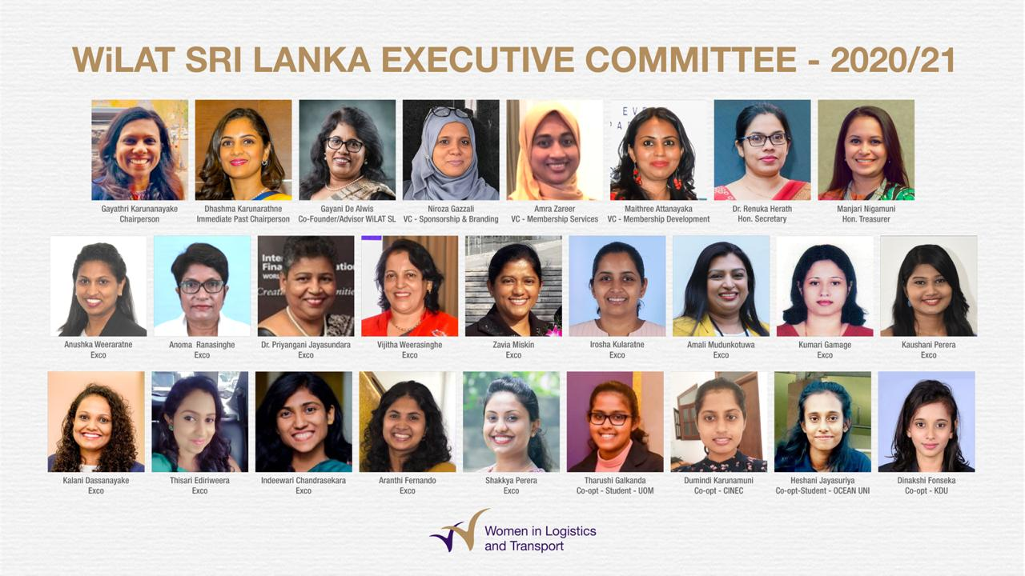

- Webinar on “Logistics Response for Covid-19, The South Asian Experience”, 11th June 2020
A webinar was organized by WiLAT South Asia team on the topic “Logistics Response for Covid 19 - South Asian Experience". Mrs. Lily Pandey FCILT, Executive Director, Railway Board, Ministry of Railway India, Dr Huma Baqai Associate Dean, IBA Paksitan, Mr Mohommad Zia Uddin CMILT Supply Chain Director GSK Bangladesh, Rtd Gen. Daya Ratnayake, Chairman Sri Lanka Ports Authorty participated at the webinar sharing the South Asian covid response in their respective sectors. The session was modearted by GVC South Asia Ms Gayani De Alwis CMILT.
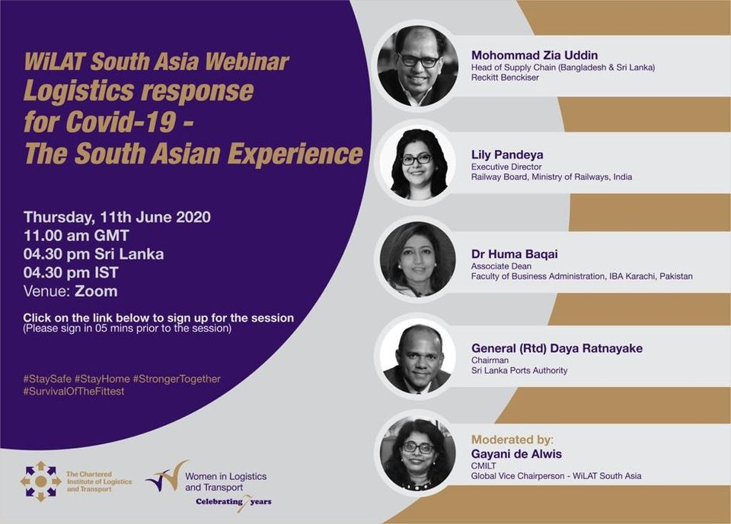
- WiLAT Nigeria Annual Founder’s Day Walk, 12th June 2020
The WiLAT Nigeria Annual Founder’s Day Walk was held on 12th June 2020 to mark the 10th Anniversary of the formation of WiLAT in Nigeria.
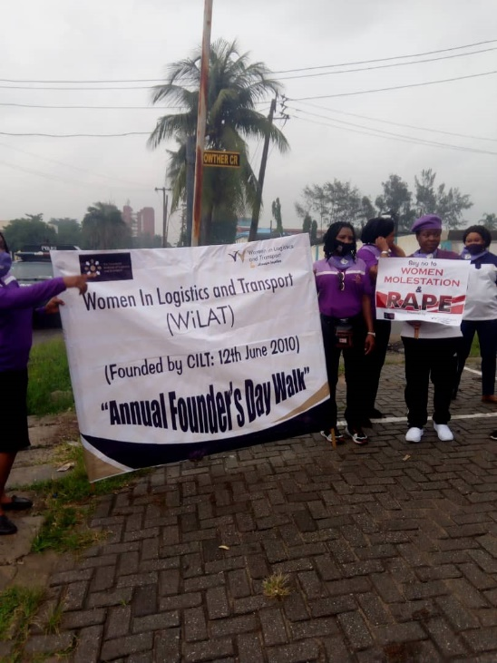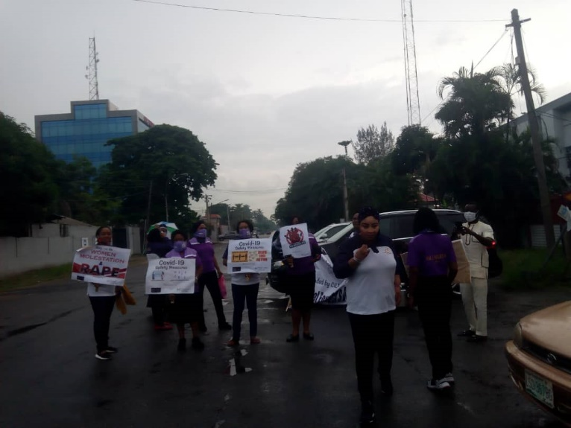

- Webinar on “Impact of COVID19 on Indian Logistics Industry & Roadmap to Recovery”, 26th June 2020
Covid-19 Pandemic not only brought the whole world to a standstill but also disrupted businesses across sectors. Things are no different for the $200 billion-plus Indian logistics industry where most supplies and deliveries came to a grinding halt when the country went into a nationwide lockdown. Though the government has allowed movement of both essential and non-essential goods, the situation is not so easy at the ground level.

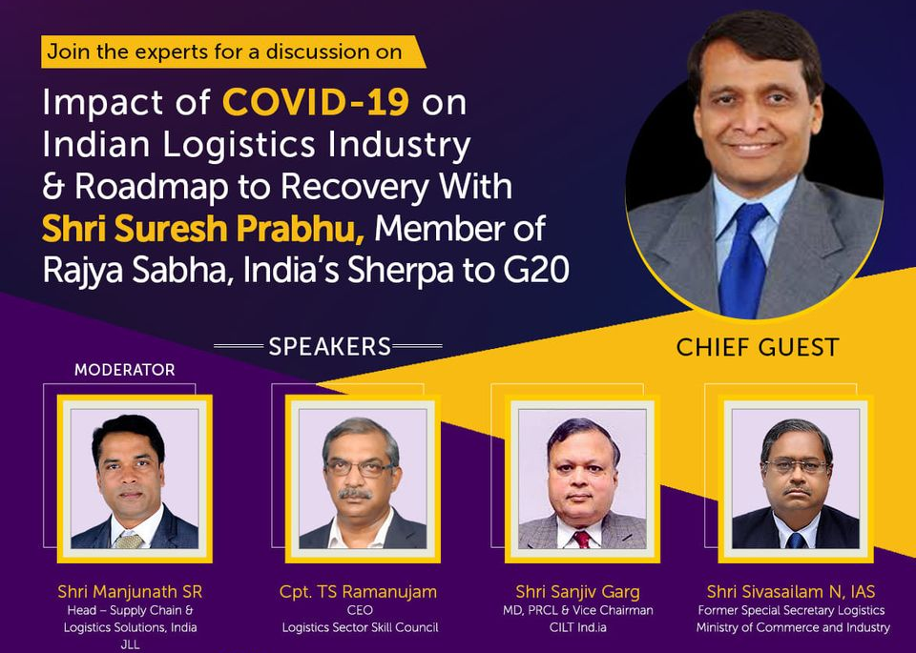

- WiLAT Sri Lanka Strategic Planning Workshop, 11th July 2020
WiLAT Sri Lanka conducted a hybrid model Strategic Planning workshop to develop 2020-2021 annual plan. WiLAT Sri Lanka came up with an active plan for the year with tentative dates of the programs focusing on WiLAT vision and strategic thrusts.
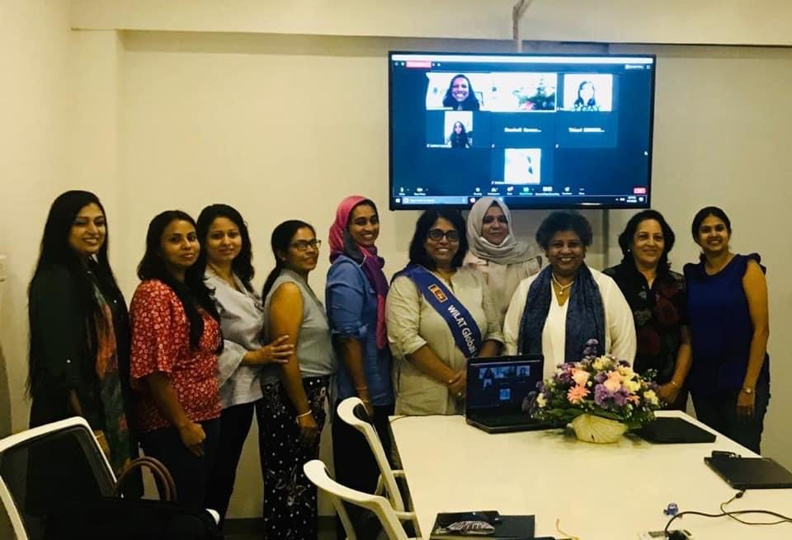

- Webinar on Logistics of COVID and Indian Railways, 11th July 2020
In year 2020-2021 the national and international economy bears the impact of the COVID-19 pandemic, which will also reflect on the transportation sector, including Indian Railways (IR). Railways, besides possessing remarkable resource mobilisation capabilities and disciplined manpower, have demonstrated agility and ingenuity to cater to completely new requirements that arose in India’s fight against COVID-19. It has played a crucial part in maintaining the supply of essential items and helping livelihoods by stepping up the transportation of goods but also leveraged its resources and demonstrated the capability to manufacture PPE, ventilators, hospital beds and COVID-19 isolation coaches.
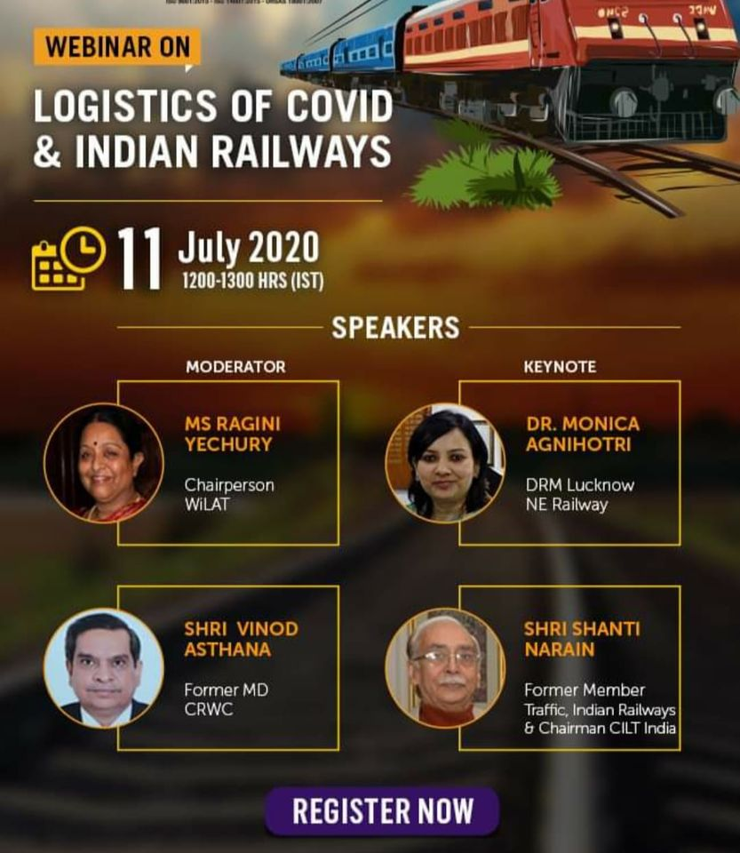

- Continuing Professional Development Program, 16th July 2020
Continuing Professional Development Program on the topic “Humanitarian Logistics - Best Practices in response to COVID 19, the CSR Factor” which was delivered by Dr. Abdul Samed Muntaka, Head of the Supply Chain and Information Systems Department, Kwame Nkrumah University of Science and Technology (KNUST) Business School of Business.
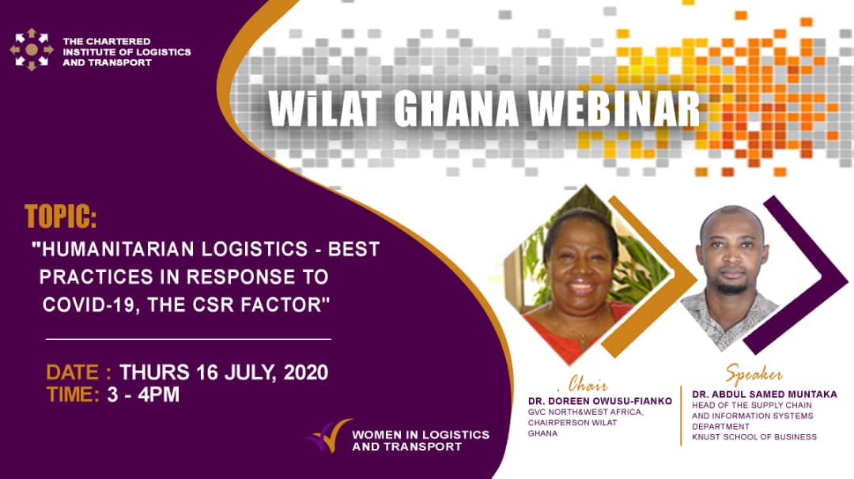

- Proposed establishment of WiLAT Egypt, 27th july 2020
A zoom meeting hosted by Mrs. Zeinab Awab of CILT Egypt was held on 27th July 2020 to discuss the launch of WiLAT in Egypt by December 2020. The Global WiLAT Chairperson Gayani De Alwis also participated in this meeting. Zeinab has been appointed as WiLAT anchor to lead the process for the formation of WiLAT Egypt and she is currently working on a rolling business plan that serves WiLAT's global mission and addresses priority areas for gender equity within the sector in Egypt. In the meantime, she has established contact with the National Council for Women and they have expressed their willingness to support WiLAT with linkages to other relevant Gender based initiatives and programs.

- WiLAT Nano Mask, 28th July 2020
To express our appreciation to the sponsors and supporters of WiLAT Hong Kong in the turbulence time of COVID 19, WiLAT Hong Kong sourced and distributed reusable Light Fresh Self-cleaning Nano Mask for distribution to our key sponsors and supporters’ front-line staff.
Positive feedback on the nano mask, both in design and its function, were received from many of the recipients. This COVID care program is helping to sustain WiLAT’s relationship and keeping the industry engaged with us. Sponsors photos below from MTRC Operations Director Tony Li; HK Tramway MD Cyril Aubin; and Turbojet COO Anna Hong.

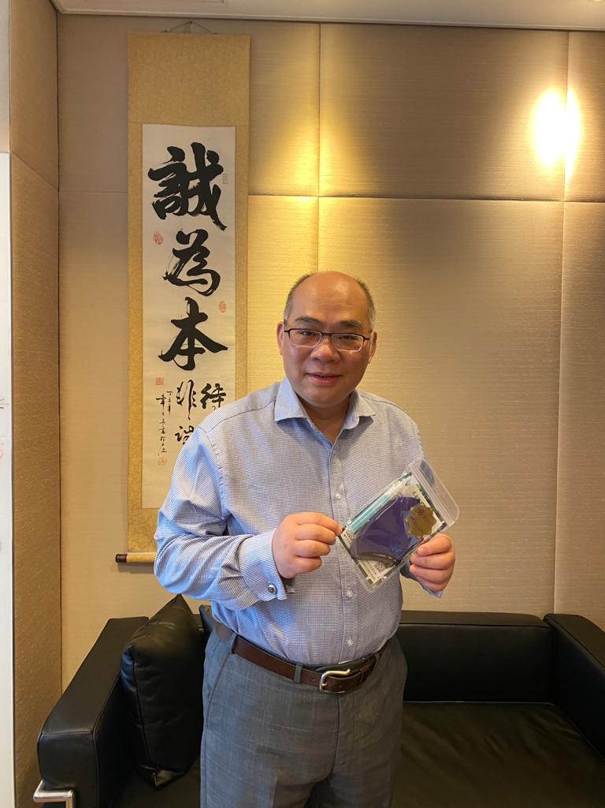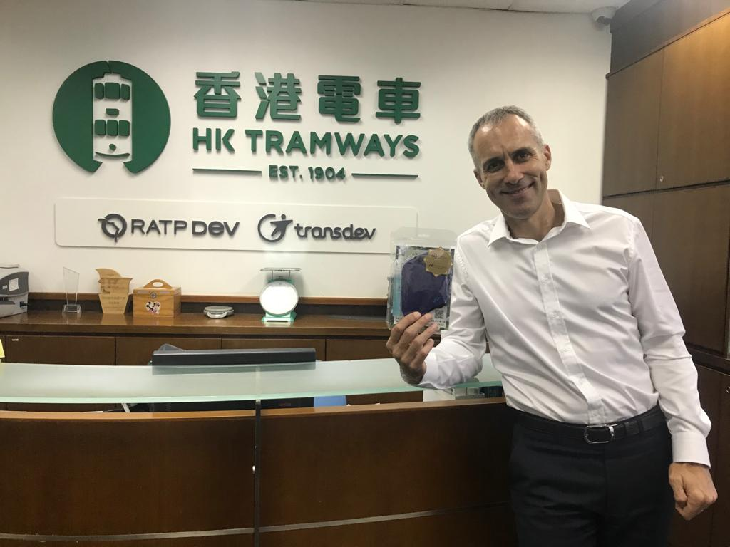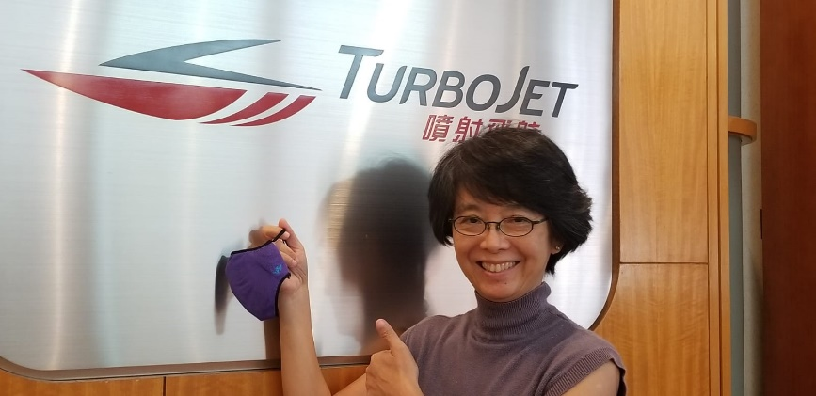
- Preparation for China Conference
Due to the outbreak of the virus, overseas participants will join the 7th China Conference (TangShan) online via ZOOM on 14th- 15th September. WiLAT Hong Kong is supporting the program and offering footages on WiLAT Hand Dance, WiLAT Chat summary etc.
WiLAT Hand Dance video has been circulated among WSC members and they are encouraged to contribute footages for the China event.
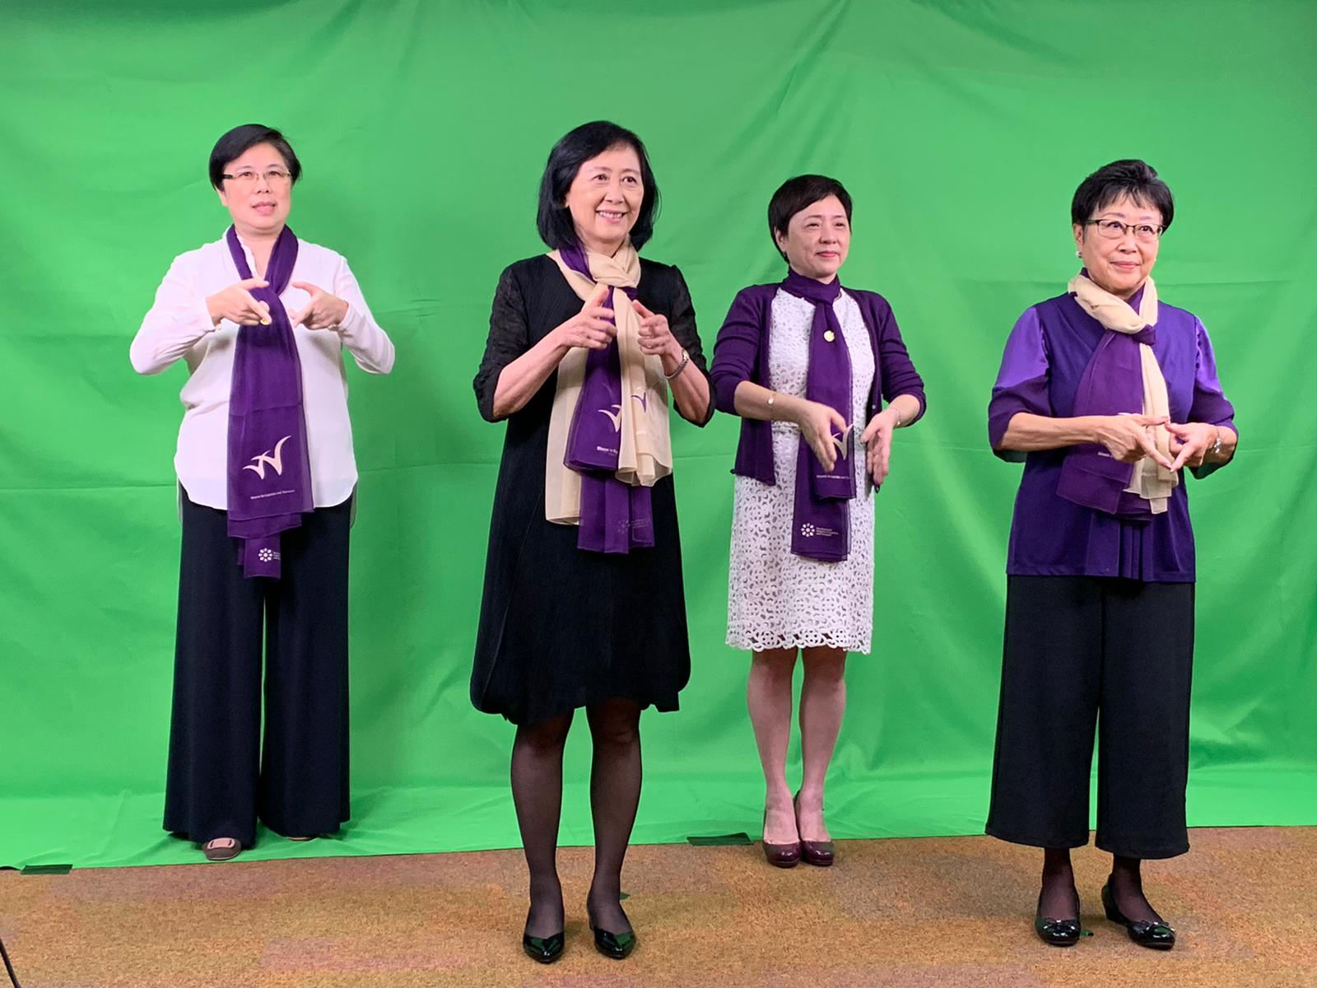

- Mentorship Webinar Program, 30th July 2020

WiLAT Sri Lanka held a successful session on Mental Health for young adults, followed by a successful survey done during Covid period, this was a closed group discussion to help for Ignite mentoring community of WiLAT.

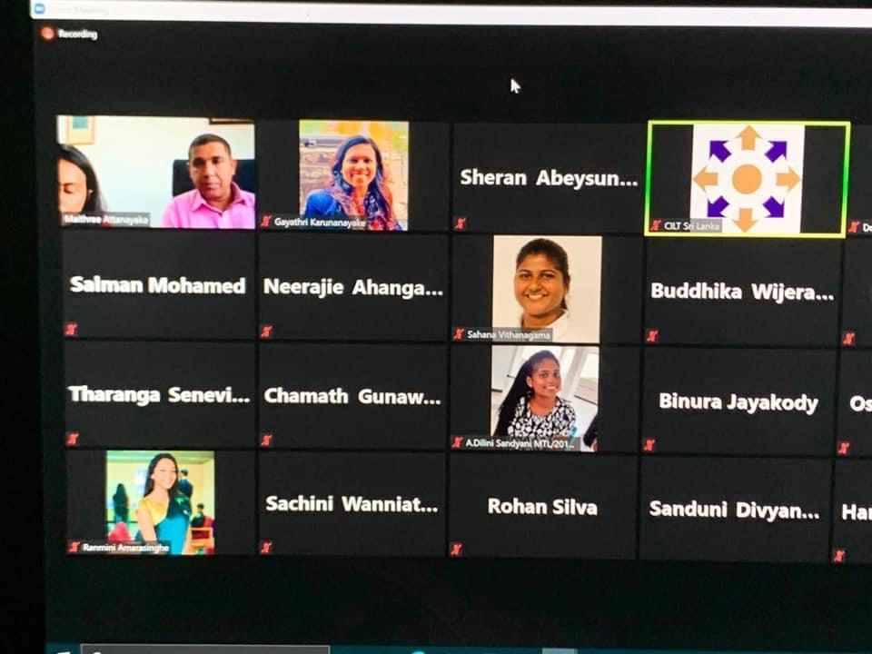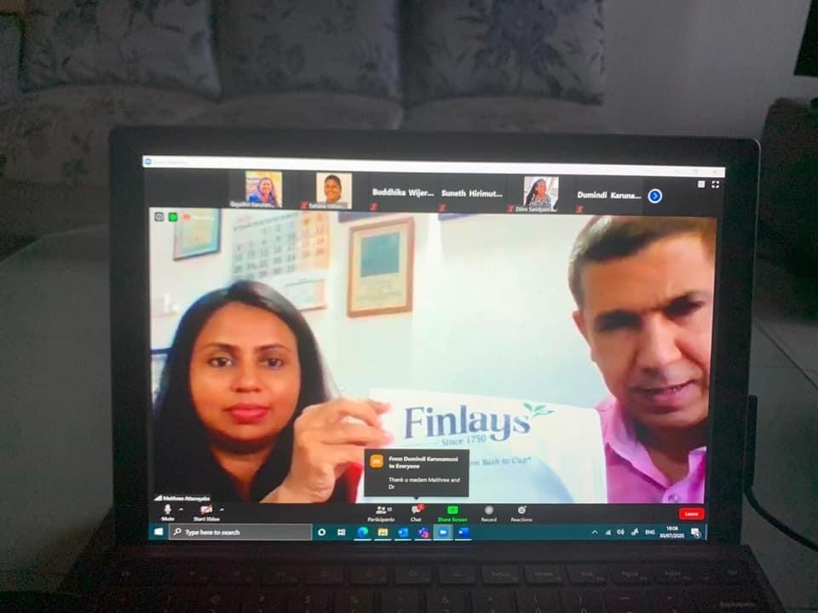

- WiLAT Nigeria Annual Conference 2020, 31st July 2020

This year’s WiLAT Nigeria day is a presentation virtually due to Covid 19. The annual conference 2020 was held on July 30^{th,} 2020. Conference papers were presented on the Topic: Adaptation of Nigeria transportation system to COVID 19…The way forward.
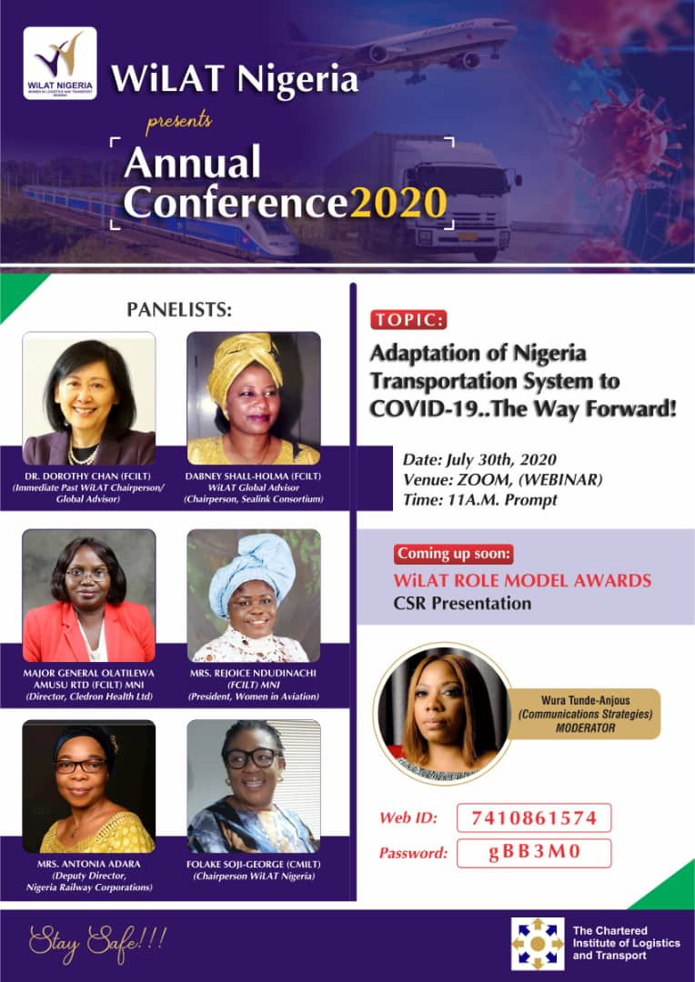

- CILT-M AGM, 15th August 2020

The official appointment of a new WiLAT Malaysia Chairperson & committees
(Management Council: WiLAT Chairperson / Sections: Deputy Chairperson)
- To Identify female CILTM members and their expertise
- To propose increase (minimum 30%) of female council members in Management Council

Incorporating WiLAT’s 4 Strategic thrusts and identify who will spearhead each of these on the National Level:
  - Leadership: 1st Webinar (25 June 2020)
  - Entrepreneurship: 2nd Webinar (9 July 2020)
  - Empowerment: 3rd Webinar (13 August 2020)
  - Mentorship; 4th Webinar (Expected in September 2020)
    - As well as CSR (Autism etc.)

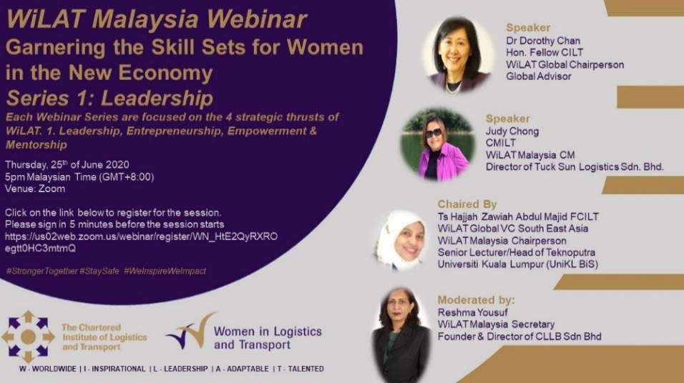

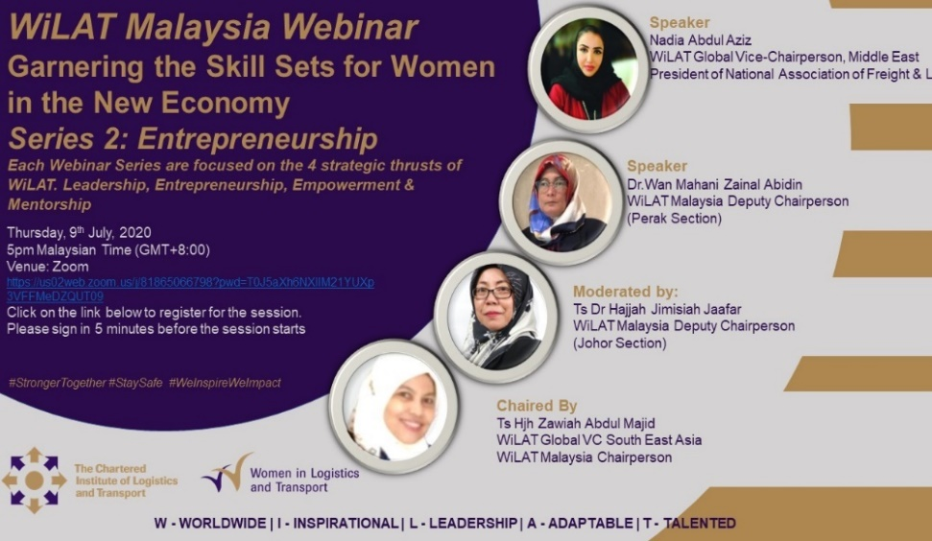

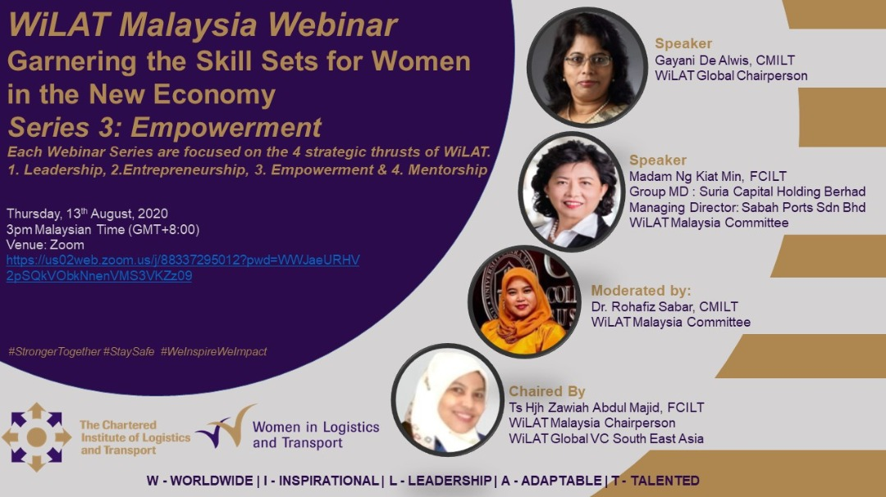

- Offical Launch of WiLAT Bangladesh, 21stAugust 2020

WiLAT Bangladesh, Women’s Forum of CILT Bangladesh Council was launched on August 21, 2020 virtually for the first time as the 22nd chapter of global WiLAT and it created a historic moment for WiLAT Bangladesh. Due to Covid Pandemic CILT Bangladesh Council decided to launch the WiLAT forum virtually via zoom platform. The CILT International Secretary General Keith Newton FCILT, WiLAT Global Chairperson Gayani De Alwis CMILT, Deputy Global Chairperson Vicky Koo FCILT also joined the launch.

Mrs. Mimnun Sultana, Assistant Professor, United International University was elected as the first Chairperson, Mrs. Syeda Tahmina Hossain CMILT, Head 0f Planning & Monitoring, Shabab Fabrics Ltd. Mrs. Israt Jahan Rimi, Manager, Admin & Training, Expeditors Bangladesh and Mrs. Razia Sultana CMILT, Director, Interport Group also was elected as Vice Chairperson, Secretary General and Treasurer respectively. Mrs. Sangeetha Nagarajah, GM, Business Development, Scanwell Logistics, Mrs. Shamima Akhter CMILT, Sr. Officer, Procurement at Save the Children. Mrs. Nighat Sultana, Agent-Ocean, Expeditors Bangladesh also was elected as Executive Committee member. To attract millennials a young female student representative each from different universities offering supply chain and logistics degree programs were co-opted. Global Vice Chairperson Gayathri Karunanayake CMILT offciated the launch program.

