From: Ceri Williams | CILT International
Sent: Wednesday, February 10, 2021 8:58 PM
Subject: CILT Green Technology and Sustainability Campaign

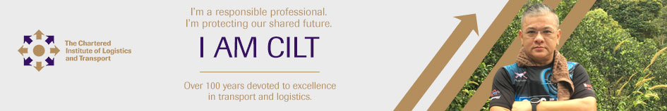
Dear Branch Key Contact,

Climate change is a clear and present danger to our planet, and in response we as professionals must change the way we operate.

With this in mind, and in line with International President Dato’ Radzak Malek’s strategy for the year, we are launching a new campaign focused on sustainability and the green agenda. We are building upon the success of the ‘I am CILT’ campaign to create engaging communications about sustainability and green technology.

Over the coming months we will also be focusing on these issues in our bulletins, webinars and social media content, dissecting both the challenges and the solutions. We hope this work inspires all branches to create their own activities to support this campaign at a local level between now and July 2021.

Please think about what you can do in your country to support and promote this vital theme, and as with the original ‘I am CILT’ campaign, please use and adapt the campaign format to represent your local members and meet the needs of your local market.

The attached guidelines will take you through how to create your own campaign layouts. Artwork and layout templates are available on the DMS. There is also an album of images which members have submitted to support the green agenda on our Flickr platform at https://www.flickr.com/photos/134390998@N06/albums.

We hope this campaign can be used not only to highlight the importance of green technology and sustainability, but also to enhance our membership experience, and build awareness of the CILT Brand at a time when we have to focus on developing our membership base.

We must continue to look forward. We must keep innovating and developing for the future.

Best regards

Ceri Williams
International Marketing, Governance and Communications Manager

E: ceri.williams@ciltinternational.org

CILT International Office
Earlstrees Court | Earlstrees Road | Corby | Northants | NN17 4AX | UK
info@ciltinternational.org | ciltinternational.org

Facebook | Twitter | LinkedIn

Registered Charity Number:313376

