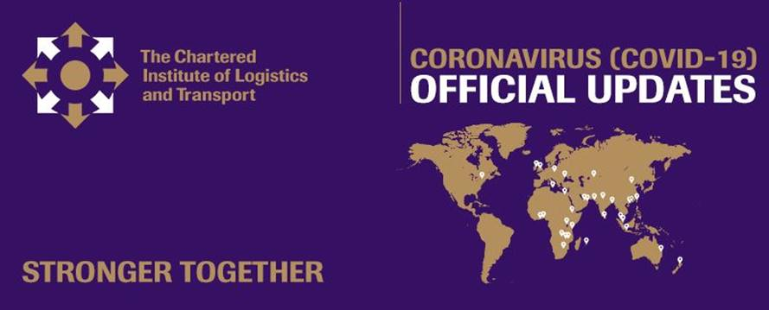

Dear Branch Key Contact

Look out for the fifth **CILT Covid-19 Bulletin** on the theme of **Global Shipping and the Supply Chain** arriving in your inbox today.

This is part of our global best practice resource to help you think about and determine appropriate responses locally. Once you have opened the email please click on the small box at the top of the message to enable the images to download.

Please share this bulletin with your country members as part of our initiative to keep members engaged and supported during the Covid-19 pandemic. The link to share is:

<https://mailchi.mp/8d7ea90a118f/cilt-covid-19-bulletin-2909353>

The **international webinar discussion** on the same theme will follow next week on Wednesday 3rd June at 11:00 GMT (12 noon BST)

Guest Speaker Romesh David, Chief Executive Officer at South Asia Gateway Terminals (Pvt) Ltd. will examine the likely impacts on container shipping lines of the fall in trade volumes on the Asia/South Asia-Europe container routes, and the potential ensuing impacts on trans-shipment ports in the South East/South Asian regions.

Mr. HO Lap Kee, Sunny, Executive Director, The Hong Kong Shippers’ Council will consider the immediate impact to operators and potential changes in global supply chains, that might be brought by the Covid-19 epidemic.

Bob Armstrong, Supply Chain Consultant, will be reviewing the implications on the movement of goods during the Covid-19 pandemic including the implications of global supply chains on North America and the world.

Registration will be held open for Branch key contacts until 12 noon on Monday 1 June after which it will be opened up to all members. We hope at least one member of every CILT branch will join the discussion, but places are limited so **please only register if you know you can join the session**. As previously, the recording will be available on the international website after the event for members who are unable to join live.

To register for the webinar please follow the link in the invitation below.

<https://us02web.zoom.us/webinar/register/WN_zVuKmbCSS4Kz0tNzkvduJQ>

After registering, you will receive a confirmation email containing information about joining the webinar

Kind regards

Tobias

**Tobias Williams**

Conference Administrator

**E:**  [tobias.williams@ciltinternational.org](mailto:tobias.williams@ciltinternational.org)

**CILT International Office**

Earlstrees Court | Earlstrees Road | Corby | Northants | NN17 4AX | UK

[info@ciltinternational.org](info@ciltinternational.org )|  [ciltinternational.org](http://www.ciltinternational.org/)

[Facebook](https://www.facebook.com/ciltinternational/)  |  [Twitter](https://twitter.com/cilt_global)  |  [LinkedIn](https://www.linkedin.com/company/the-chartered-institute-of-logistics-&-transport)

Registered Charity Number:313376