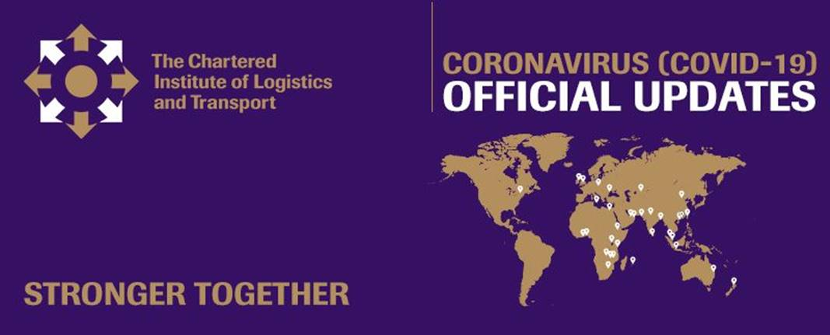

Dear CILT Branch,

As you are aware, our President, Dato’ Ts Abd Radzak Abd Malek, has asked all country branches to do local research and build up a local response to a series of questions relating to the Covid-19 crisis. Thank you to everyone who has been responding to these requests.

**This week branches are asked to consider and comment on Business Continuity and the Ongoing Management of Risk.**

We would like all country offices to feedback a summary of their current experience and understanding on this topic to [Keith Newton](mailto:keith.newton@ciltinternational.org), **by the end of Friday 5 June 2020.**

**As previously, these responses will be used to generate a series of Covid-19 Best Practice Responses on the international website which will then be collated into a Covid-19 Response Bulletin on Thursday 11 June 2020. An international webinar discussion will follow on Wednesday 17 June.**

**Research responses from the previous topic of Global Shipping and the Supply Chain – the short and long term response** **will be shared in a Covid-19 Response Bulletin on Thursday 28 May, and discussed in a webinar on Wednesday 3 June.**

**Please ensure that you are sharing the research questions and the Best Practice Response Bulletins with your members. The recording of each international webinar will also be published on the international website and circulated for branches to share with members. Please use all of these materials to engage locally with members and generate further conversation and response.**

**Best regards**

**Ceri**

**Ceri Williams**

International Marketing, Governance and Communications Manager

**E:** <ceri.williams@ciltinternational.org>

**CILT International Office**

Earlstrees Court | Earlstrees Road | Corby | Northants | NN17 4AX | UK

[info@ciltinternational.org](info@ciltinternational.org%20) | [ciltinternational.org](http://www.ciltinternational.org/)

[Facebook](https://www.facebook.com/ciltinternational/) | [Twitter](https://twitter.com/cilt_global) | [LinkedIn](https://www.linkedin.com/company/the-chartered-institute-of-logistics-&-transport)

Registered Charity Number:313376